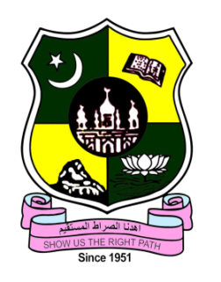
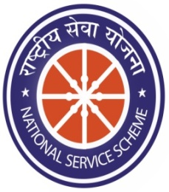
JAMAL MOHAMED COLLEGE (AUTONOMOUS)

College with Potential for Excellence

Accredited (3rd Cycle) with ‘A’ Grade by NAAC

DBT Star Scheme & DST – FIST Funded

(Affiliated to Bharathidasan University)

TIRUCHIRAPPALLI-20

NATIONAL SERVICE SCHEME

REGULAR ACTIVITIES FOR ACADEMIC YEAR (2021-2022)

COVID-19 PREVENTION HELP CENTRE OPENING

On the date of 01 June 2021, Covid-19 help Centre was opened at Jamal Mohamed College. Minister of municipal administration, urban and water supply of Tamilnadu Hon. Mr. K. N. NEHRU, Tiruchirappalli district collector Mr. S. Sivarasu and Trichy district Special officer and Commissioner Mr. S. Subramaniyan has opened the Covid-19prevention help centre and our college principal has instructed our NSS Programme officers and our NSS volunteers to provide the groceries to the needy people. We organized the people with social distance in good manner.
Number of NSS Volunteers Participated: 15 Date: 01.06.2021 Number of NSS Programme Officers Participated: 02
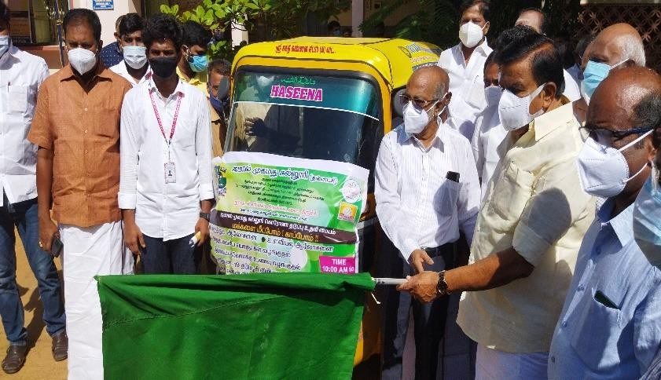

WORLD ENVIRONMENT DAY
On the date of 05 June 2021, The World Environment Day was celebrated by National Service Scheme of Jamal Mohamed College at home ... In this programme The NSS volunteer’s maintenance the tree and taken pledge at their home
Total no. Of volunteers Participated: 35 Date: 05.06.2021

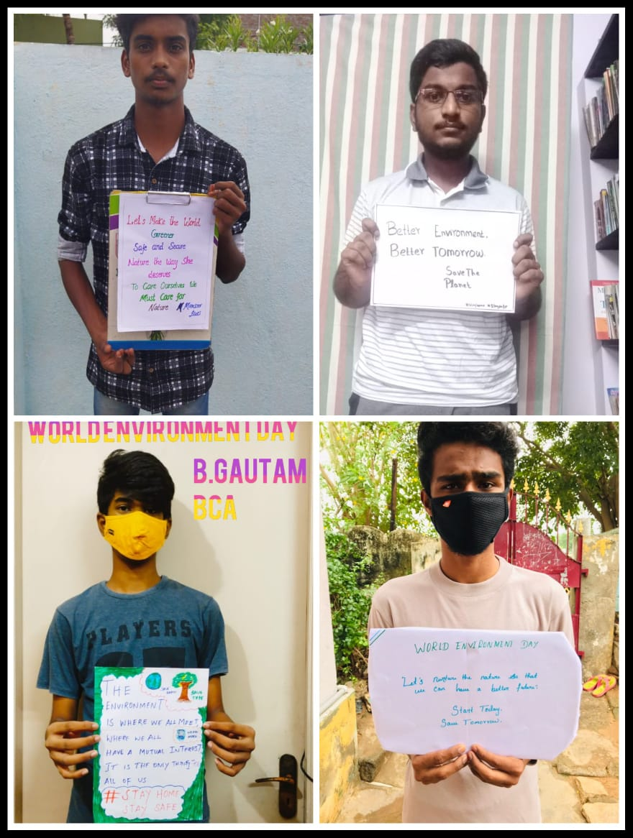
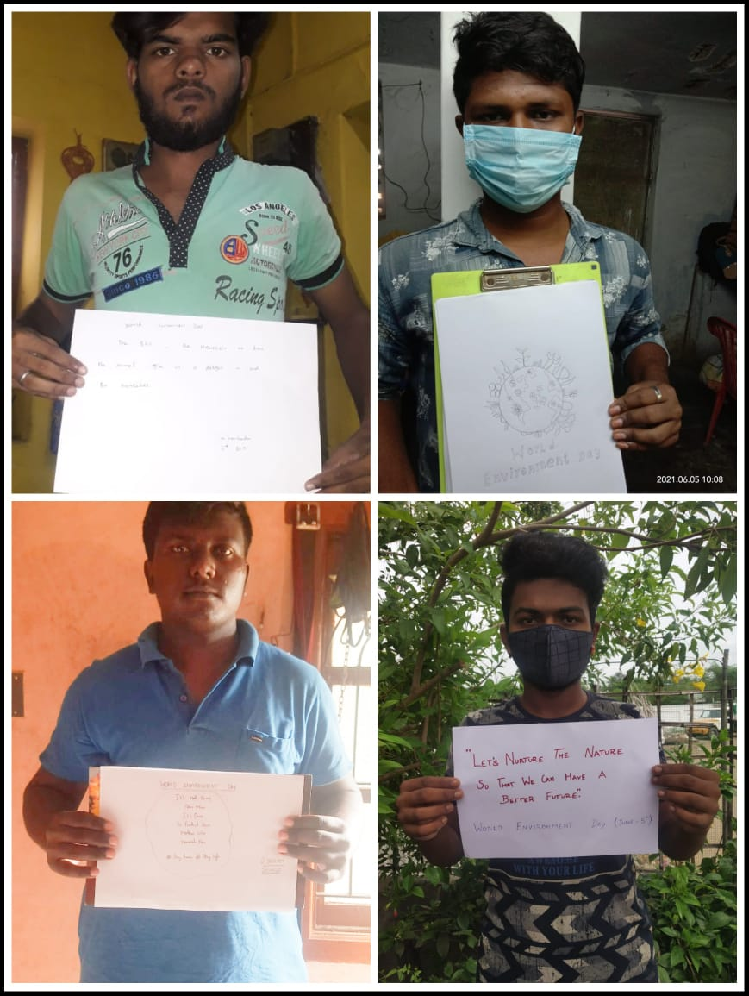

VACCINATION CAMP REPORT

On The Date of 16thJune 2021 Covid-19 Vaccination camp was conducted at Jamal Mohamed College. Our college staff member’s students and many external people were vaccinated in the camp. Our college NSS programme officer instructed our NSS Volunteers to make awareness among the public about the importance of vaccination against Covid-19. Our NSS Volunteers has done their duty in good manner.

No. of NSS Volunteers of Participated: 06 Date: 16.06.2021
No. of NSS Programme officers participated: 04

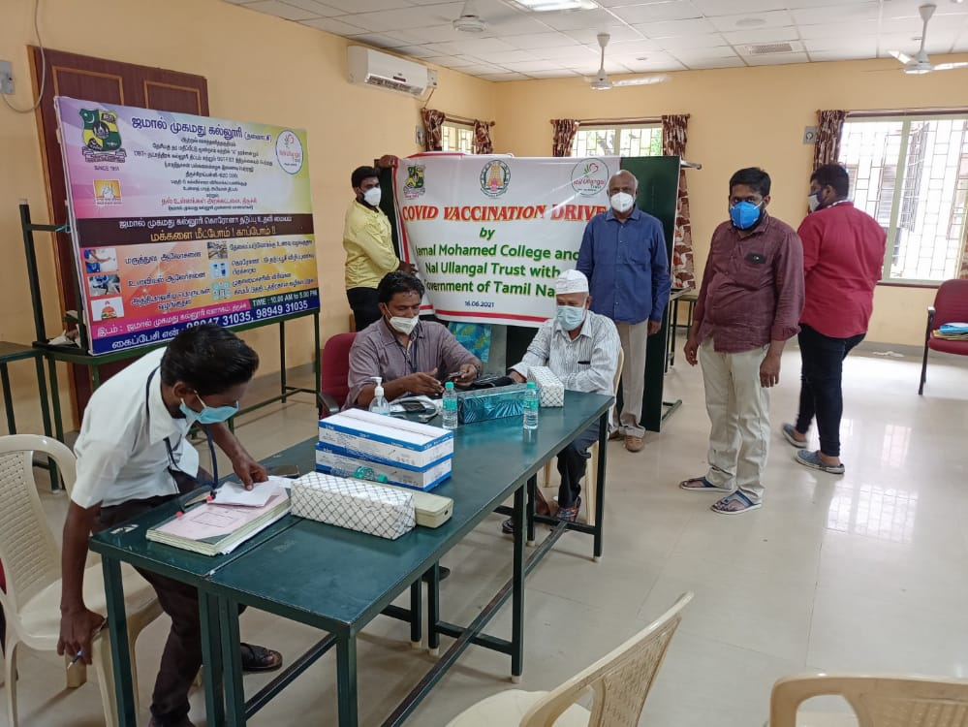

INTERNATIONAL YOGA DAY REPORT
On the date of 21st June 2021, the 7th International Yoga Day was celebrated at our home with based on the theme “Be with Yoga. Be at home”. The Principal of Jamal Mohamed College instructed NSS programme officers and NSS volunteers. We celebrate 7th International yoga day more than30 Volunteers was participated in this programme.
Number of NSS Volunteers Participated: 30 DATE: 21.06.2021
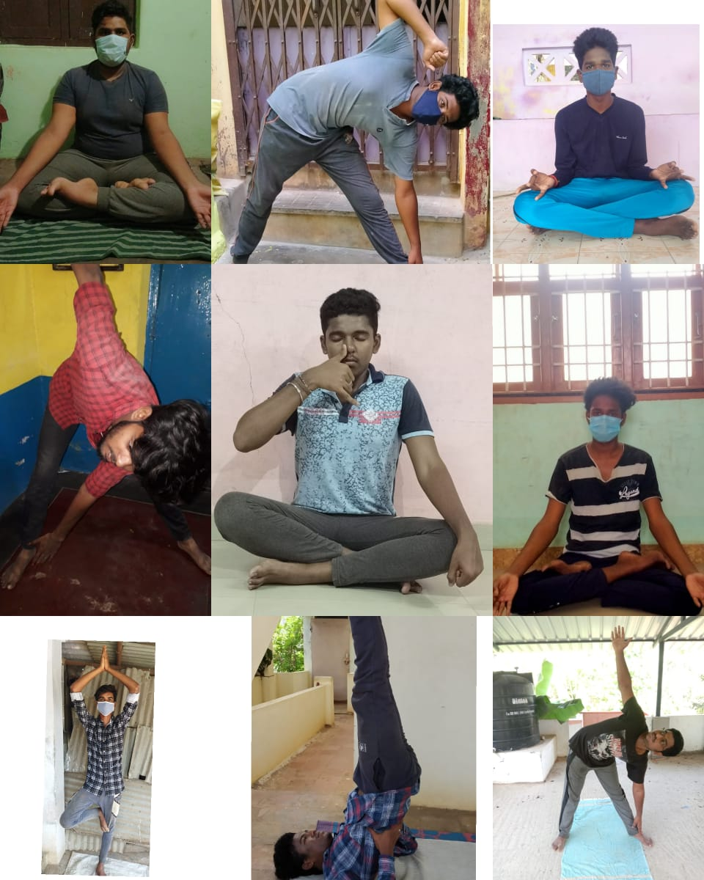

INTERNATIONAL DAY AGAINST DRUG ABUSE PLEDGE

On the date of 26.06.2021, The International Day against Drug Abuse programme was organized by the National Service Scheme of Jamal Mohamed College. In this Event the National Service Scheme of Jamal Mohamed College Programme officers and volunteers were participated and enrolled their Due Pledge. This moment was held at the volunteer’s respective places.
Total no. Of volunteers Participated: 12 Date: 26.06.2021

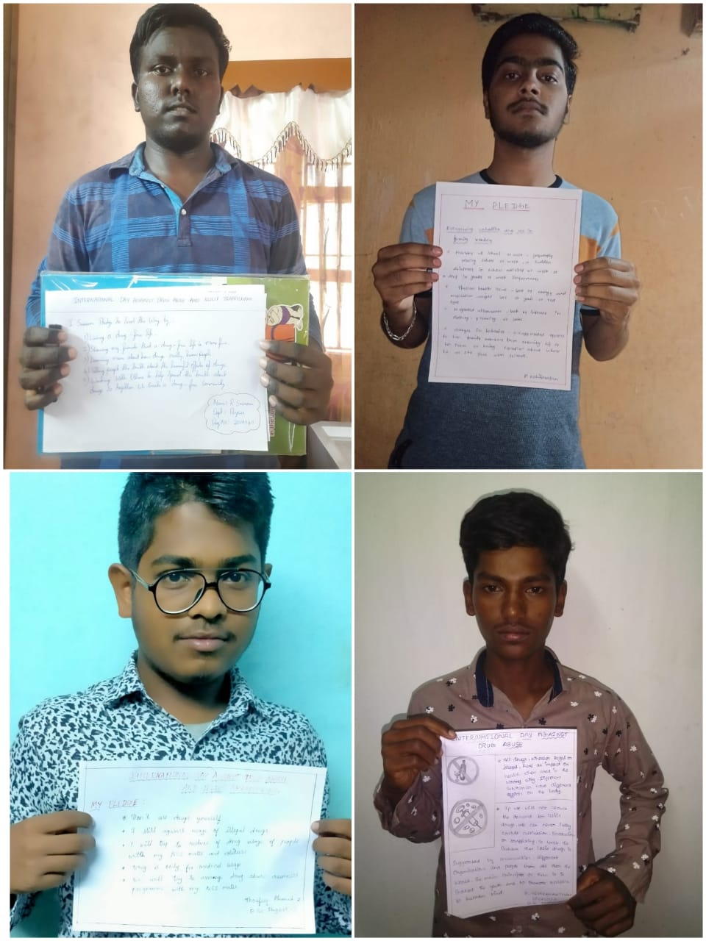

WORLD POPULATION DAY PLEDGE TAKING REPORT
On the date 11th August 2021, World population day pledge was taken Jamal Mohamed College. Our College Principal instructed NSS Programme officers and NSSVolunteers to take pledge in good manner. Our College NSS Volunteerstook pledge as per information given by the programme officer
Number of NSS Volunteers Participated: 36 DATE: 15.07.2021 Number of NSS Programme Officers Participated:02

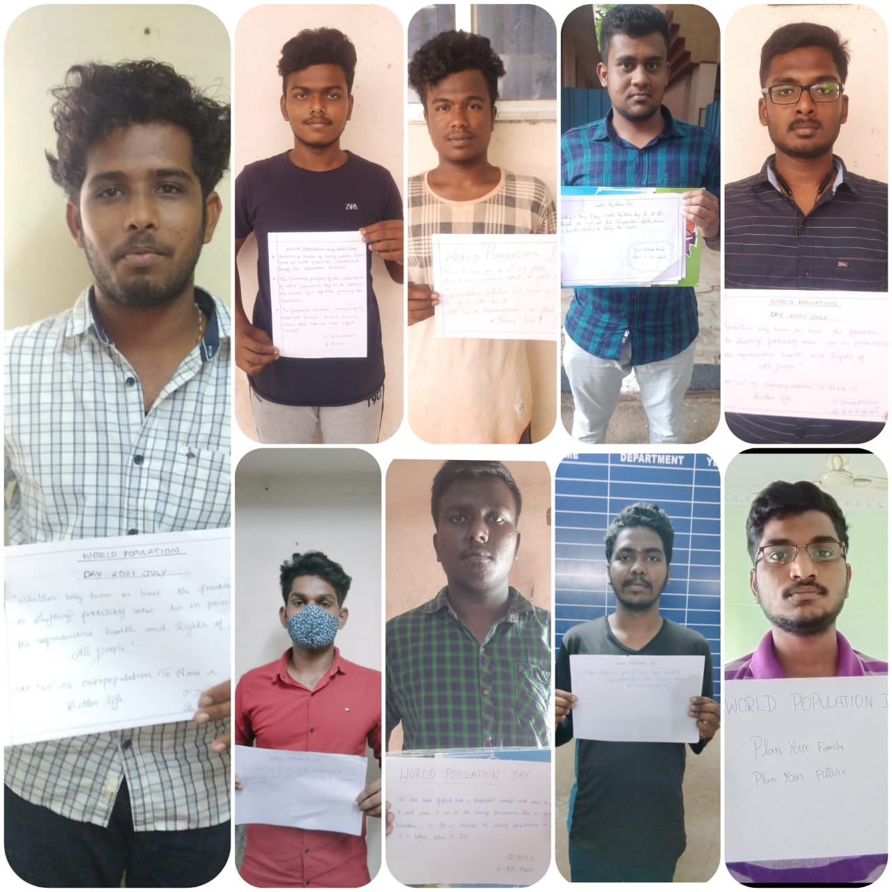

WORLD NATURE CONSERVATION DAY

On the date of 28 July 2021, World Nature Conservation Day was celebrated by National Service Scheme of Jamal Mohamed College at Khajamian Hostel Gate. In this programme the NSS volunteers ‘Cleaned around the tree and maintaining the tree in Good Manner.

No. Of NSS volunteers Participated: 10 Date: 28.07.2021
No. of NSS Programme Officer’s:01

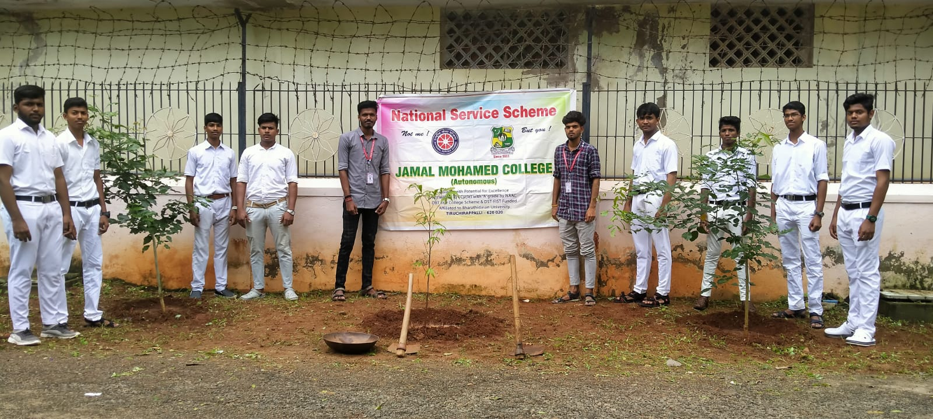

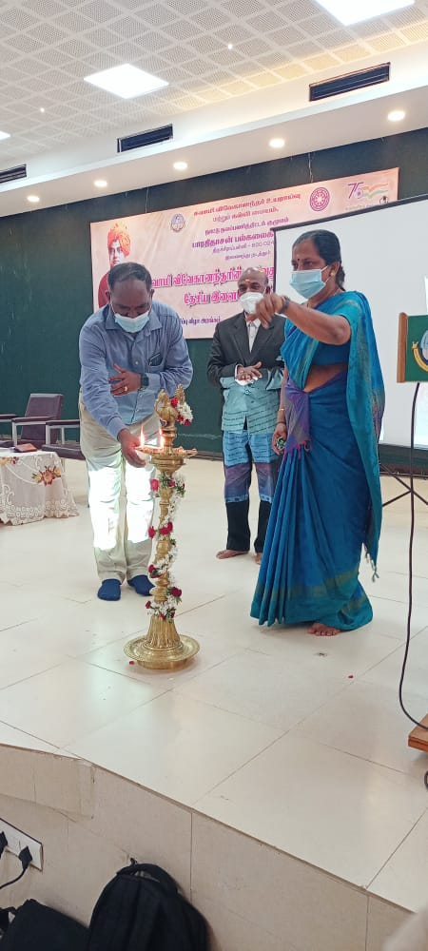

NATIONAL HOSPITAL DAY REPORT
On the date of 30th July 2021, National Hospital Day was celebrated at Jamal Mohamed College. Our college Principal addressed about hospital day. Our NSS programme officer instructed our NSS volunteers to make a video for hospital day. Our Volunteers make a video by narrating a quote for hospital day. We celebrate the hospital day in good manner.
Number of NSS Volunteers Participated: 15 DATE: 30.07.2021 Number of NSS Programme Officers Participated: 01

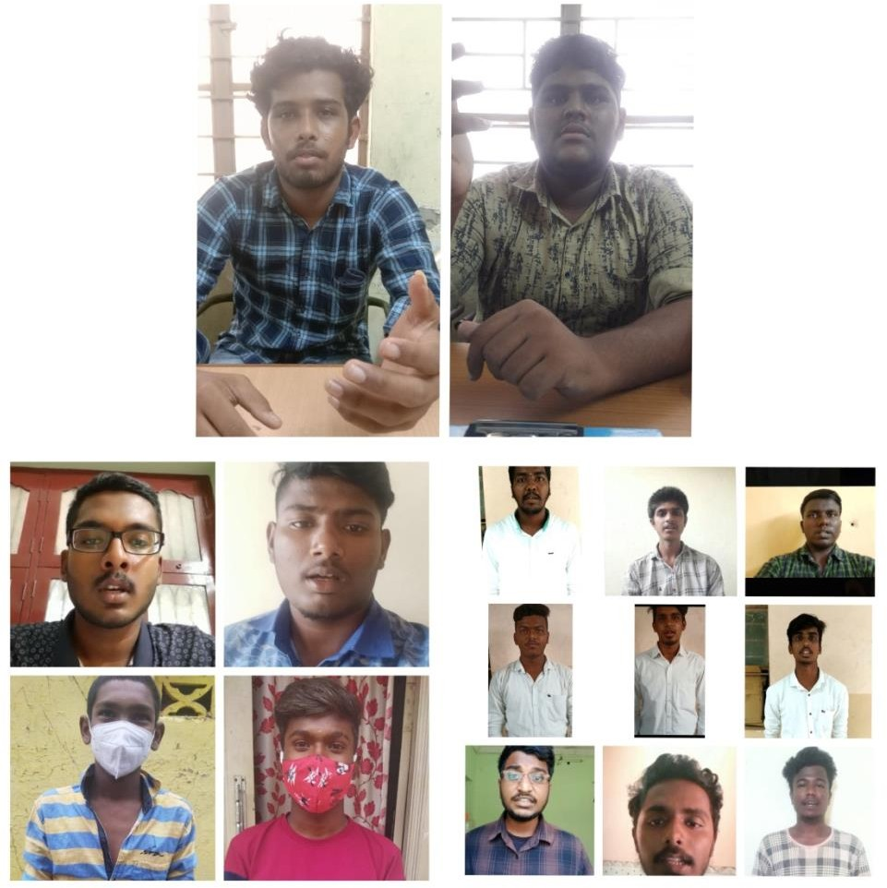

NATIONAL ANTHEM SINGING PROGRAMME
As per the instruction given by Ministry of Culture, Govt. of India. Our Principal and NSS Programme Officers were instructed our NSS Volunteers were participated in the National Anthem Singing Programm for 75thIndependence day from 7th August to 14th August 2021. We are aware about the importance of Indian Independence and we sang along with the national anthem music in the respected website provide by the Govt. of India. Our NSS Volunteers were participated and got the E-Certificate which is provided by the Ministry of Culture and Govt., of India.
No. of NSS Volunteers participated: 61 Date: 07. 08. 2021

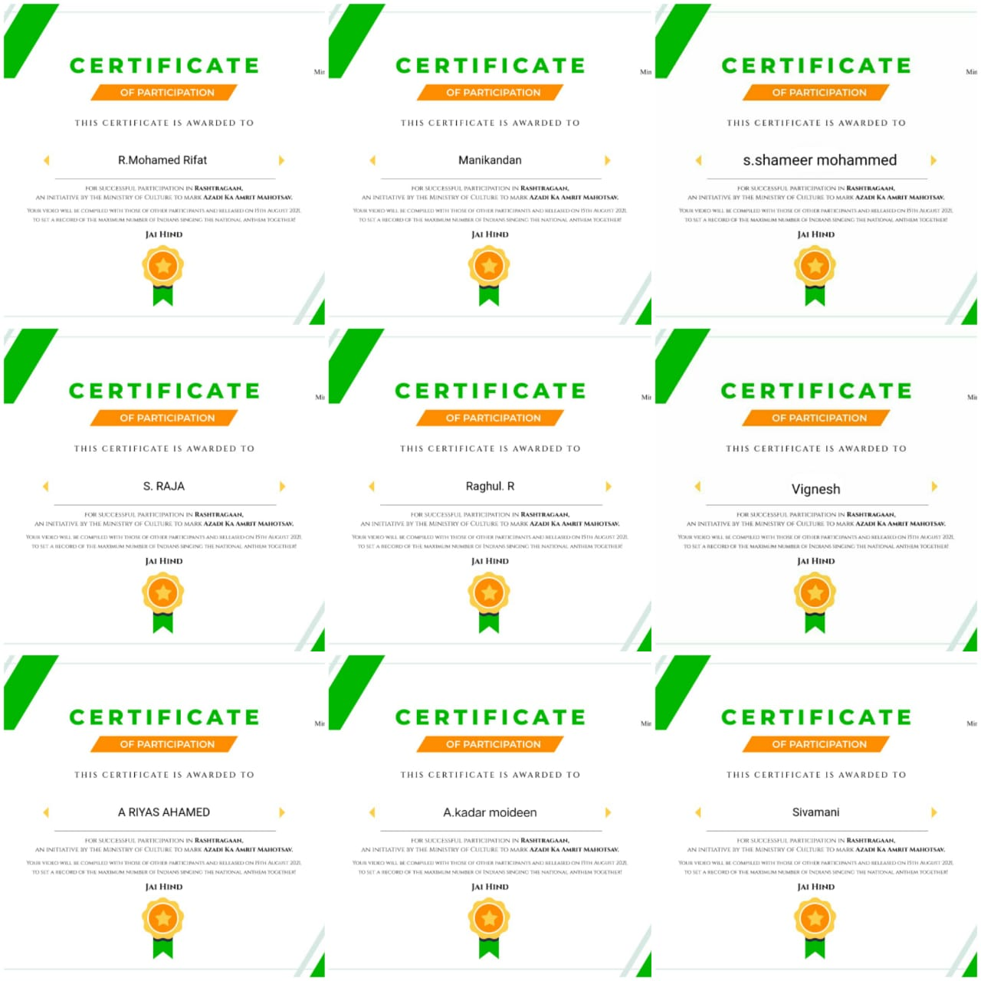

INTERNATIONAL YOUTH DAY

On The date of 12.08.2021 International Youth Day was celebrated at Jamal Mohamed College. Our NSS Programme officer instructed our NSS volunteers to attend the programme. Our NSS volunteer has participated in the poster making competition and they participated with full involvement. NSS volunteer of II-B. Sc. Zoology ASKAR ALI has won in the competition. The winner was honored in the special camp. And they participated in good manner

No. of NSS Volunteers of Participated: 40 Date: 12.08.2021
No. of NSS Programme officers participated: 02

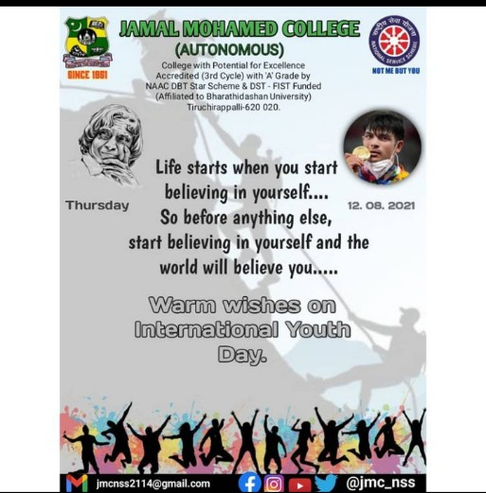

75THINDEPENDENCE DAY AT BDU
On the date 15 August 2021, 75th Independence Day was celebrated by NSS Cell of Bharathidasan University. The National Service Scheme of Jamal Mohamed College Volunteers was participated in this Independence Day programmed. M. SELVAM Vice-Chancellor of Bharathidasan University presided over the programme. Mrs. A. LAKSHMI PRABHA NSS Co-ordinator of Bharathidasan University, NSS Staffs and our college Programme officer has guided our NSS Volunteers to make the program grand success
Number of NSS Volunteers Participated: 31 DATE: 15.08.2021
Number of Programme Officers participated: 01

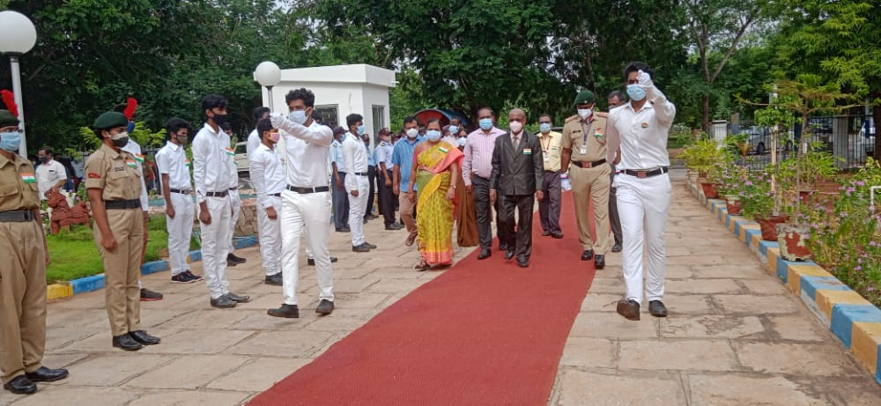

INDEPENDENCE DAY CELEBRATION JAMAL MOHAMED COLLEGE REPORT
On the date 15 August 2021, 75th Independence day was celebrated at Jamal Mohamed college. Our College Principal addressed the speech about Indian Independence and our College Secretary Hosted the flag and distributed the sweets. Our college Programme officers and NSS Volunteers has participated in the programme at Jamal Mohamed college.
Number of NSS Volunteers Participated: 16 DATE: 15.08.2021 Number of NSS Programme Officers Participated: 03

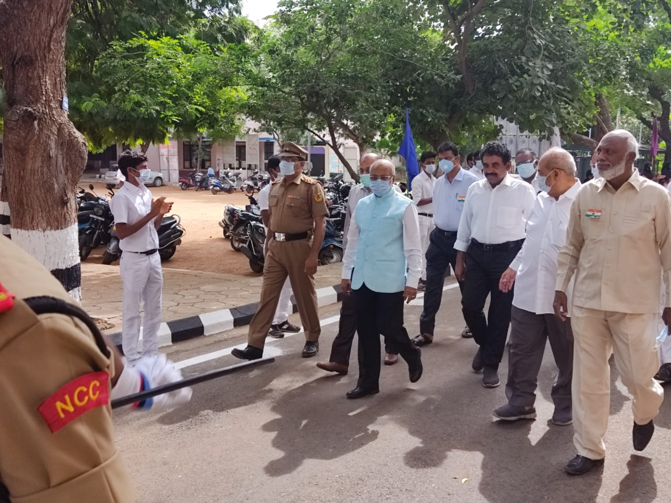

FRESHERS CERTIFICATE VERIFICATION PROGRAMME
On the date of 1st September to 4th September 2021 Certificate verification programme for UG Self finance 1styear students were held at our college in Almanhal Hall. The Volunteers of National Service Scheme of Jamal Mohamed College were participated and our NSS Programme Officers were instructed our NSS Volunteers to help the Students. Our NSS Volunteers organized the students with social distance and help the staff members who are all in charge for the certificate verification and done their work in good manner.
Date: 04. 09. 2021

Day 1 | No. of NSS Volunteers Participated:03
Day 2 | No. of NSS Volunteers Participated:03
Day 3 | No. of NSS Volunteers Participated:03
Day 4 | No. of NSS Volunteers Participated:03

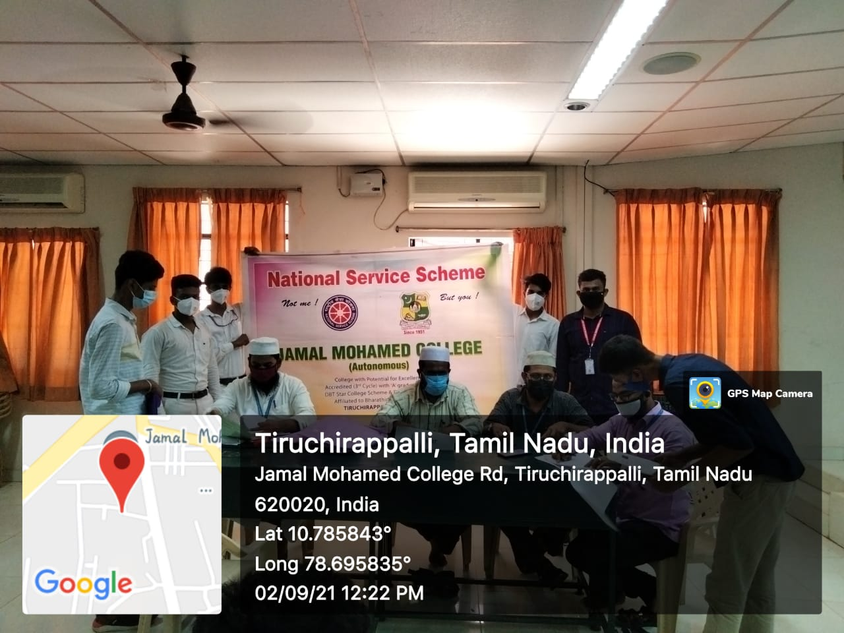

FRESHERS CERTIFICATE VERIFICATION PROGRAMME
On the date of 1st September to 4th September 2021 Certificate verification programme for UG Aided1styear students were held at our college in Syed Hussainudeen Hall. The Volunteers of National Service Scheme of Jamal Mohamed College were participated and our NSS Programme Officers were instructed our NSS Volunteers to help the students. Our NSS Volunteers organized the students with social distance and help the staff members who are all in charge for the certificate verification and done their work in good manner.
Date: 04. 09. 2021

Day 1 | No. of NSS Volunteers Participated:03
Day 2 | No. of NSS Volunteers Participated:03
Day 3 | No. of NSS Volunteers Participated:03
Day 4 | No. of NSS Volunteers Participated:03

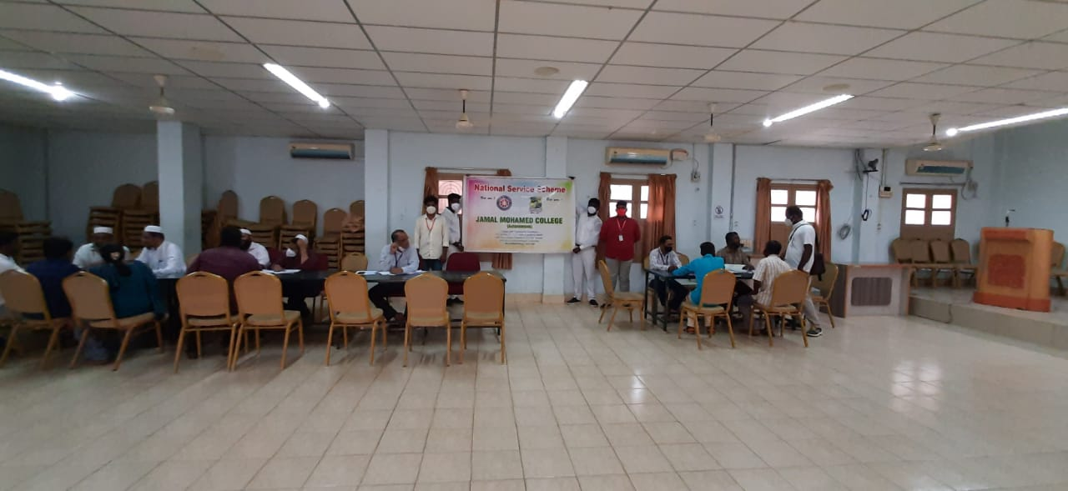

VACCINATION CAMP REPORT

On The Date of 02ndSeptember2021 Covid-19 Vaccination camp was conducted at Placement Cell in our College. Our college staff member’s students and many external people were vaccinated in the camp. Our college NSS programme officer instructed our NSS Volunteers to make awareness among the public about the importance of vaccination against Covid-19. Our NSS Volunteers has done their duty in good manner.

No. of NSS Volunteers of Participated: 05 Date: 02.09.2021
No. of NSS Programme officers participated: 03

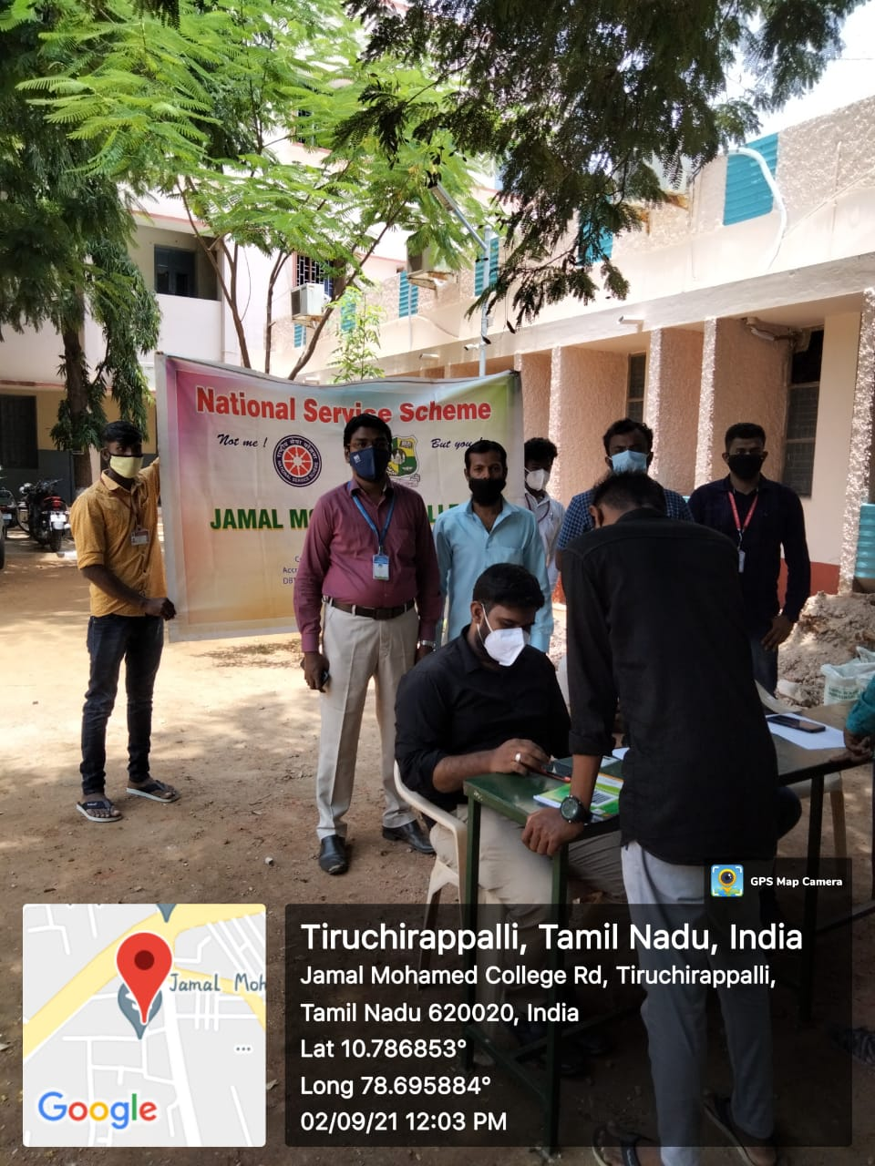

TEACHER’S DAY CELEBRATION PROGRAMME

On the date of 4th September 2021 Teacher’s Day was celebrated in advance at our college. The National Service Scheme of Jamal Mohamed College volunteers were participated and our NSS Programme Officers were instructed our NSS Volunteers to wish the Principal, Secretary, Treasurer and Teaching Staff Members of our college with sweets, greetings and gift and our NSS volunteers were welcome our college staff members with NSS clap from the college entrance. We celebrated the teacher’s day programme in great manner.
No. of NSS Volunteers participated: 24 Date: 04. 09.2021
No. of NSS Programme officers participated: 04
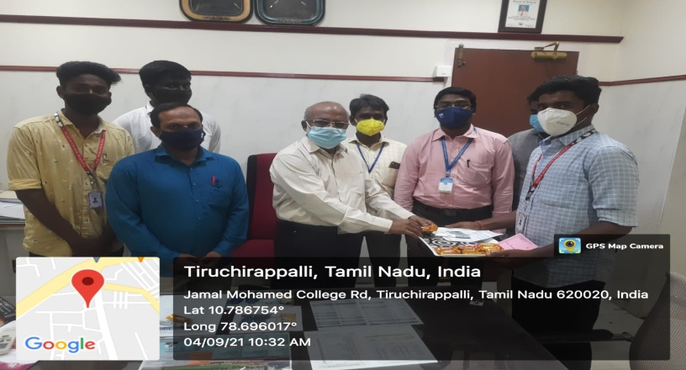
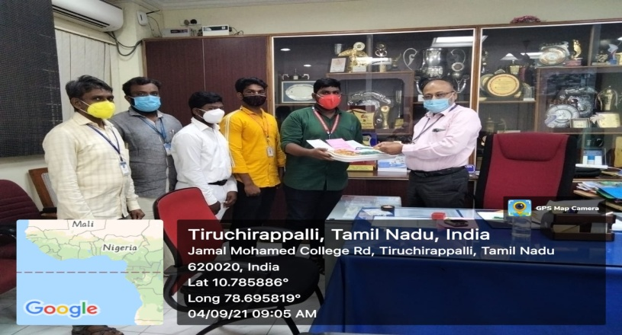
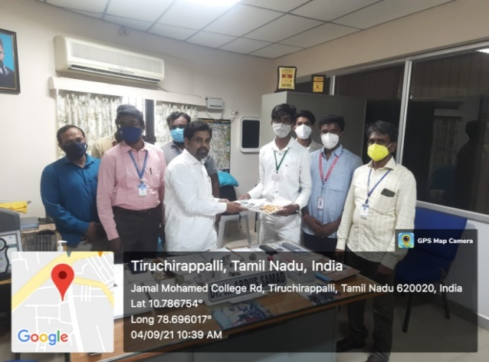
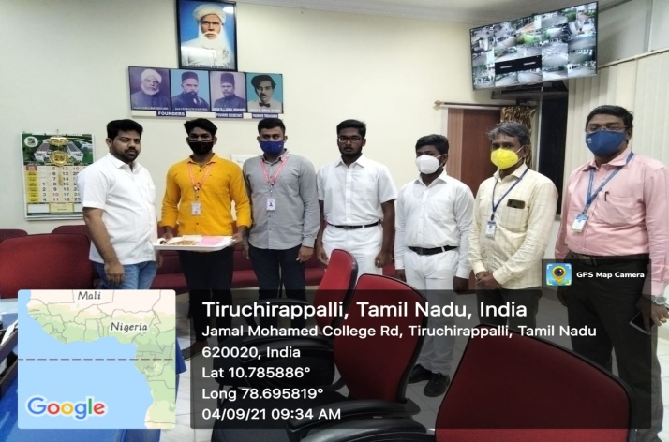

INTERNATIONAL LITERACY DAY QUIZ REPORT

On The Date of 8th September 2021 International Literacy Day was celebrated at Jamal Mohamed College. We conducted quiz through online
Our NSS programme officer instructed our NSS Volunteers to attend the quiz programme and we provided the E-Certificate for the students who secured 50% and above. We asked 25 questions about Tamil and English literature each question carries 2 points the question, our NSS volunteers participated with lots of interest our volunteers attend the programme in good manner.

No. of NSS Volunteers of Participated: 130 Date: 08.09.2021

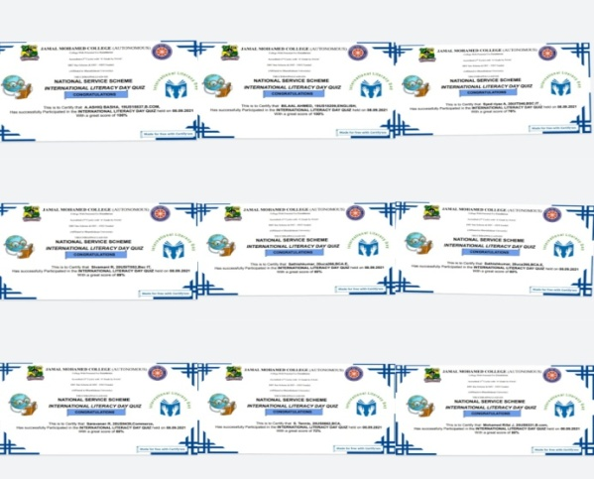
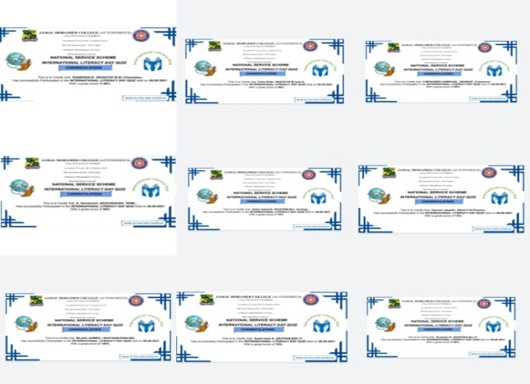

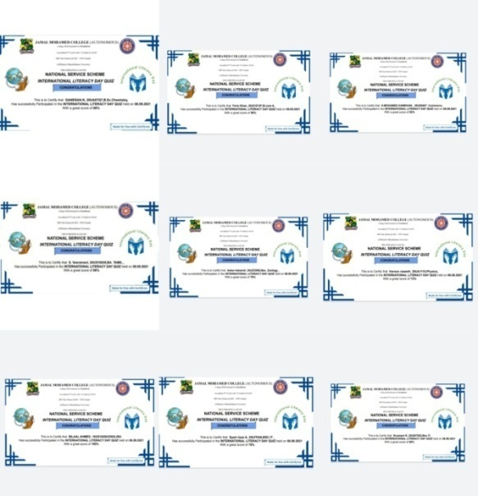
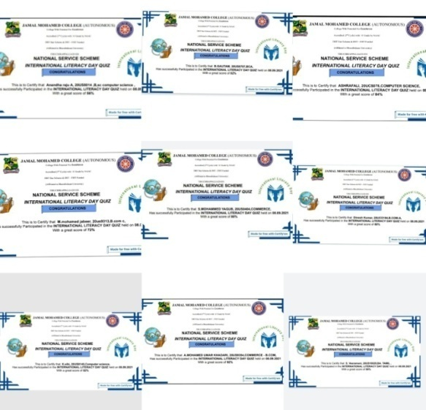

VACCINATION CAMP REPORT

On The Date of 11th September 2021 Covid-19 Vaccination camp was conducted at Jamal Mohamed College. Our college staff member’s students and many external people were vaccinated in the camp. Our college NSS programme officer instructed our NSS Volunteers to make awareness among the public about the importance of vaccination against Covid-19. Our NSS Volunteers has done their duty in good manner.

No. of NSS Volunteers of Participated: 10 Date: 11.09.2021
No. of NSS Programme officers participated: 04

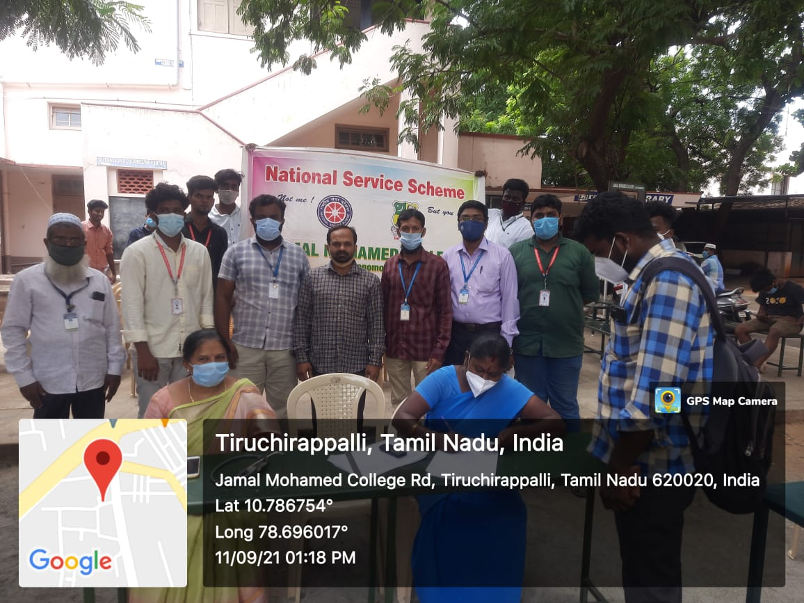

MEGA VACCINATION CAMP PROGRAME REPORT

On The Date of 12th September 2021 Covid-19 Mega Vaccination camp was conducted by Govt. of Tamil Nadu. Along with Tiruchirappalli Corporation our College NSS Programme officer instructed our NSS volunteers to follow the instruction given by the Corporation of Tiruchirappalli. Our College NSS Volunteers were taken Survey in various places in Trichy about the No. of people who have vaccinated and not vaccinated and distribute the Brochure to public and tell them about the importance of Covid-19 vaccine. People had vaccinated in the camps which is nearer to their house. Our College NSS Volunteers has done their duty in good manner.

No. of NSS Volunteers of Participated: 30 Date: 12.09.2021
No. of NSS Programme Officers: 02

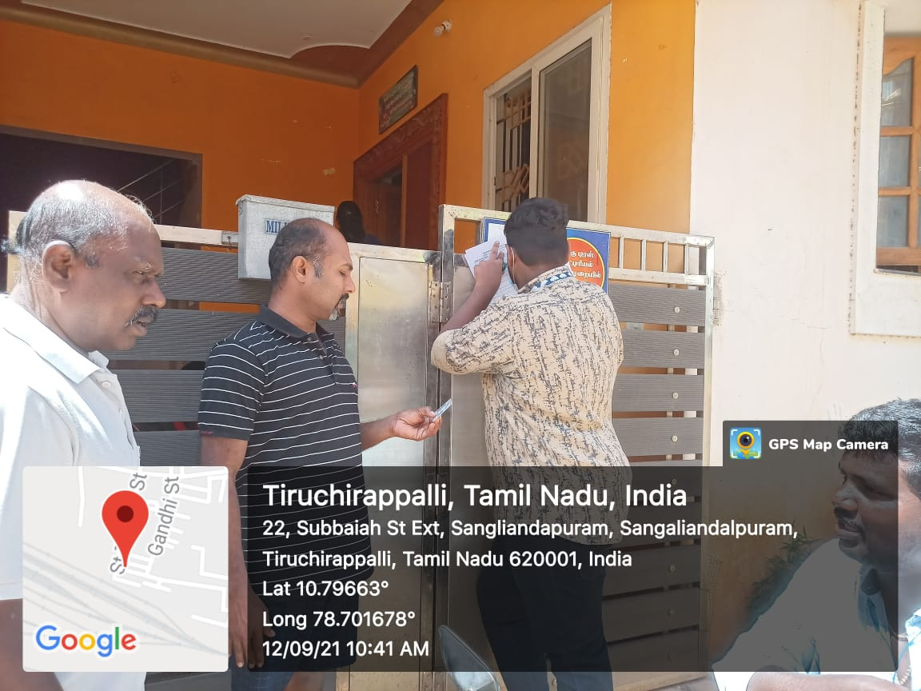
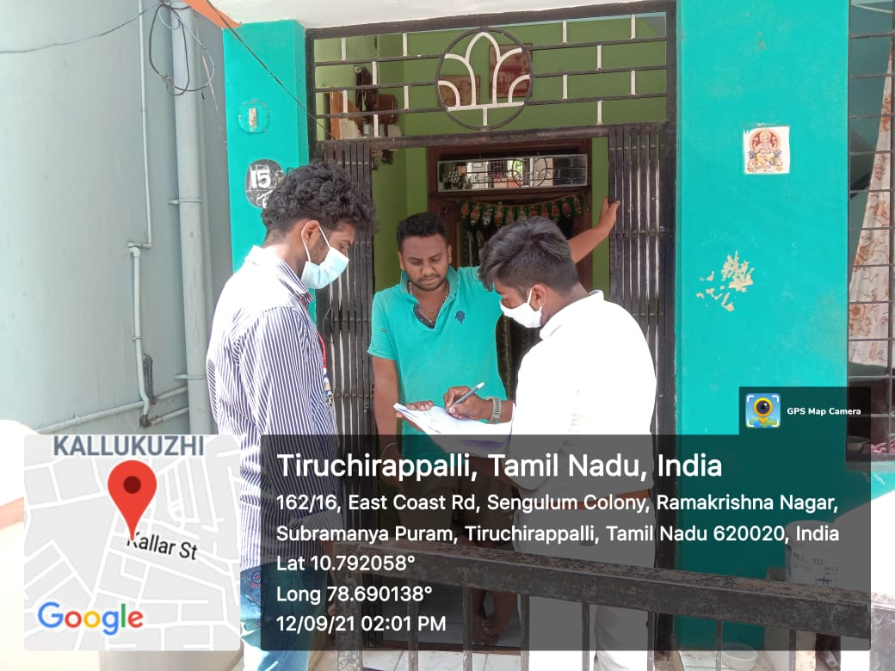

NATIONAL DEWORMING DAY PROGRAMME REPORT

On The Date of 13th September 2021 National deworming day was conducted at Jamal Mohamed College. Our College NSS Programme officer instructed our NSS volunteers to attend the programme. Doctor from UPHC, Subramaniyapuram has addressed the speech about the Deworming awareness and Distributed Albendazole Tablet to the students and NSS Volunteers of Jamal Mohamed College and our volunteers distribute the tablets in good manner.

No. of NSS Volunteers of Participated: 30 Date: 13.09.2021
No. of NSS Programme officers participated: 01
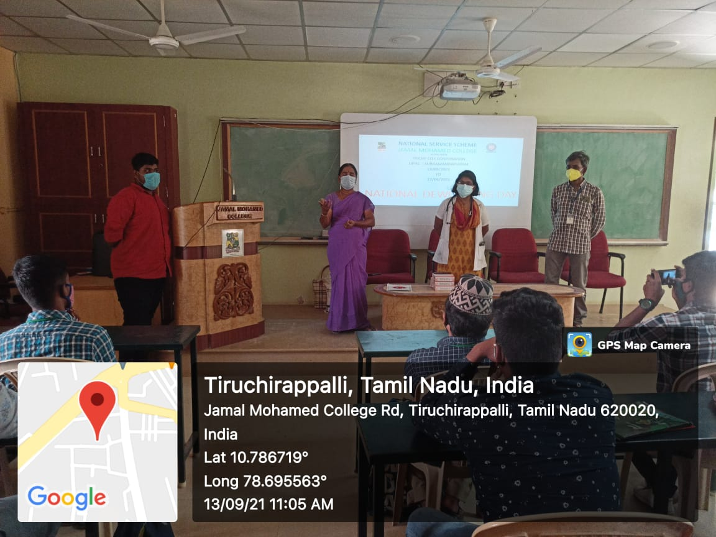

Social justice day pledge

On the date of 17th September 2021 social justice pledge was taken at Jamal Mohamed College. Our College Principal, staff members and student were participated in the social justice pledge taking programme infront of our Jamal institution of Management. Our college Principal instructed to our NSS programme officer and NSS Volunteers to take pledge for social justice and
Our NSS volunteers to take pledge.

No. of NSS Volunteers of Participated: 50 Date: 17.09.2021
No. of NSS Programme officers participated: 5

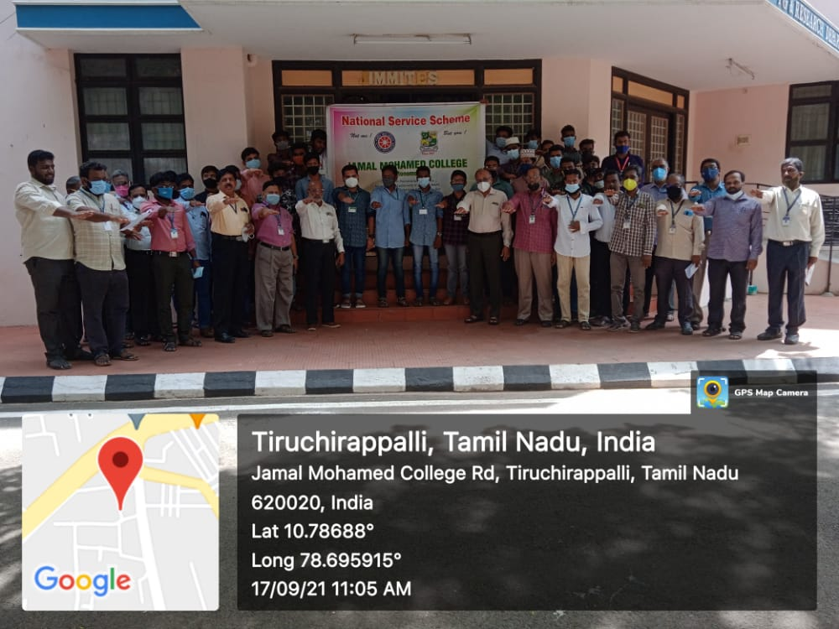

KABASURA KUDINEER REPORT

On The Date of 17th September 2021 Kabasura kudineer was distributed at Jamal Mohamed College. Our college staff members, students and many external peoples were come and participated .The kabasura kudineer was distributed in two different places at our college campus at nearby General staff room and ALMAN HALL. Our college NSS programmme officer instructed our NSS Volunteers to make awareness among the public about the importance of Covid-19. Our NSS Volunteers has done their duty in good manner.

No. of NSS Volunteers of Participated: 6 Date: 17.09.2021
No. of NSS Programme officers participated: 2

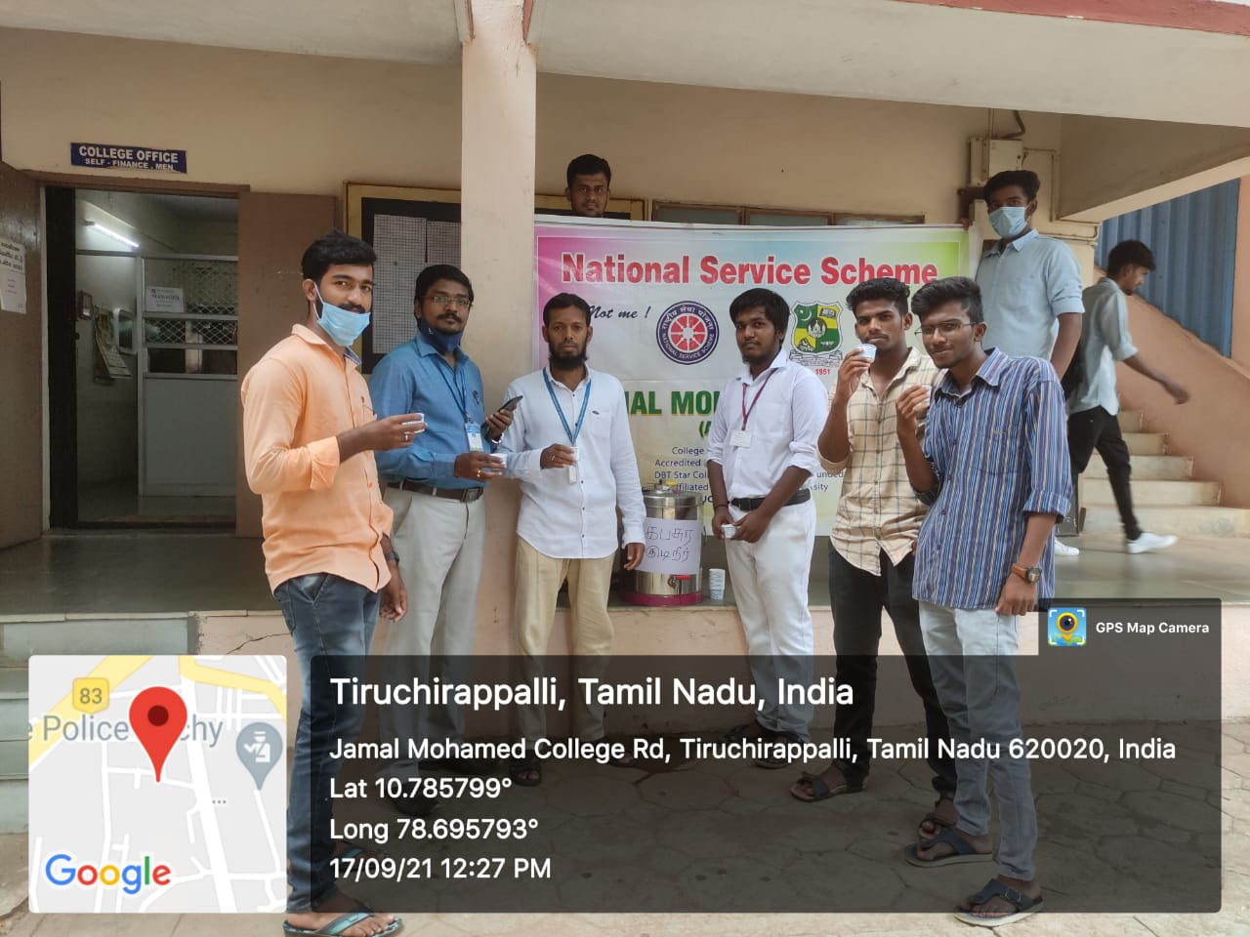

VACCINATION CAMP REPORT

On The Date of 19thSeptember 2021 Covid-19 Vaccination camp was conducted at Jamal Mohamed College. Our college staff member’s students and many external people were vaccinated in the camp. Our college NSS programme officer instructed our NSS Volunteers to make awareness among the public about the importance of vaccination against Covid-19. Our NSS Volunteers has done their duty in good manner.

No. of NSS Volunteers of Participated: 06 Date: 19.09.2021
No. of NSS Programme officers participated: 02

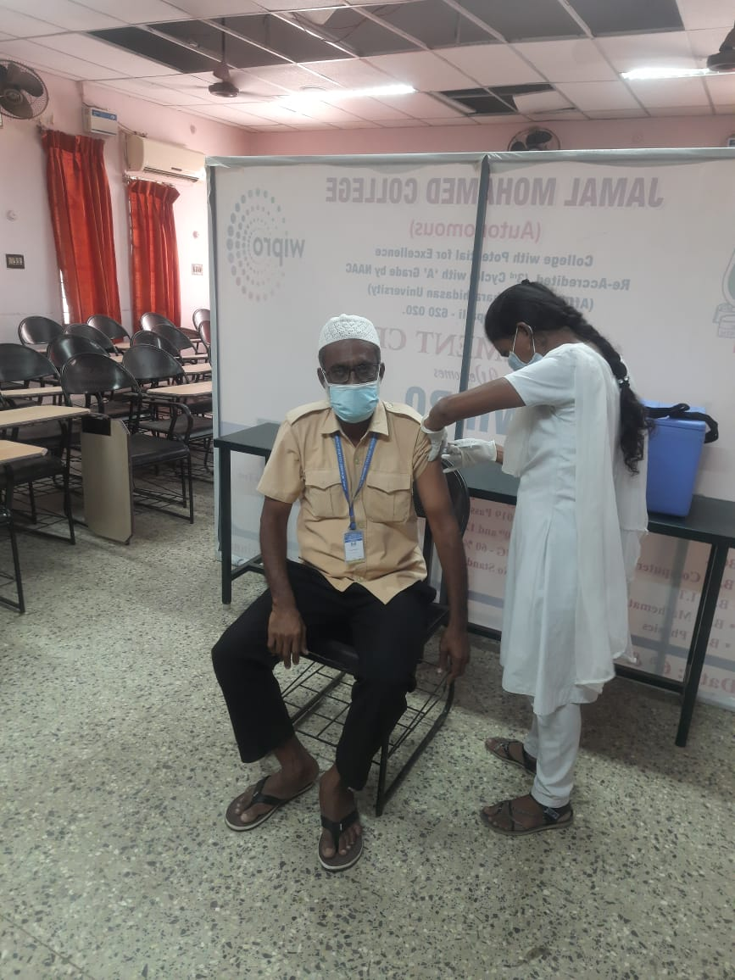

75th INDEPENDENCE DAY TREE PLANTATION DAY REPORT

On The Date of 24th September 2021 Tree was planted in Jamal Mohamed College near Minnah Block. In the memory of 75th year of independence we planted a tree in our college campus. Our College Secretary and correspondent, Principal, Assistant Secretary and our Chief Guest Dr. Ameer Ahamed were participated. Our NSS programme officer instructed our NSS Volunteers to attend programme and we attend the programme in good manner.
.
No. of NSS Programme officers of Participated: 05 Date: 24.09.2021
No. of NSS Volunteers of Participated: 10
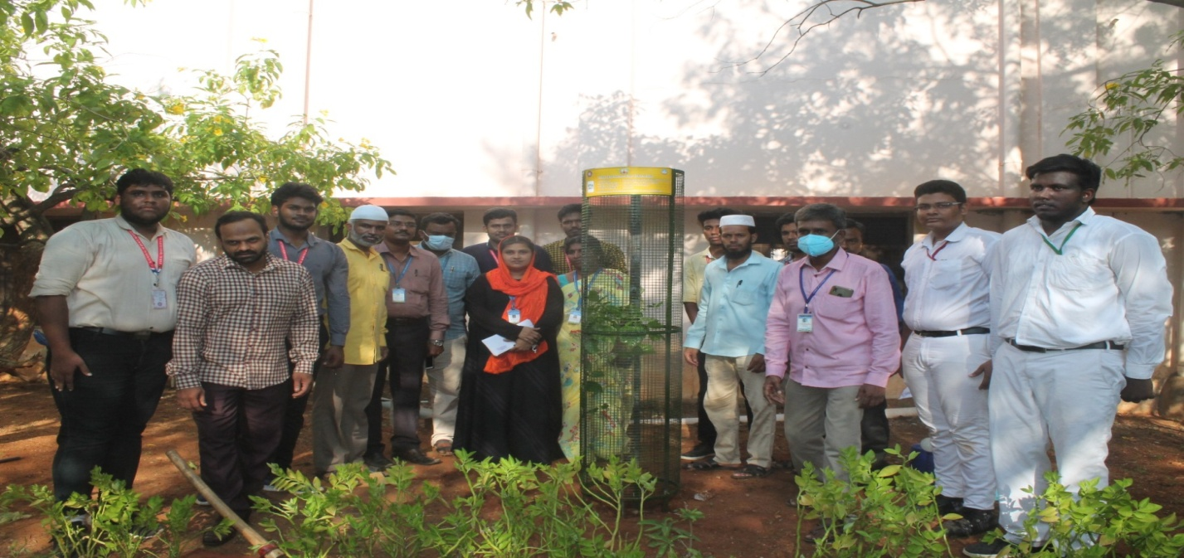

NSS DAY CELEBRATION REPORT

On The Date of 24th September 2021 NSS day was celebrated at Jamal Mohamed College. We conducted this Programme through online and offline modes. In offline mode the programme held at Hussainudeen hall and in virtual mode the Programme were live telecast on Microsoft teams, Instagram and YouTube platforms; In the memory of 75th year of independence we planted a tree in our college campus. Our College Secretary and correspondent, Principal, Assistant Secretary were participated and our Chief Guest Dr. Ameer Ahamed where addressed the Speech and motivated our NSS Volunteers. Our NSS programme officer instructed our NSS Volunteers to attend programme and we attend the programme in good manner

No. of NSS Programme officers of Participated: 05 Date: 08.09.2021
No. of NSS Volunteers of Participated: 150

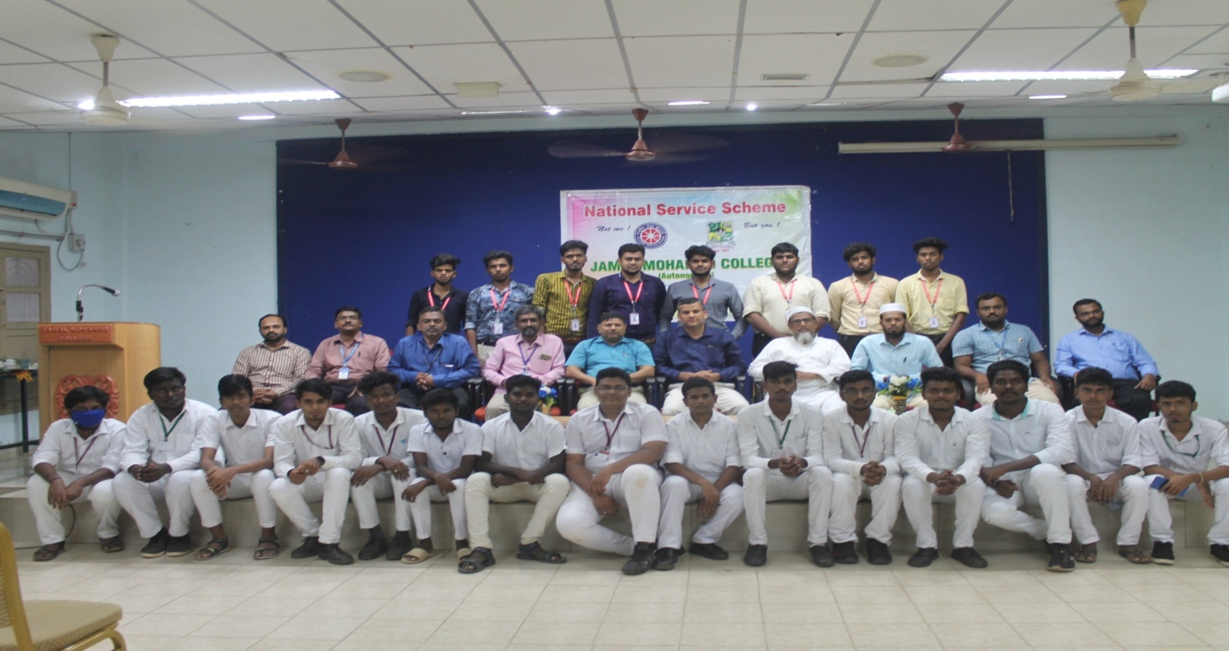

COLLEGE DAY CELEBRATION REPORT

On The Date of 27th September 2021 College day Was Celebrated at Jamal Mohamed College. The Programme was conducted at NABG A/C Auditorium. Our College Secretary and Correspondent, Principal, Vice Principal, Joint Director were felicitated The Programme. College Annual Report was addressed by Our College Principal Dr. ISMAIL MOHIDEEN. Dr. C. JOTHI VENKATESWARAN Joint Director of Collegiate Education, Dharmapuri was attended as a Chief Guest and motivated our College Students. Our NSS Programme Officers Instructed our NSS Volunteers to organize the audience and our NSS Volunteers done their duty in good manner

No. of NSS Volunteers of Participated: 30 Date: 27.09.2021
No. of NSS Programme officers participated: 05

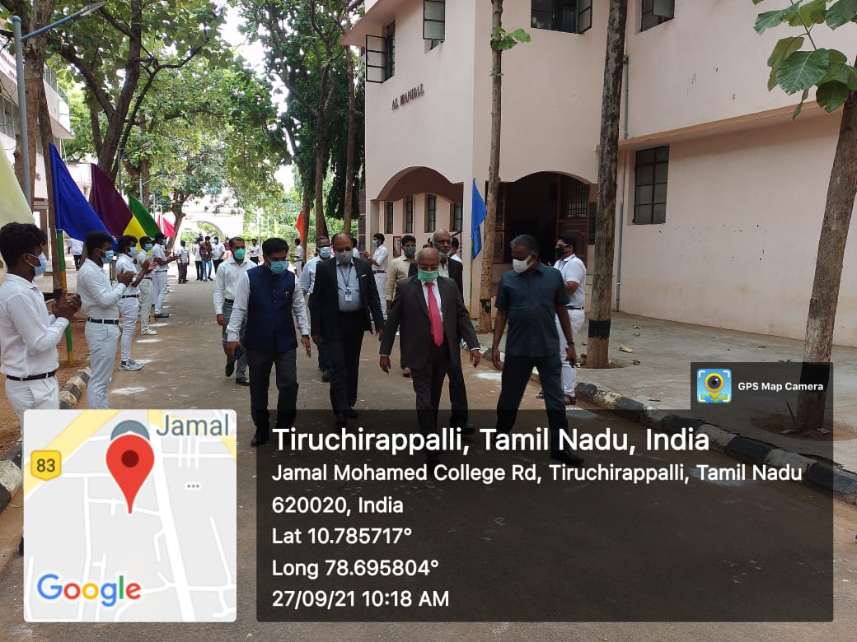

UNIVERSITY WISH PROGRAMME
On the Date of 1st October 2021 Wish Programme Held at Bharathidasan University. Our College NSS volunteers organized the programme. Our NSS Programme Officers Instructed to the NSS Volunteers organizing the Programme with Good Manner.
No. Of NSS Volunteers Participated: 15 Date: 01.10.2021 No. Of NSS Programme officer participated: 01

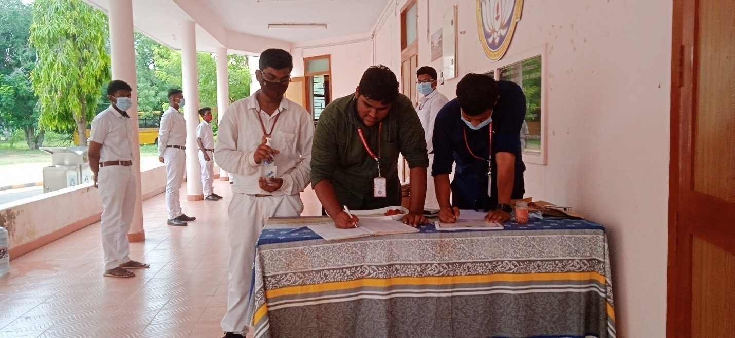

FIT INDIA RALLY 2.0
On The Date of 2nd October 2021 the Fit India Rally 2.0 Held at Trichy Junction Bus stand to Anna Stadium. The Nehru Yuva Kendra & the Bharathidasan University NSS Cell Organized the Fit India Marathon Rally 2.0. Our NSS Volunteer Participated the marathon Rally and Successfully Completed with Good Manner.
No. of NSS Volunteers Participated: 01 Date: 02.10.2021
No. of NSS Programme officers participated: 01
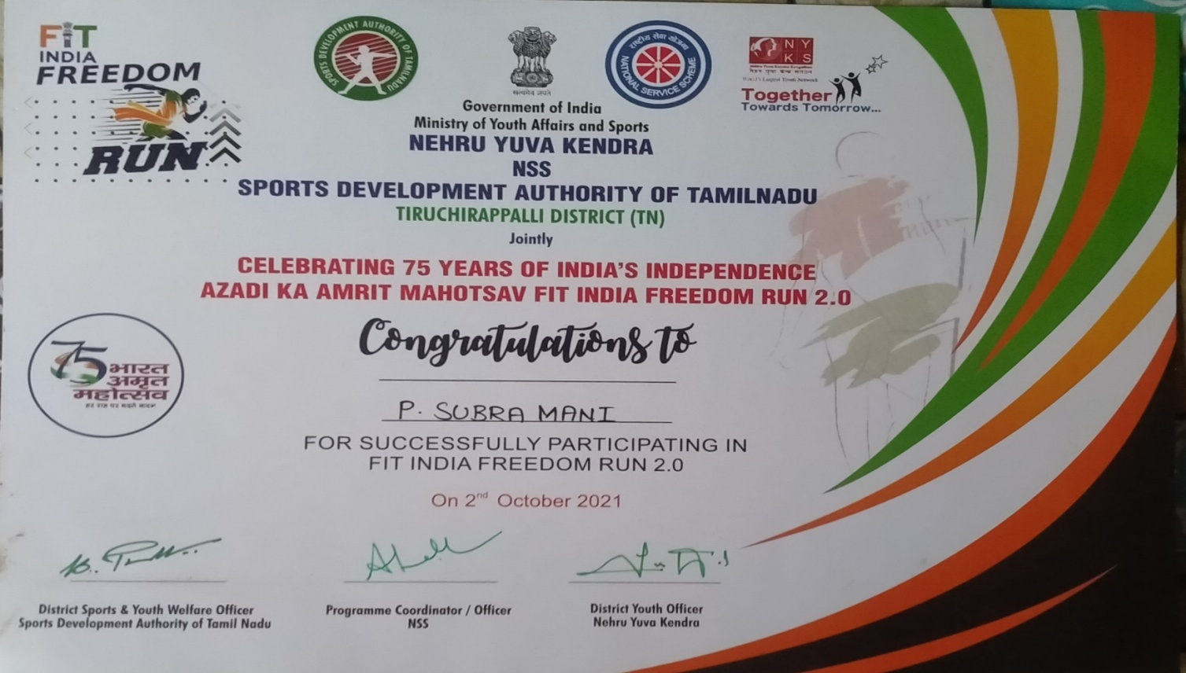

MEGA-VACCINATION CAMP REPORT

On The Date of 03rdOctober 2021 Covid-19 Mega Vaccination camp was conducted at Jamal Mohamed College. Our College staff member’s students and many external people were vaccinated in the camp. Our college NSS Programme officer instructed our NSS Volunteers to make awareness among the public about the importance of vaccination against Covid-19. Our NSS Volunteers has done their duty in good manner.

No. of NSS Volunteers of Participated: 04 Date: 03.10.2021
No. of NSS Programme officers participated: 01

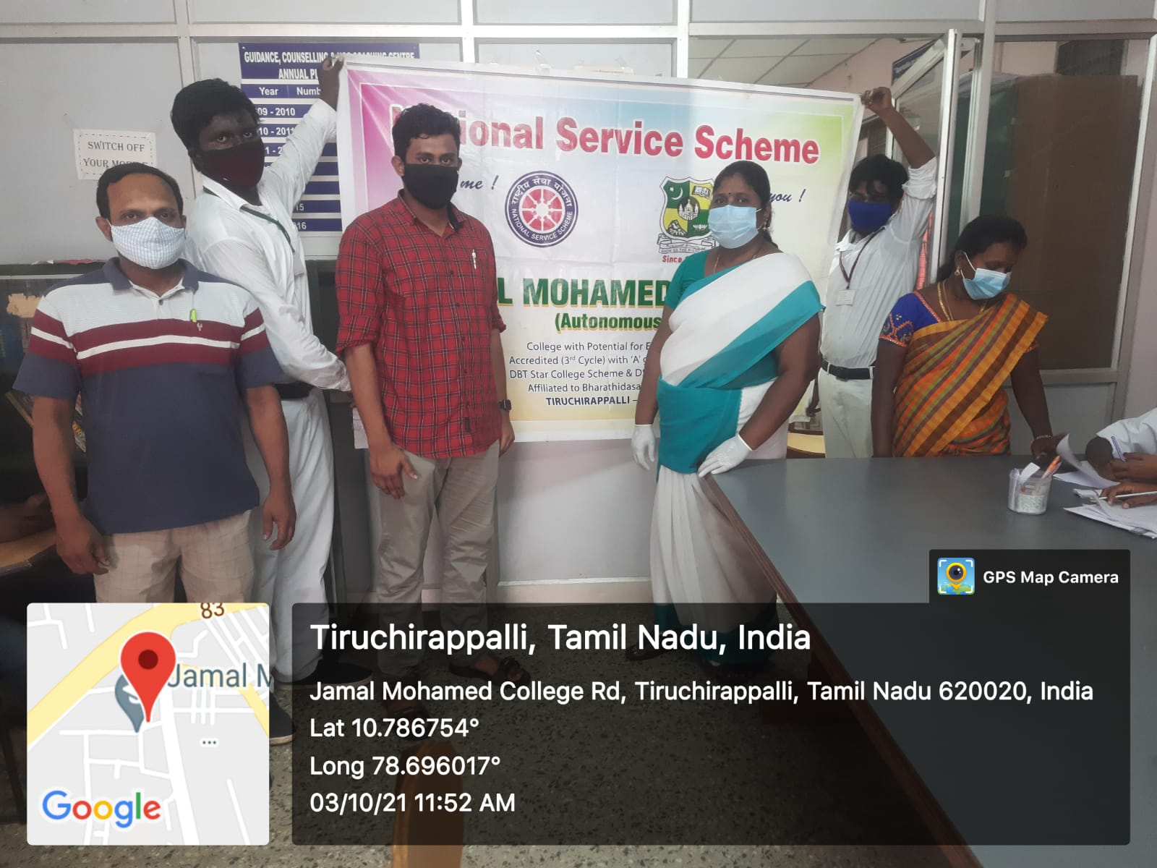

UNIVERSITY LEVEL PRE RD PARADE SELECTION CAMP REPORT

On The Date of 06th October 2021 University level Pre RD Parade selection camp was held at Bharathidasan University. Regional director of NSS Dr. C. SAMUEL CHELLAIAH has addressed about the Pre RD Selection. Dr. M. SENTHILKUMAR State NSS officer has motivated the students and Our College NSS Programme officer instructed our NSS volunteers to attend the programme. And our Volunteers done services for the participants and our volunteers done their duty in good manner.

No. of NSS Volunteers of Participated: 30 Date: 06.10.2021
No. of NSS Programme officers participated: 01

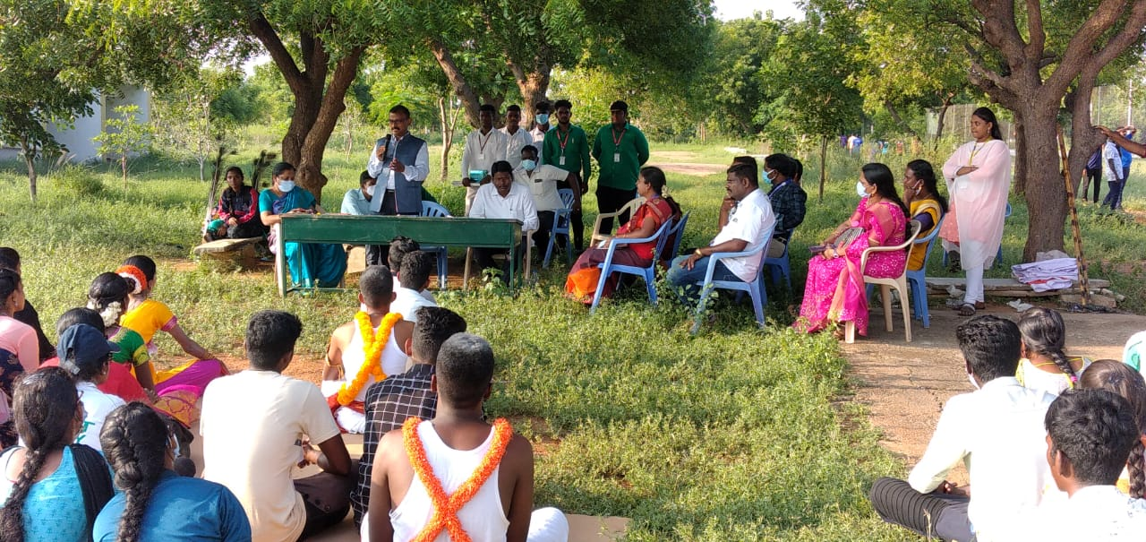

CAMPUS CLEANING PROGRAMME

On The Date of 09thOctober2021 Campus Cleaning Programme Was Conducted at Jamal Mohamed College campus. Our College Principal Dr. S. ISMAIL MOHIDEEN and Management Committee member and Director Dr. K. N. ABDUL KADER NIHAL and Mr. FAROOK USA Chapter alumni, North America were participated in the event. Our College Principal has addressed to our NSS Volunteers about the importance of cleanness. Our NSS Programme officer instructed our NSS Volunteers to clean the campus and our NSS Volunteers were done their duty with full dedication.

No. of NSS Volunteers of Participated: 21 Date: 09.10.2021
No. of NSS Programme officers participated: 05

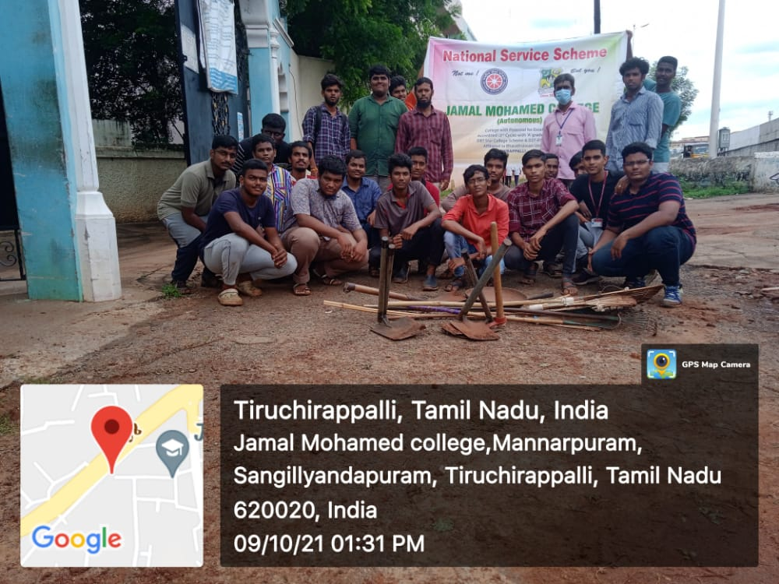

MEGA VACCINATION CAMP REPORT

On The Date of 10thOctober 2021 Covid-19 Mega Vaccination camp was conducted at Jamal Mohamed College. Our college staff member’s students and many external people were vaccinated in the camp. Our college NSS programme officer instructed our NSS Volunteers to make awareness among the public about the importance of vaccination against Covid-19. Our NSS Volunteers has done their duty in good manner.

No. of NSS Volunteers of Participated: 05 Date: 10.10.2021
No. of NSS Programme officers participated: 04

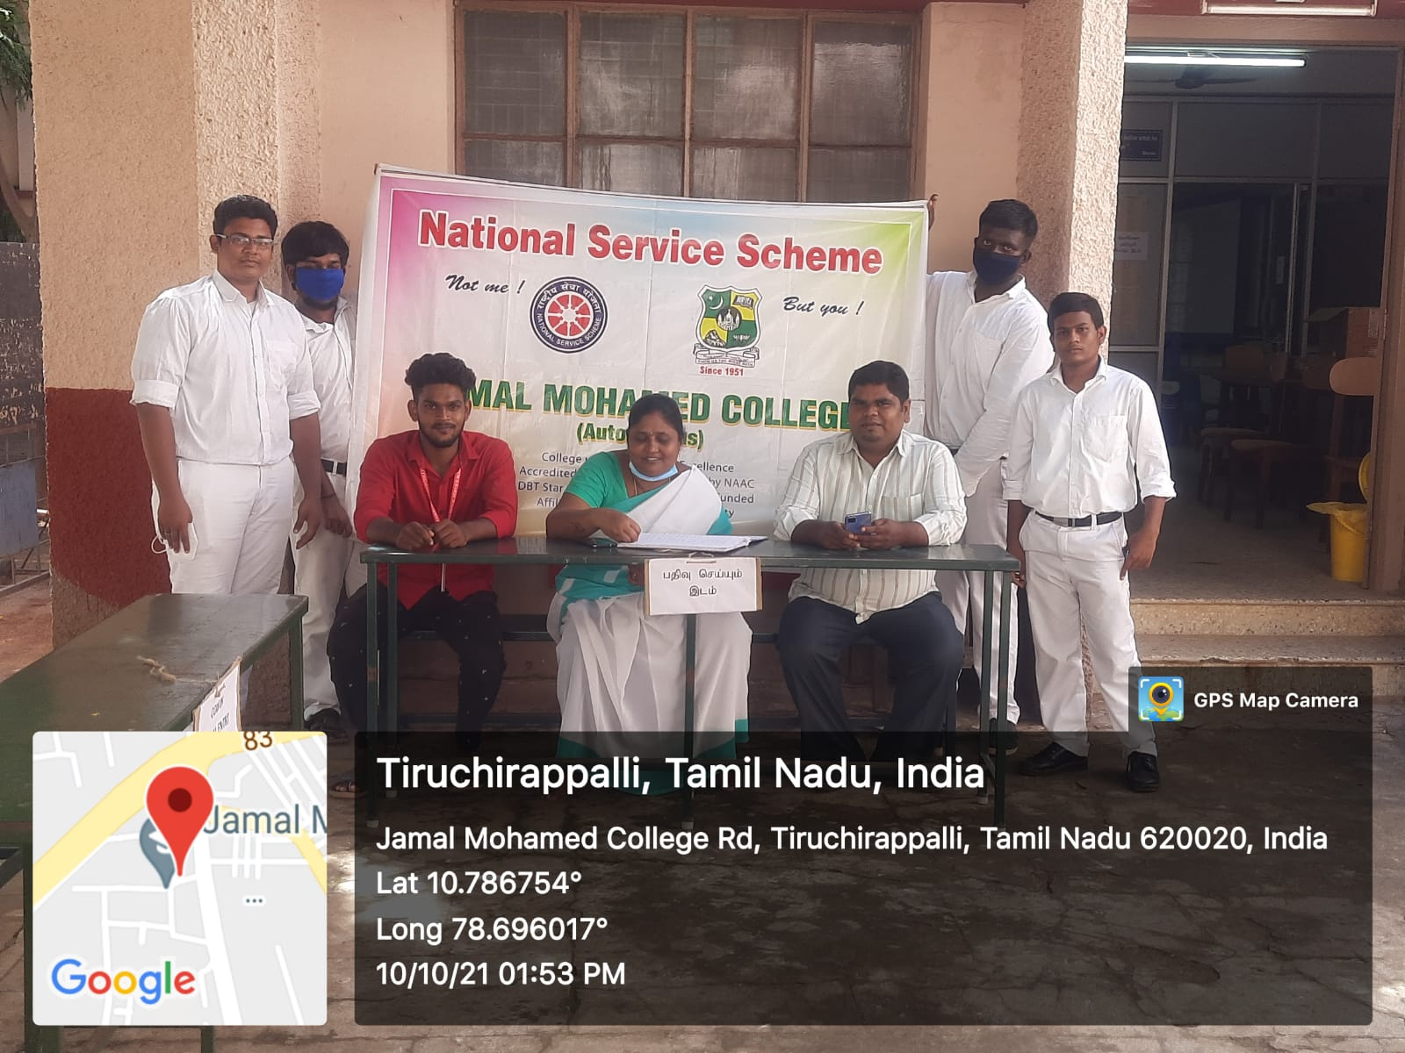

FRESHERS WELCOME DAY REPORT

On The Date of 18th October 2021 College was opened for first year students. Our College principal instructed our NSS programme officer and NSS Volunteers to invite the students from the college. Our College NSS Volunteers were warmly welcomed the students with sweets and our College NSS Volunteers helped the students to find their classrooms and directions to important offices. As per the instruction given by Programme officer our NSS Volunteers Done their duty in good manner

No. of NSS Volunteers of Participated: 30 Date: 18.10.2021
No. of NSS Programme officers participated: 02

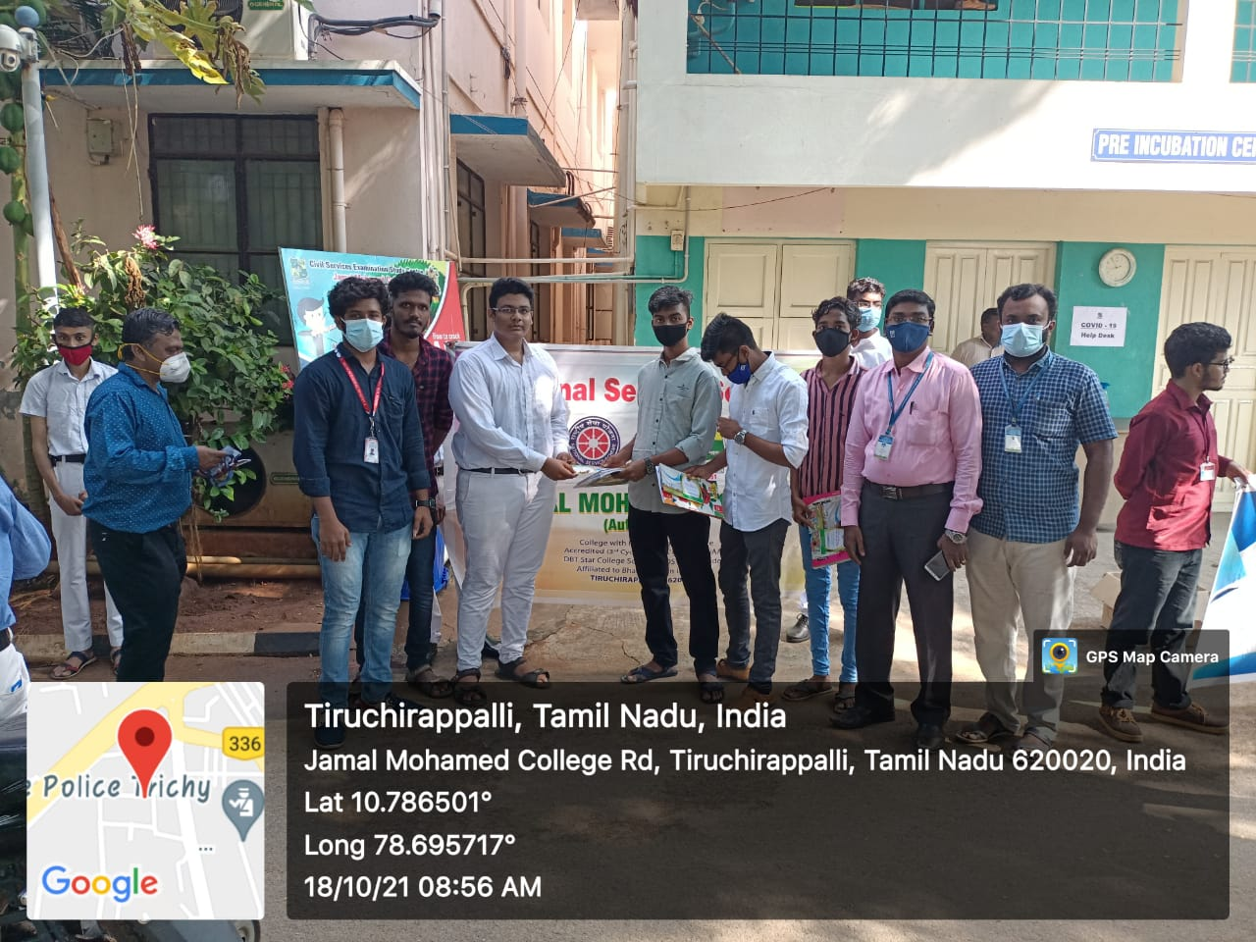

WORLD SIGHT DAY CAMPAIGN

On The Date of 21st October 2021 World Sight Day Campaign was organized by Joseph Eye Hospital and NSS Cell of Bharadhidasan University. The programme was conducted at Joseph Eye Hospital. Our Programme officer instructed our. NSS Volunteers to attend the Programme. Deputy Commissioner of Police, Tiruchirappalli was the chief guest. Chief gust were addressed the speech and Motivated the students. After the programme Chief Guest has taken the pledge along with the participants and flew away the balloons along with the Programme organizers and NSS Volunteers. Our NSS Volunteers has attend the programme in good manner

Date: 21.10.2021
No. of NSS Volunteers Participated:110
No. of NSS Programme officers participated: 01

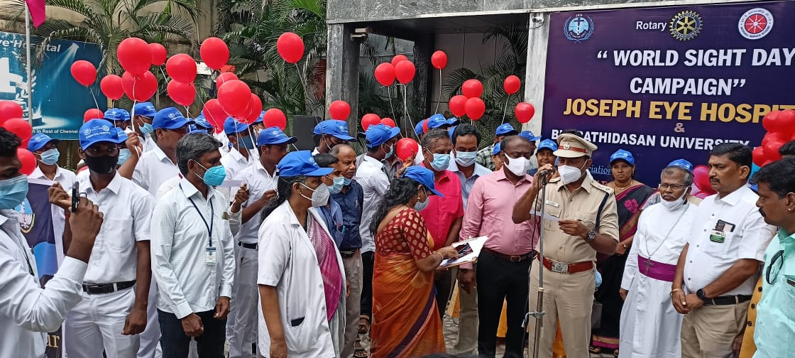

CYCLE RALLY AND MEGA CLEAN INDIA PROGRAMME

On The Date of 23rd October 2021 The Cycle Rally was Held at Bharathidasan University, Khajamalai campus. The Vice Challenger of Bharathidasan University Dr. M. Selvam Felicitated the Cycle Rally. The Bharathidasan University NSS Co-Ordinator Dr. A. Laxmi Prabha and Our NSS Programme Officers Instructed to the NSS Volunteers to safe cycle Rally Our Volunteers successfully completed the Programme with Good Manner

No. of NSS Volunteers of Participated: 80 Date: 23.10.2021 No. of NSS Programme officers participated: 05
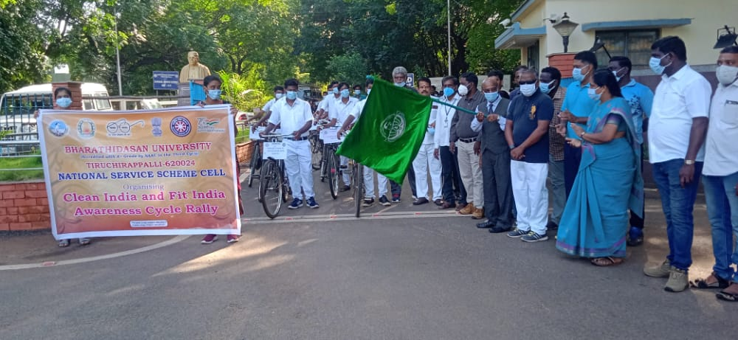

CLEAN INDIA (MEGA CLEANING)
On The Date of 23rd October 2021 Dept of Youth Affairs, Ministry of Youth affairs and Sports, Govt. of India has organized Mega Clean India Programme via NSS Cell of Bharathidasan University. The Bharathidasan University NSS Co-ordinator Dr. A. Laxmi Prabha visited the cleaning place and our NSS Programme Officers Instructed to the NSS Volunteers the programme was successfully complete with good manner.
No. Of.NSS Volunteers Participated: 60 Date: 23.10.2021
No. Of.NSS Programme Officers: 03

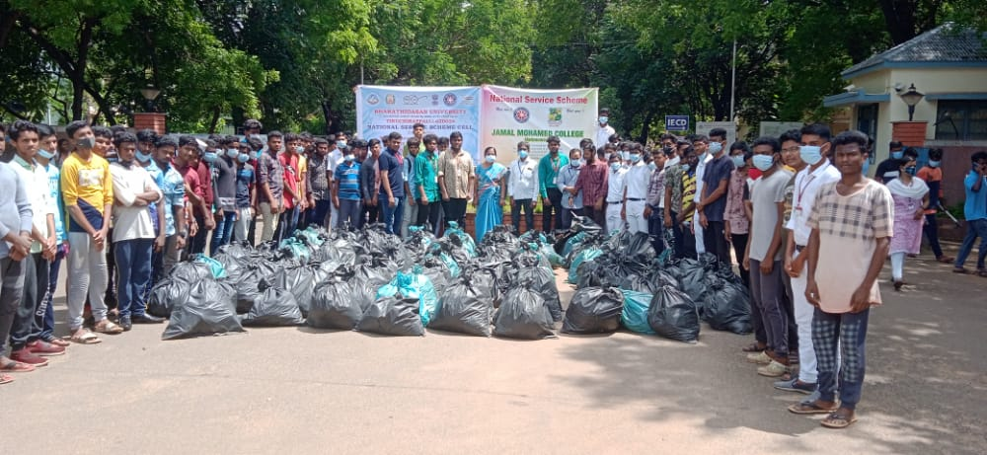

TRANSGENDER IDENDITY CARD UPDATING PROGRAMME REPORT

On The Date of 25thSeptember 2021 Transgender Identity card updating Programme was conducted at Tiruchirappalli Collector Office. Our college NSS Volunteers had taken a part of it and done their duty and service in a good manner.

No. of NSS Volunteers of Participated: 02 Date: 25.09.2021
No. of NSS Programme officers participated: 01

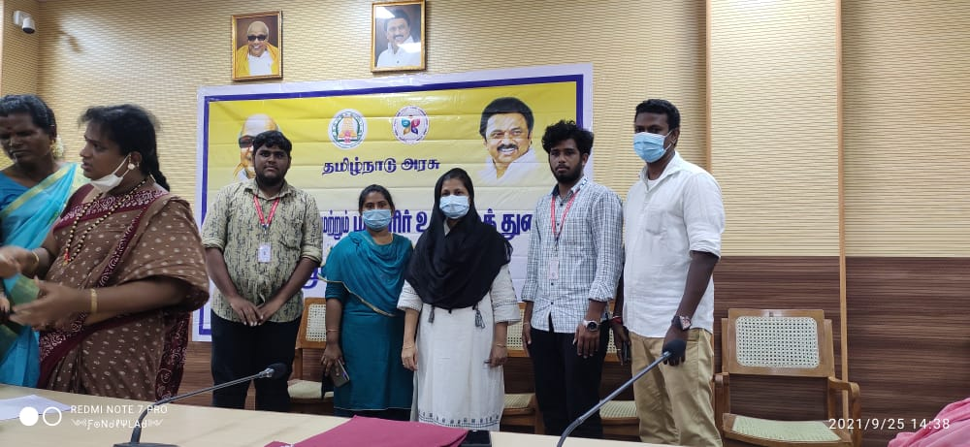

DIWALI AWARENESS PROGRAMME REPORT

On The Date of 28th October 2021 Diwali Awareness Programme was conducted by Rotary Club of Tiruchirappalli and Joseph Eye Hospital. Our NSS Programme officer instructed our NSS Volunteers to attend the programme and gain the Knowledge about fire safety, Members from Tamil Nadu Fire Service Department were shown the live demo for the NSS Volunteers, and they taught how to prevent from dangerous. Our college NSS Volunteers has actively participated in the programme and done their duty in good manner.

No. of NSS Volunteers of Participated: 95 Date: 28.10.2021
No. of NSS Programme officers participated: 02

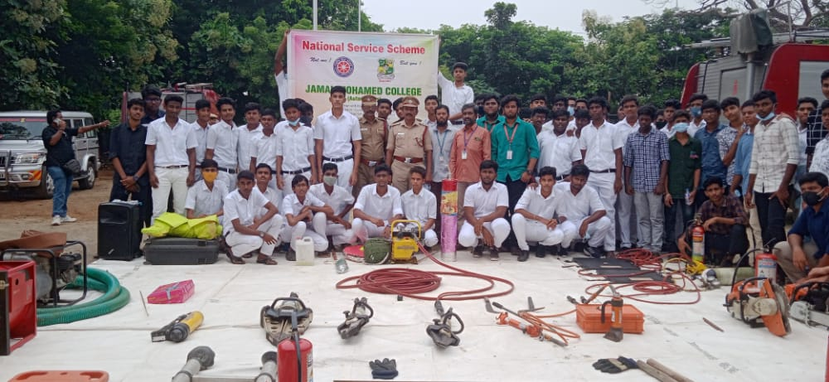

CLEAN INDIA PROGRAMME

On The Date of 1st November 2021 Clean India Programme was Conducted at Jamal Mohamed College, Anvarul Ulum Arabic College near Khaja Nagar, Our college NSS Programme officer has instructed our NSS Volunteer to Clean the Places of Arabic college campus and our volunteers has clean the place With team work. All the volunteers has Participated in the programme with full involvement and our NSS Volunteers has do their duties in good manner

No. of NSS Volunteers of Participated: 107 Date: 01.11.2021
No. of NSS Programme officers participated: 05

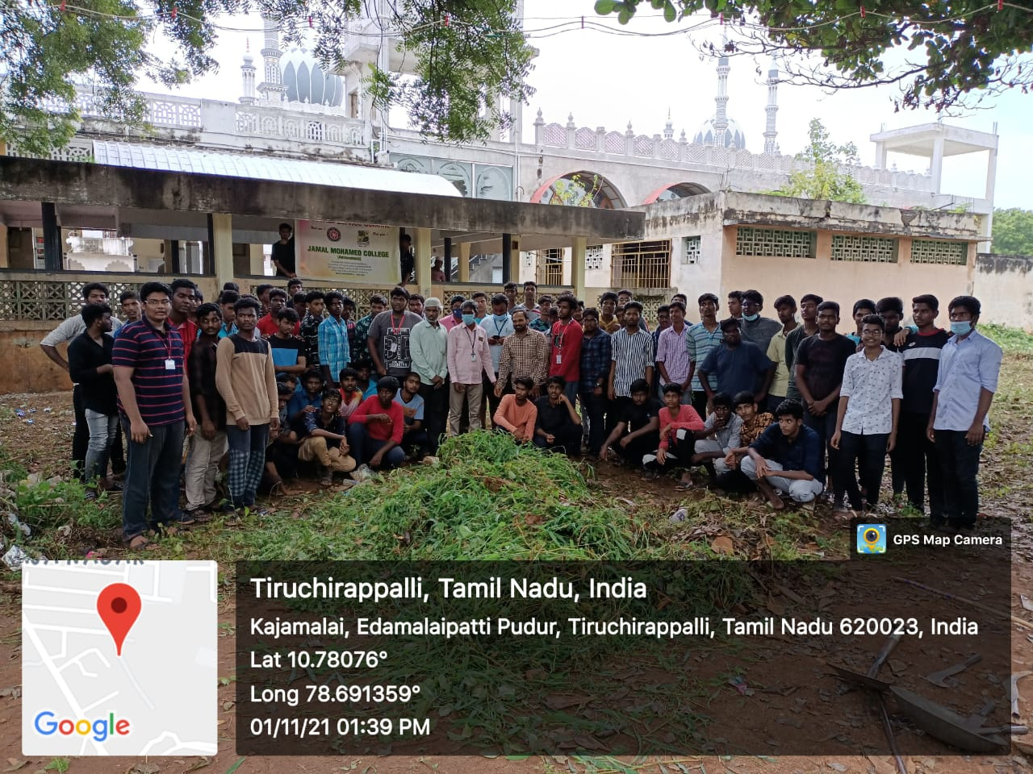

MEGA VACCINATION CAMP

On The Date of 30th October 2021 Mega Vaccination camp was conducted by TiruchirappalliCorporation. Our College NSS Volunteers were took part in the camp
Our College NSS Programme officer instructed our NSS volunteers to follow the instructions given by the corporation of Tiruchirappalli. Our College NSS Volunteers make awareness among the public about the importance of covid-19 vaccination and make the people to take the vaccine in correct time and they do their duties with the perfect safety measures like using Masks, Sanitizers and Gloves. Volunteers has done duties in different work space like Vaccine Certificate entries, Queue arrangements, online verification etc., NSS Volunteers of Jamal Mohamed College were done their duties in good manner

No. of NSS Volunteers Participated: 30 Date: 30.10.2021
No. of NSS Programme officers participated: 01
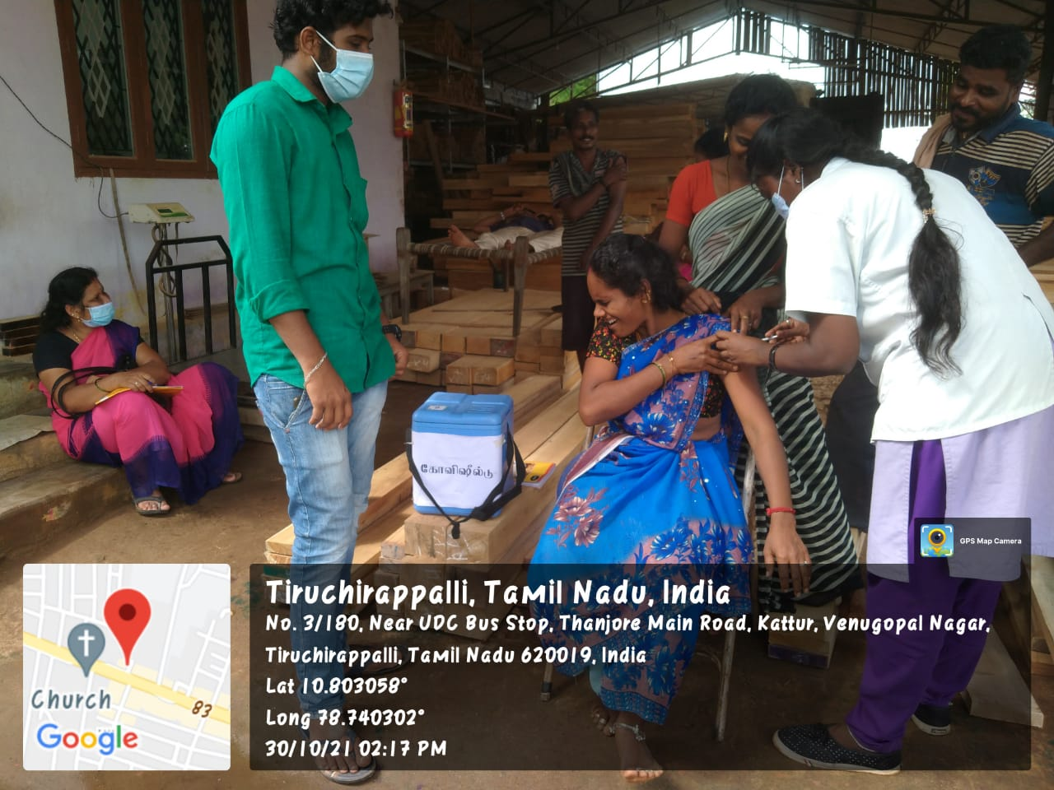
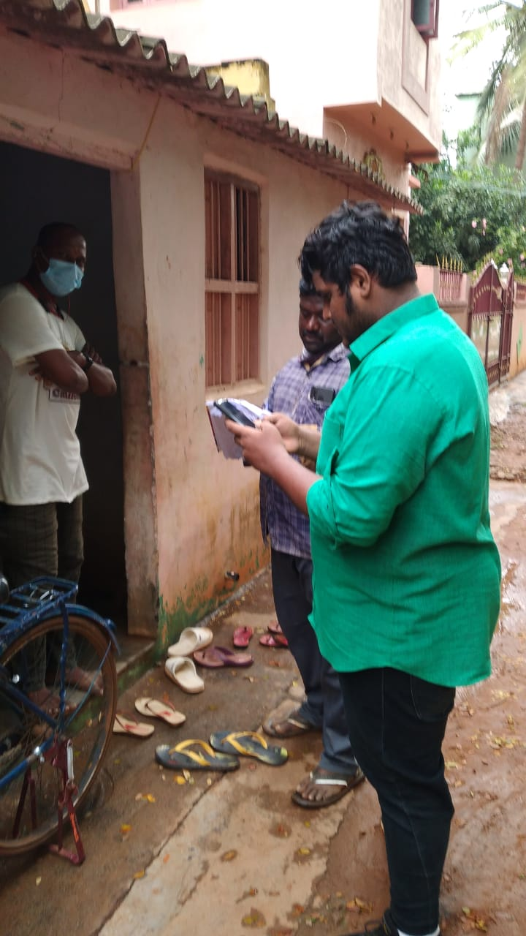

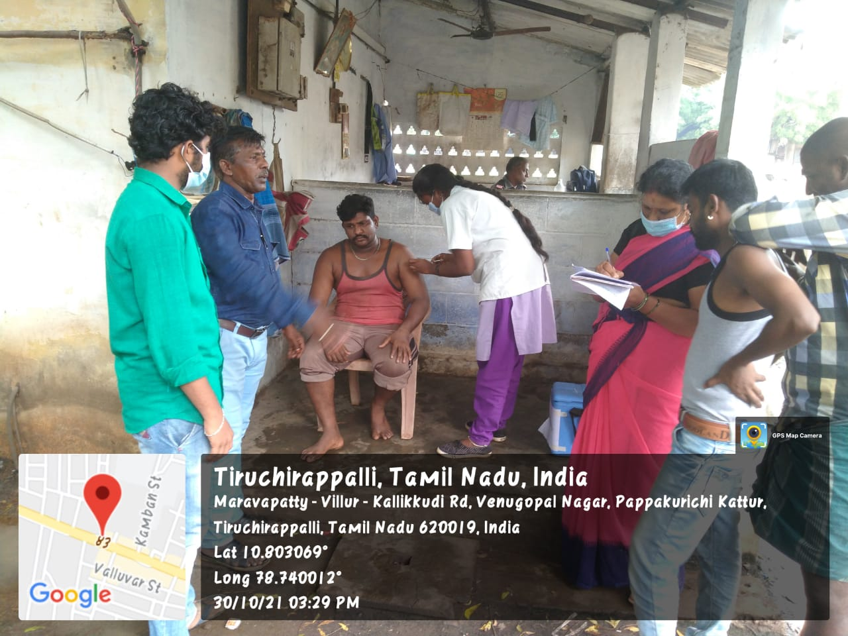

NATIONAL UNITY DAY

On The Date of 30th October 2021 National Unity Day (Sardar Vallabai Patel Birthday) Pledge was taken at Jamal Mohamed College. Our College Secretary and Corresspondent Dr. A. K. NAZEEMUDEEN, Principal Dr. S. ISMAIL MOHIDEEN, Part-V Co-ordinator Mr.S. SHEIK ISMAIL Were Felicitate the programme. The pledge programme was held in front of Jamal Institute of Management (JIM). Our NSS Programme officers were instructed our NSS Volunteers to participate in the pledge and our College Principal has addressed the speech to the NSS Volunteers about National Unity. Secretary and Corresspondent, principal, Part V Co-ordinator were taken a pledge along With the NSS Volunteers, NSS Volunteers were participated in the programme in good manner

No. of NSS Volunteers Participated: 40 Date: 30.10.2021
No. of NSS Programme officers participated: 04

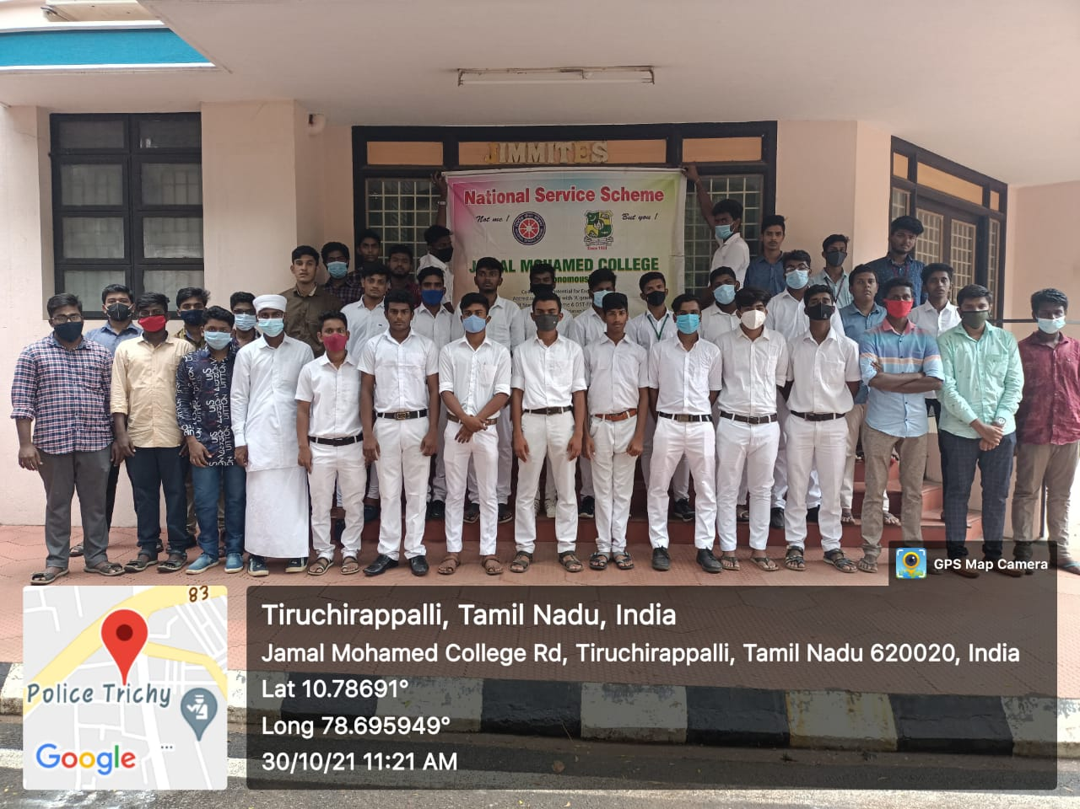

CHILDREN’S DAY CELEBRATION
On the Date of 15th November 2021 on behalf of Jamal Mohamed College NSS Cell Children’s Day was Celebrated Held at Govt. Middle School, Theeran Manager, Nagamangalm. Our NSS Programme Officers Instructed NSS Volunteers distributed the sweets to the Students and Conducted the Games. Our College NSS volunteers has conducted games and distribute the prize to the Students Who won in games NSS Volunteers of Jamal Mohamed College were the done their duty in Good Manner.
No. of NSS Volunteers Participated: 15 Date: 30.10.2021
No. of NSS Programme officers participated: 02

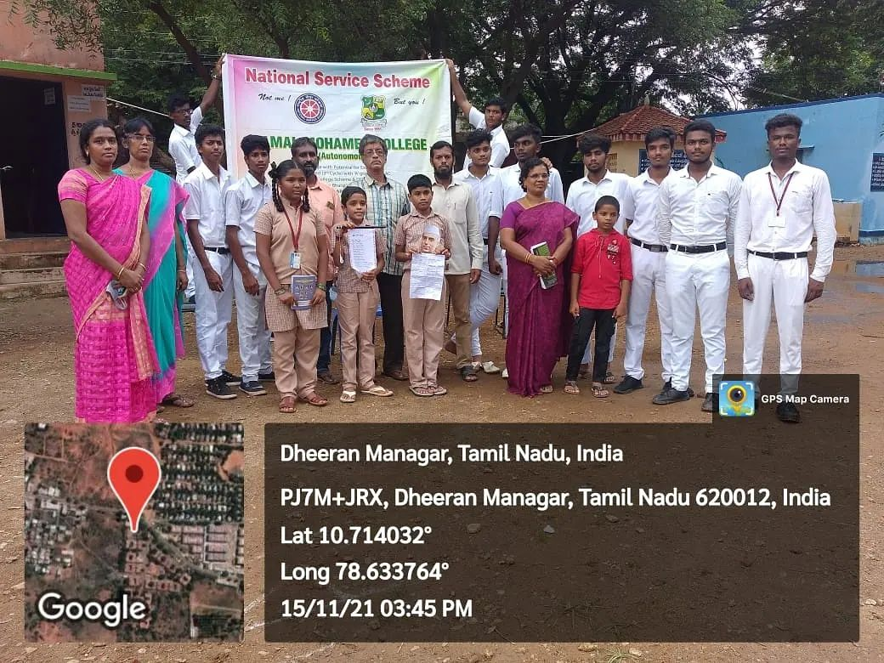

BOOK FAIR
On the date of 15th& 16th November 2021 the Book Fair Held at Hussainudeen Hall, Jamal Mohamed College. The Principal of Jamal Mohamed College. S. Ismail Mohideen and The Secretary Dr. A. K. Khaja Nazeemudeen, The Treasurer M. J. Jamal Mohamed Opened The Book Fair. The Management of Jamal Mohamed Visited the Book Fair. Our College NSS Programme Officers Instructed to Our NSS Volunteers Successfully Completed the Book Fair with Good Manner.
No. of NSS Volunteers Participated: 08 Date: 15.11.2021
No. of NSS Programme officers participated: 01

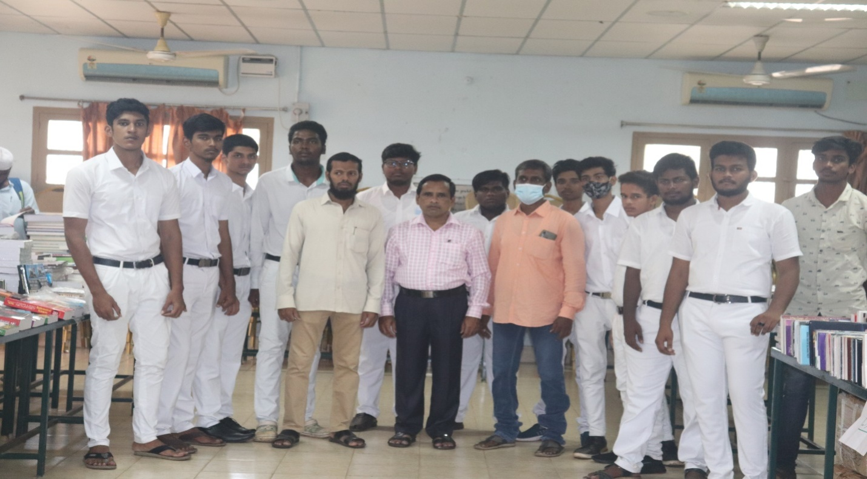

WORLD DIABETES DAY AWARENESS PROGRAMME &MEDICAL CAMP
On the date 17th November 2021, World Diabetes Day awareness programme and medical camp was conducted at Bharathidasan University, our NSS Programme officers instructed our NSS volunteer to attend the programme and gain the knowledge about diabetes and its causes. Vice Chancellor of Bharathidasan University Dr.M.SELVAM has addressed the speech about diabetis health conditions and our College NSS Volunteers has taken the check up for knowing the blood glucose level and blood pressure level and participated in the programme in good manner.
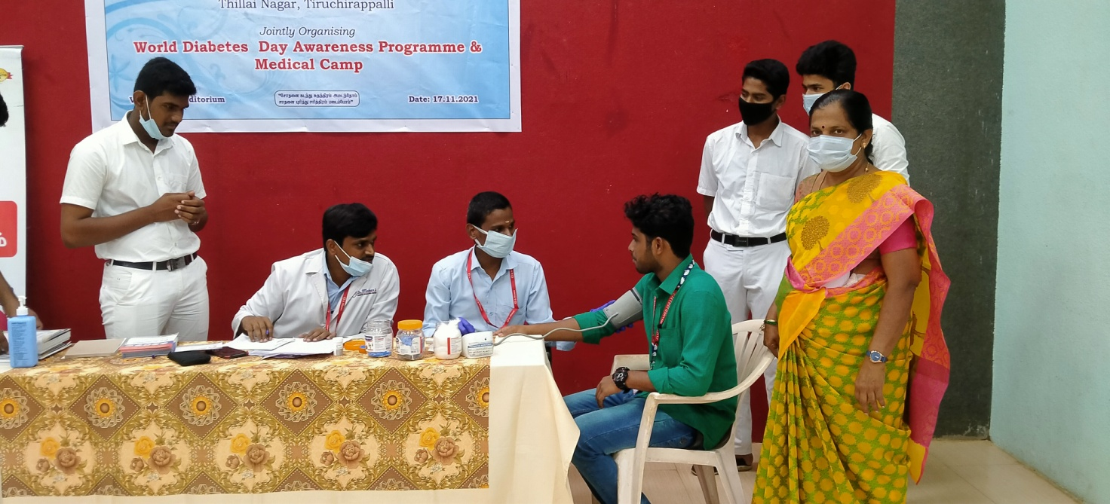
Number of NSS Volunteers Participated: 55 DATE:17.11.2021 Number of Programme Officers participated: 01

NATIONAL INTEGRATION DAY PLEDGE
On the date of 19th November 2021 NATIONAL INTEGRATION PLEDGE was taken at Jamal Mohamed College Our College NSS Programme Officer Instructed our NSS Volunteers to attend the Programme activity. Our college an NSS volunteer has taken pledge and our college volunteer has participated in great manner.
No. of NSS Volunteers Participated: 12 Date: 19.12.2021
No. of NSS Programme officers participated: 05

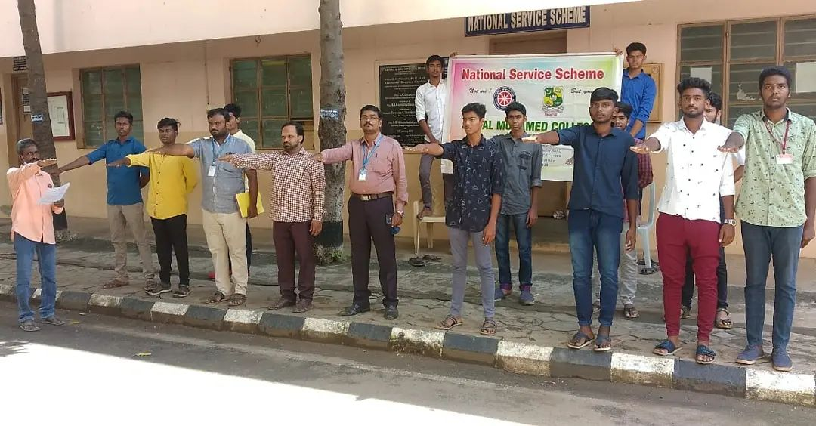

STUDENT’S INDUCTION PROGRAM
On the date of 29th November 2021 & 1st December 2021 Student Induction Programme was Held at Bharathidasan University. The NSS Unit Cell of Bharathidasan University Conducted the Programme for Fresher students of both and PG. Here all the incoming students are visited the campus Infrastructure our NSS volunteers were guide the students and direct them to respective places, And on 01.12.2021 the In-Charge members of extension activities like NSS, NCC, RRC, etc.….. Explained about the clubs and its value in the future our NSS Volunteers has organised the students and make serve them in Good Manner.
No. Of NSS Volunteers Participated: Day 01: 30 Date 01: 29. 11.2021
No. Of NSS Programme officer participated 02: 01 Day 02: 01.12.2021
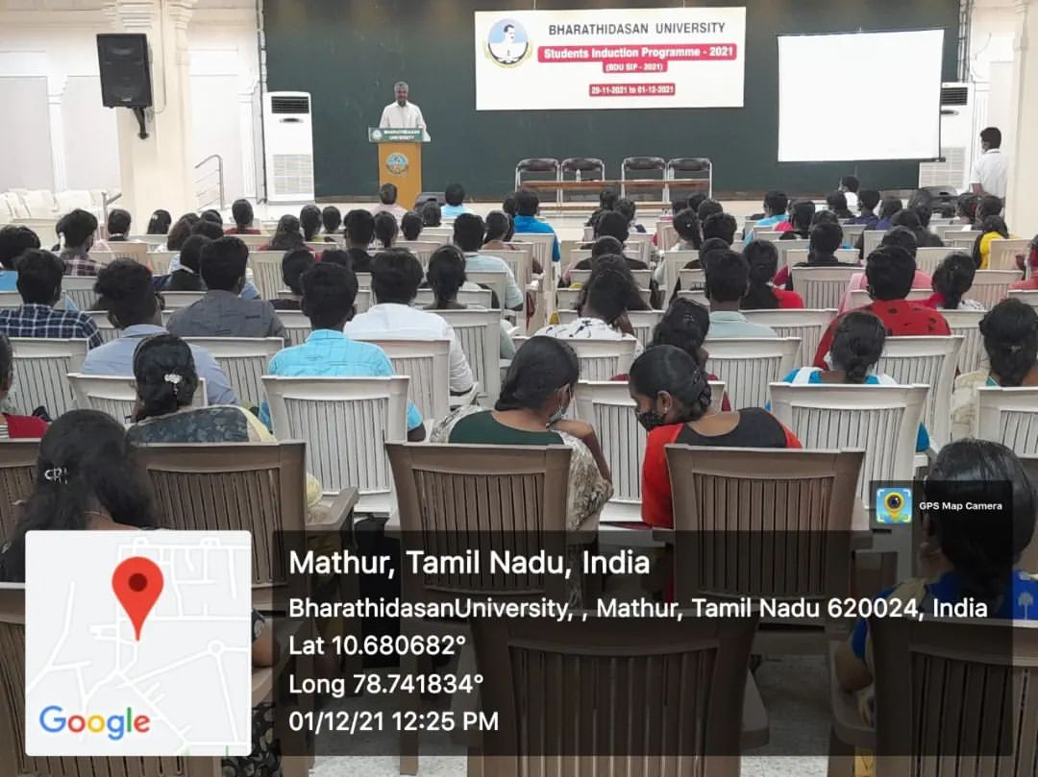

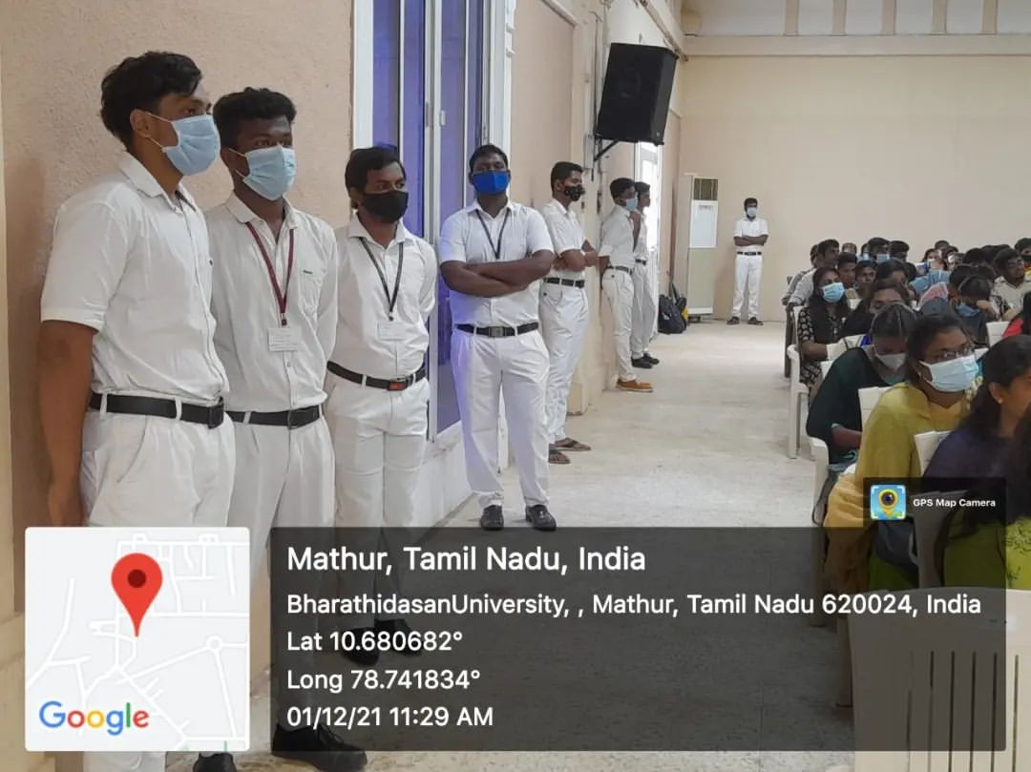

TREE PLANTATION AT BDU

On the date of 4th December 2021 tree plantation programme was conducted at BHARATHIDASAN UNIVERSITY herbal garden our college NSS programme officer instructed our NSS volunteers to attend the programme. Vice chancellor of BHARATHDASAN UNIVERSITY Dr. M. SELVAM was the chief guest and our honourable chief guest has addressed the speech about importance of tree planting. Our College NSS Volunteers were participated in the event with full involemenmt and in way.
Number of NSS Volunteers Participated: 15 DATE: 04.12.2021 Number of Programme Officers participated: 01

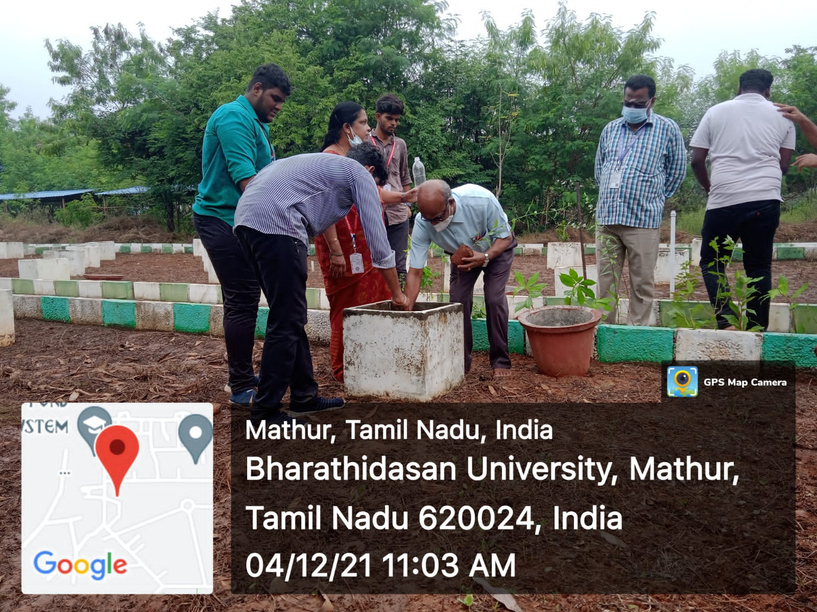

HERBAL GARDEN CLEANING

On the date of 6th December 2021, The Herbal Garden Cleaning Was Held at Bharathidasan University. The Bharathidasan University NSS Co-Ordinator Dr. A. Laxmi Prabha instructed to the NSS Volunteers. Our College NSS Volunteers Cleaned the Herbal Garden with Full involvement and in Good Manner.

No. of NSS Volunteers Participated: 40 Date: 06.12.2021
No. of NSS Programme officers participated: 01

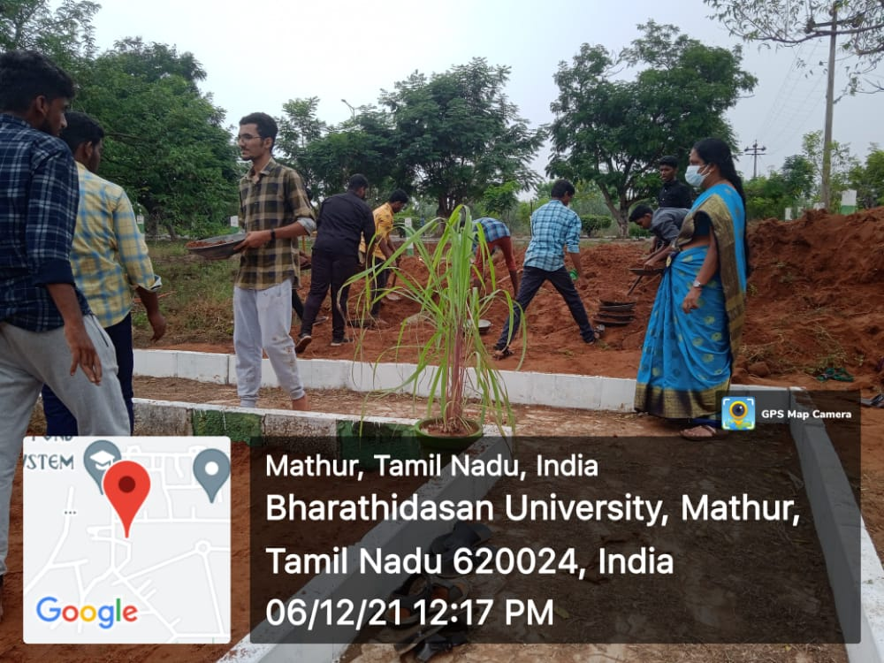

HERBAL GARDEN CLEANING

On the date of 6th December 2021, The Herbal Garden Cleaning Was Held at Bharathidasan University. The Bharathidasan University NSS Co-Ordinator Dr. A. Laxmi Prabha instructed to the NSS Volunteers. Our College NSS Volunteers Cleaned the Herbal Garden with Full involvement and in Good Manner.

No. of NSS Volunteers Participated: 40 Date: 07.12.2021
No. of NSS Programme officers participated: 01

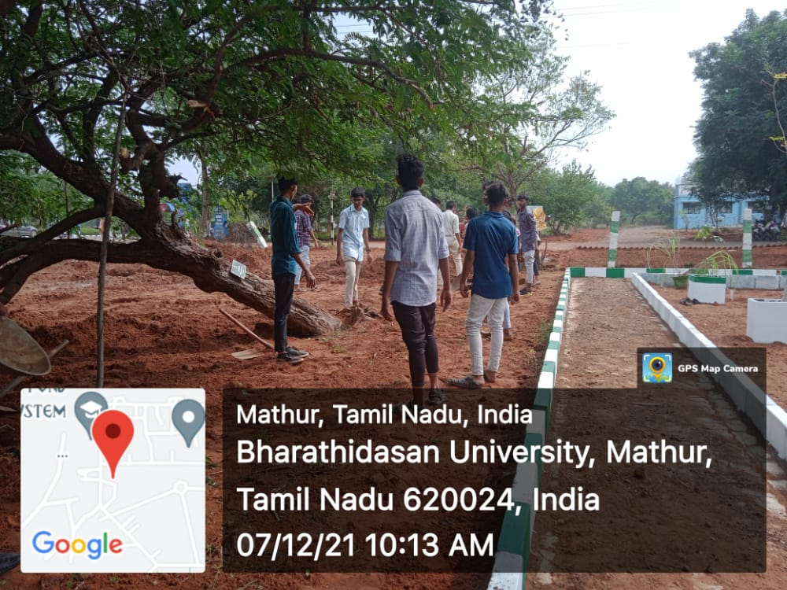

NSS ORIENTATION PROGRAMME

On the date of 08.12.2021 NSS Orientation programme was conducted at Khajamian Rowther auditorium. Our College Secretary and Correspondent were addressed the speech and motivated our NSS Volunteers, Our college Vice-Principal has motivated our NSS Volunteers and our Chief Dr. ABDUL HAKEEM former NSS programme officer has shared his experience as programme officer and tell about the opportunities for NSS Volunteers in Govt. job the dignitaries were honored the achievers of NSS those who participated in National Camps like Pre-RD Parade camp, National Integration Camp, National youth festival…and distributed the identity card and badges to the senior Volunteers, at the end of the function our NSS Volunteers do cultural activities like dancing and our fresher’s had gain lots of knowledge

No. of NSS Volunteers of Participated: 250 Date: 08.12.2021
No. of NSS Programme officers participated: 5
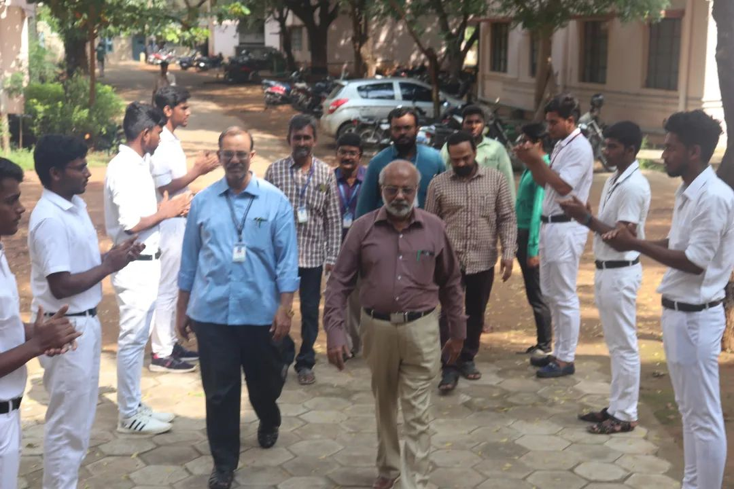

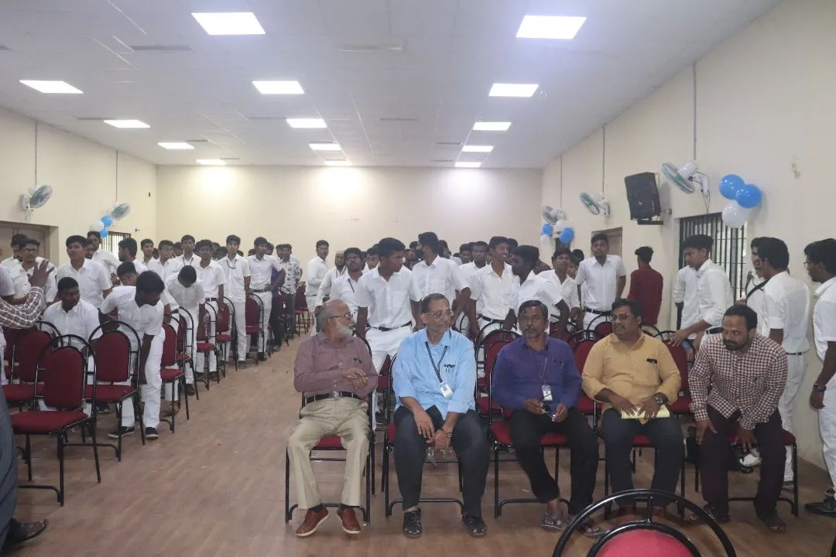

UNIVERSITY CONVOCATION PROGRAMME

On the Date of 9th December 2022 The Convocation Programme was Held at Bharathidasan University. Honourable Governor Dr. R.N. RAVI gave the degree to the Graduates. Our Programme officers Instructed to the NSS volunteers organized the Programme with Good manner.

No. of NSS Volunteers Participated: 50 Date: 30.10.2021
No. of NSS Programme officers participated: 01

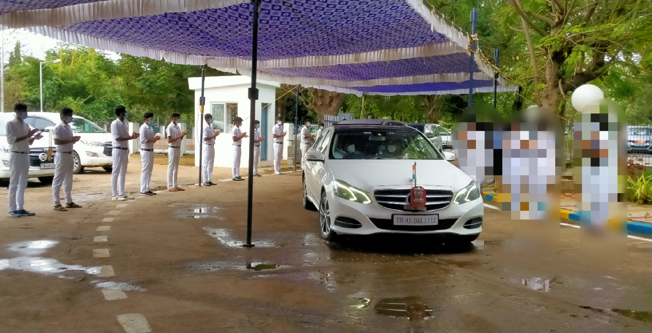

PLACEMENT CELL INTERVIEW PROGRAMME

On the date of 15thDecember of 2021 campus interview was conducted by placement cell of Jamal Mohamed College. Our NSS Programme officer instructed our NSS volunteers to organize the programme and help the candidates of interview. Our NSS Volunteers were worked with full involvement and our NSS volunteers done their duty in great manner.

No. of NSS Volunteers Participated: 05 Date: 15.12.2021
No. of NSS Programme officers participated: 01

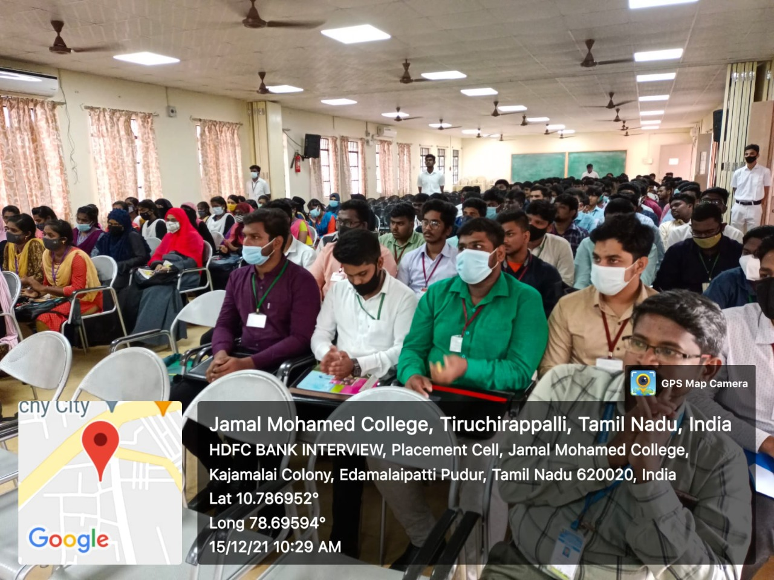

PLACEMENT CELL INTERVIEW PROGRAMME

On the date of 17th December of 2021 campus interview was conducted by placement cell of Jamal Mohamed College. Our NSS Programme officer instructed our NSS volunteers to organize the programme and help the candidates of interview. Our NSS Volunteers were worked with full involvement and our NSS volunteers done their duty in great manner.
No. of NSS Volunteers Participated: 10 Date: 17.12.2021
No. of NSS Programme officers participated: 01

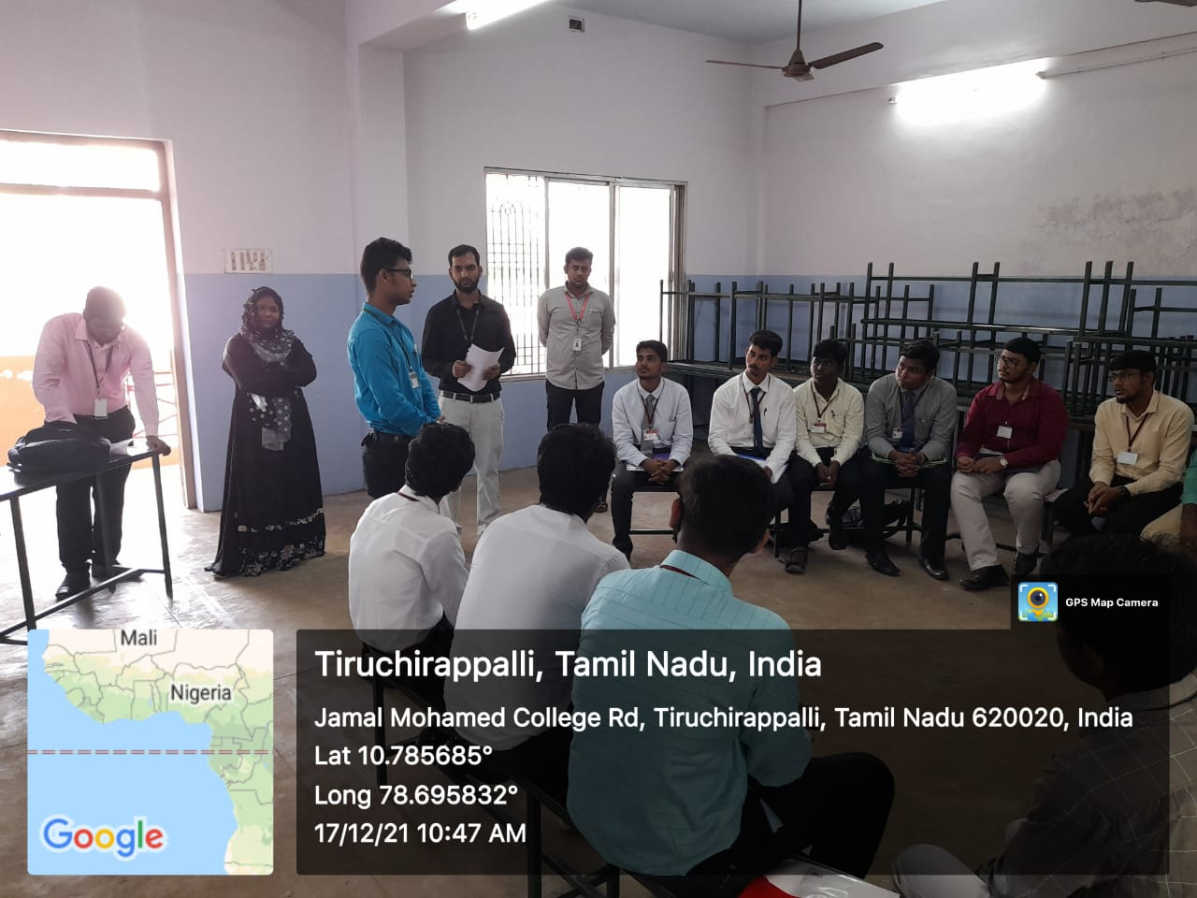

TAMIL DEPARTMENT MUTHAMIL VIZHA PROGRAMME

On The Date of 16th December 2022 Department of Tamil has organized Muperum vizha at Syed Hussainudeen hall at our college campus. Our college Tamil department faculty has released the book. And our college Secretary and correspondent and our college principal has felicitate the programme and our NSS Programme officer instructed our NSS Volunteers to serve the dignitaries and organize the programme and they done their duty in good manner

No. of NSS Volunteers Participated: 10 Date: 16.12.2021
No. of NSS Programme officers participated:
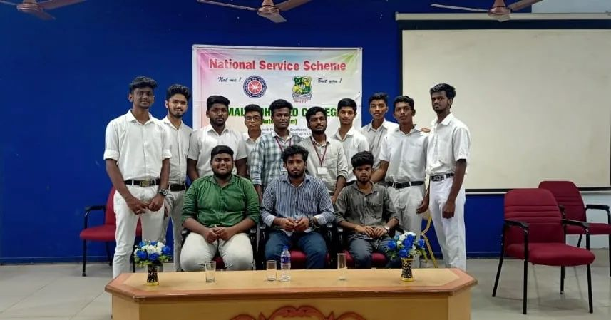

NATIONAL YOUTH DAY

On The Date of 12th January of 2021 National youth day was conducted at
Bharathidasan University. The day was celebrated behalf of SWAMI VIVEKANADA’S birthday. A Special guest were addressed the speech about Swami Vivekananda. Our NSS Programme officer instructed our NSS Volunteers to make use of this programme Volunteers participated with full involvement. And they participated with good manner.

No. of NSS Volunteers of Participated: 06 Date: 01.12.2021
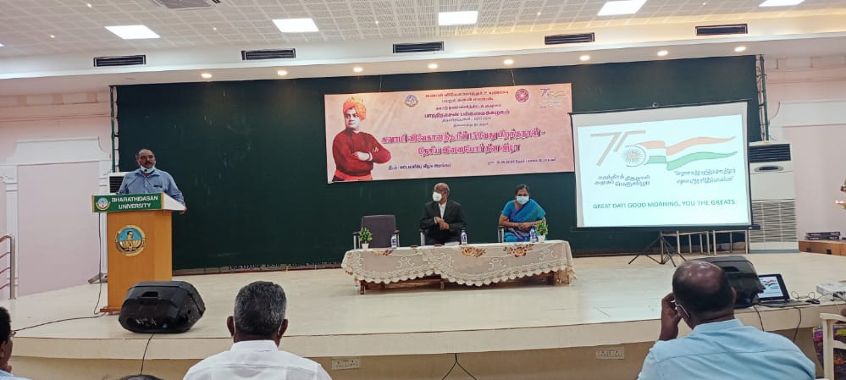
No. of NSS Programme officers participated: 01
R. S. PURAM KOVIL CLEANING
On the date of 12th January 2022 Cleaning Programme was Held at R. S. Puram kovil, J.K. Nagar. The Register of Bharathidasan University Dr. L. Ganesan Informed to our NSS Programme Officer. Our College NSS Programme Officers Instructed to NSS Volunteers to Clean with Good Manner.
No. of NSS Volunteers Participated: 10 Date: 12.01.2022
No. of NSS Programme officers participated: 01

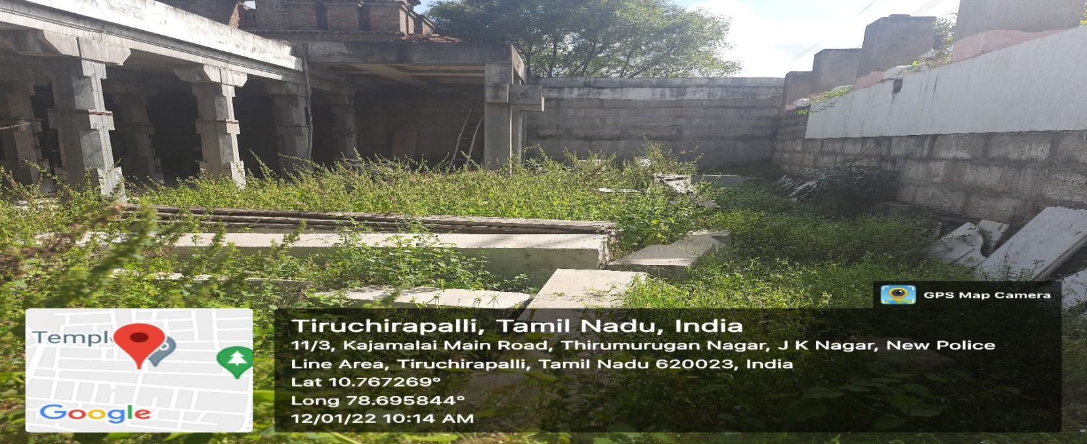

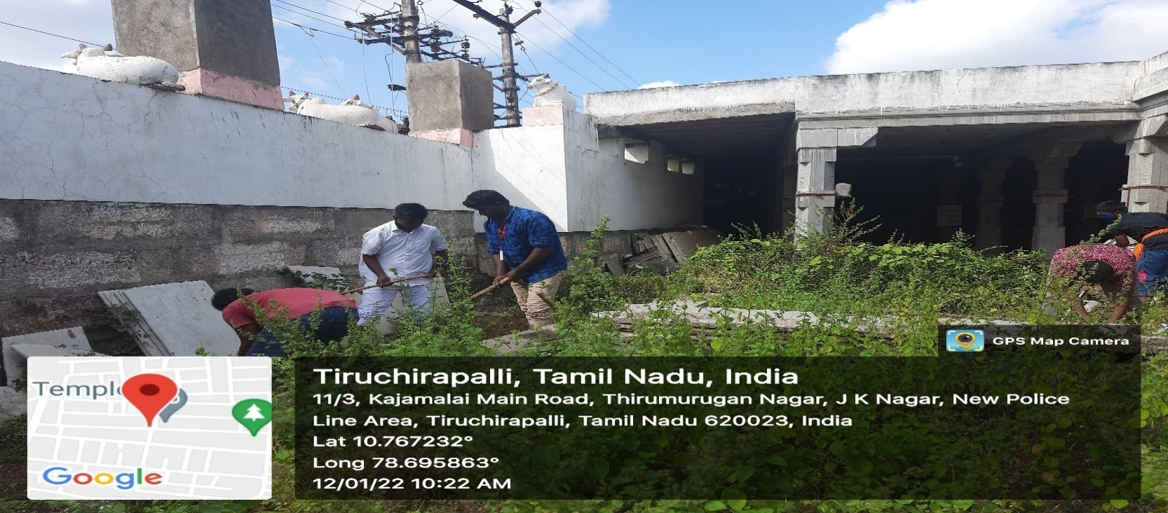

R. S. PURAM KOVIL CLEANING
On the date of 13th January 2022 Cleaning Programme was Held at R. S. Puram kovil, J.K. Nagar. The Register of Bharathidasan University Dr. L. Ganesan Informed to our NSS Programme Officer. Our College NSS Programme Officers Instructed to NSS Volunteers to Clean with Good Manner.
No. of NSS Volunteers Participated: 15 Date: 13.01.2022
No. of NSS Programme officers participated: 01

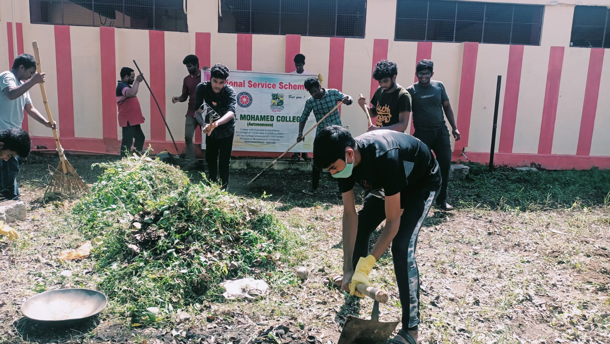

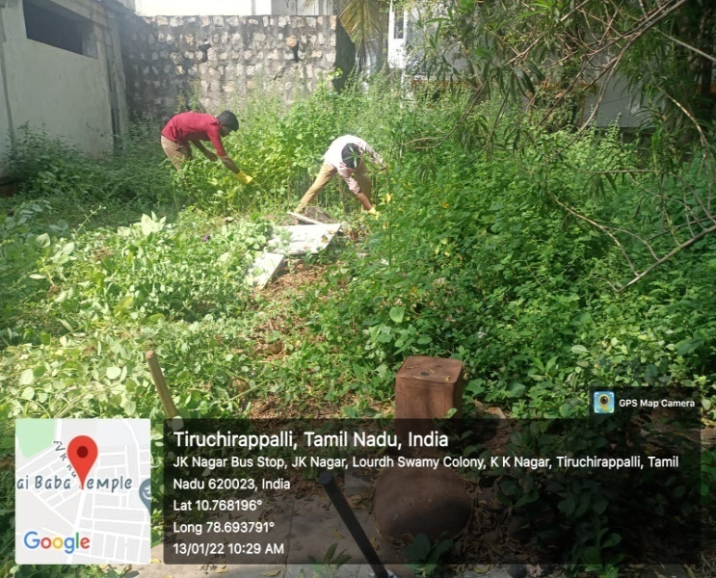
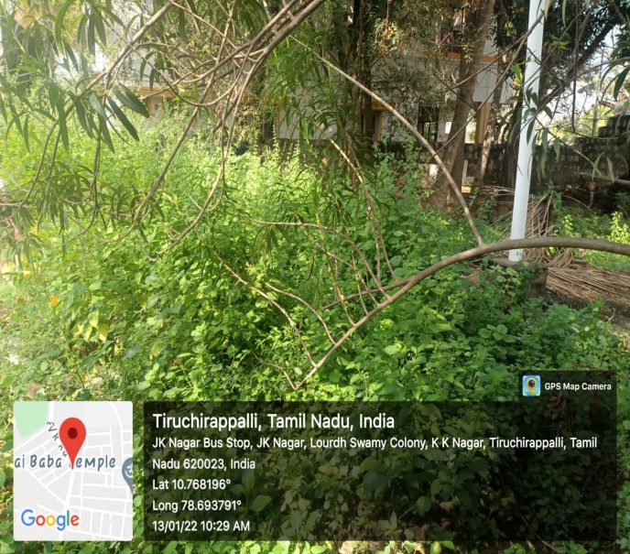

NATIONAL VOTERS DAY

On The Date of 25th January 2022 National Voters day was celebrated at Jamal Mohamed College, we conducted this programme via online due to pandemic situation
Our NSS Volunteers were taken pledge. Our NSS Programme officer instructed our NSS Volunteers to make use of the programme. Our NSS Volunteers were participates with full involvement and they done their duty in good manner

No. of NSS Volunteers of Participated: 48 Date: 25.01.2022
No. of NSS Programme officers participated: 02
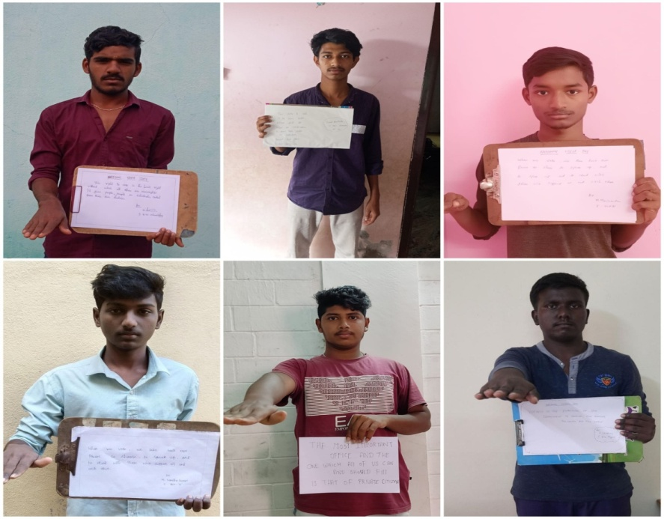

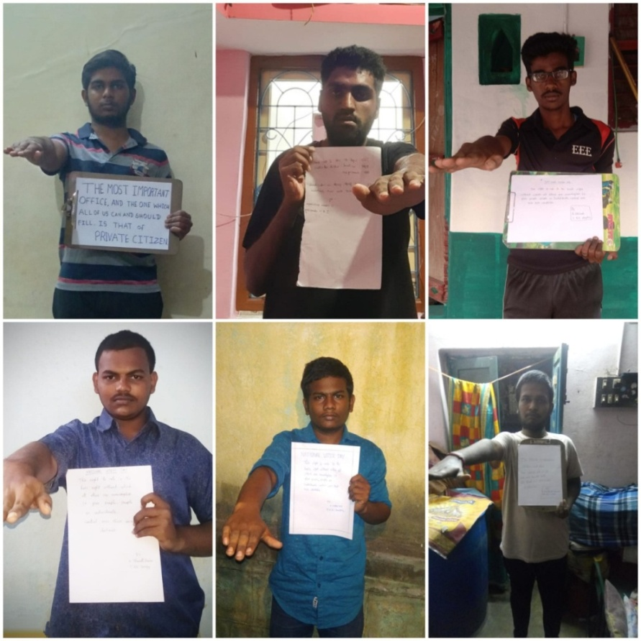

REPUBLIC DAY CELEBRATION JAMAL MOHAMED COLLEGE REPORT
On the date 26 January 2022, 72nd Republic day was celebrated at Jamal Mohamed College. Our College Principal addressed the speech about Indian Republic and our College Secretary Hosted the flag and distributed the sweets. Our college Programme officers and NSS Volunteers have participated in the programme at Jamal Mohamed College.

Number of NSS Volunteers Participated: 40 DATE: 26. 01.2022 Number of NSS Programme Officers Participated: 03

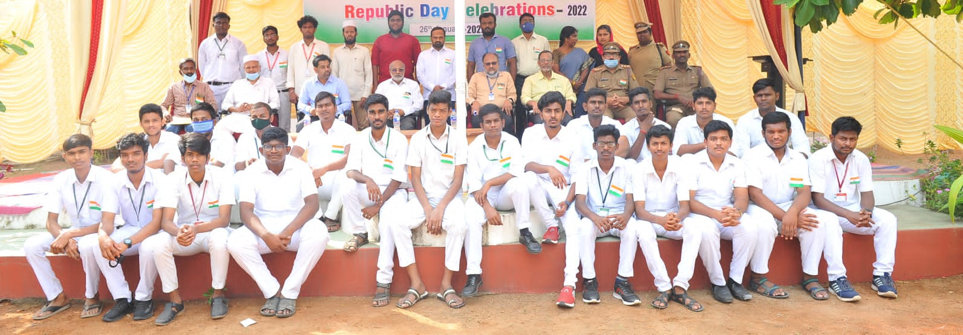

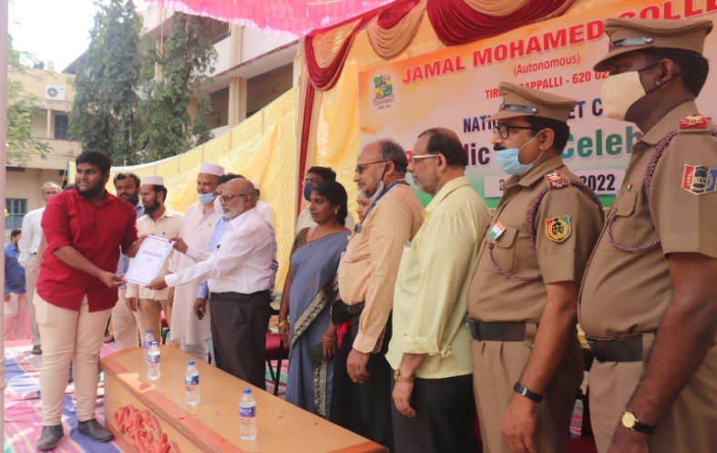
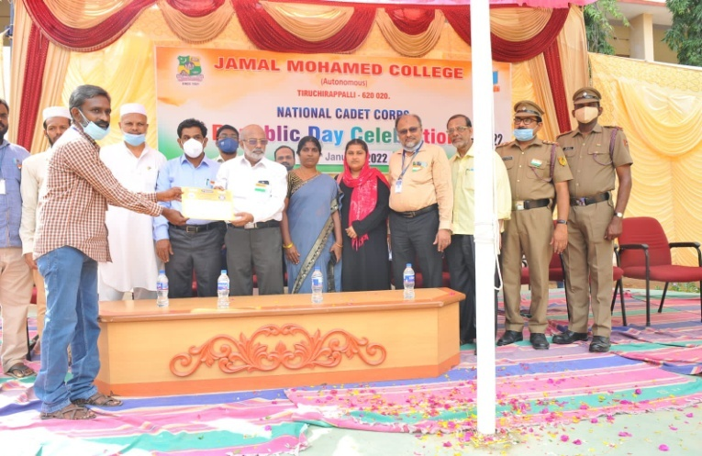

72NDREPUBLIC DAY AT BDU
On the date 26th January 2022, 72nd Republic day was celebrated by NSS Cell of Bharathidasan University. The National Service Scheme of Jamal Mohamed College Volunteers were participated in this Republic Day programmed. M. SELVAM Vice-Chancellor of Bharathidasan University presided over the programme. Mrs. A. LAKSHMI PRABHA NSS Co-ordinator of Bharathidasan University, NSS Staffs and our college Programme officer has guided our NSS Volunteers to make the program grand success.

Number of NSS Volunteers Participated: 40 DATE: 26.01.2022 Number of Programme Officers participated: 02
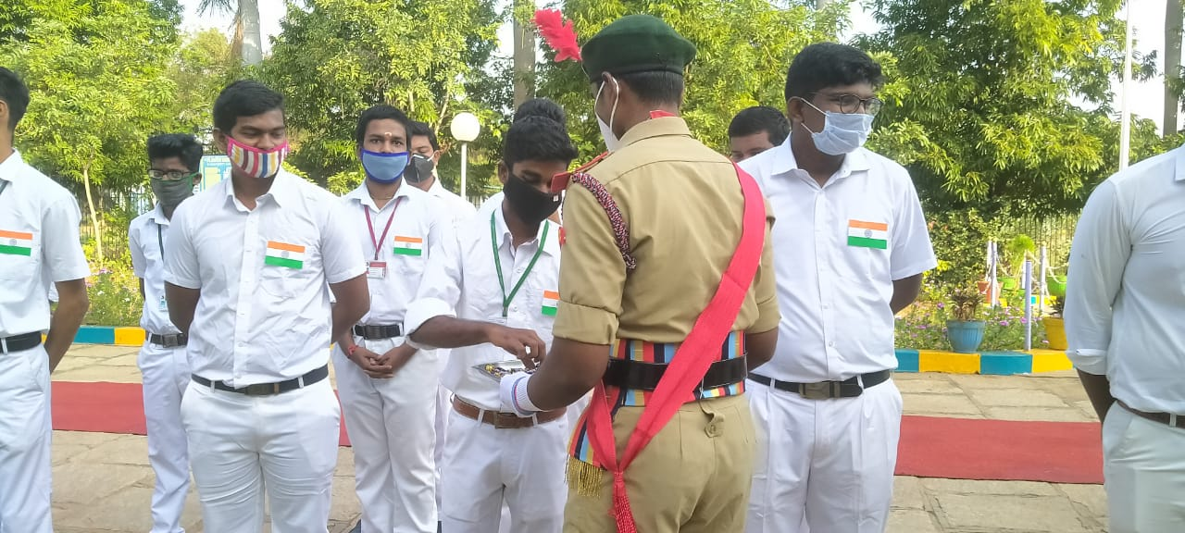
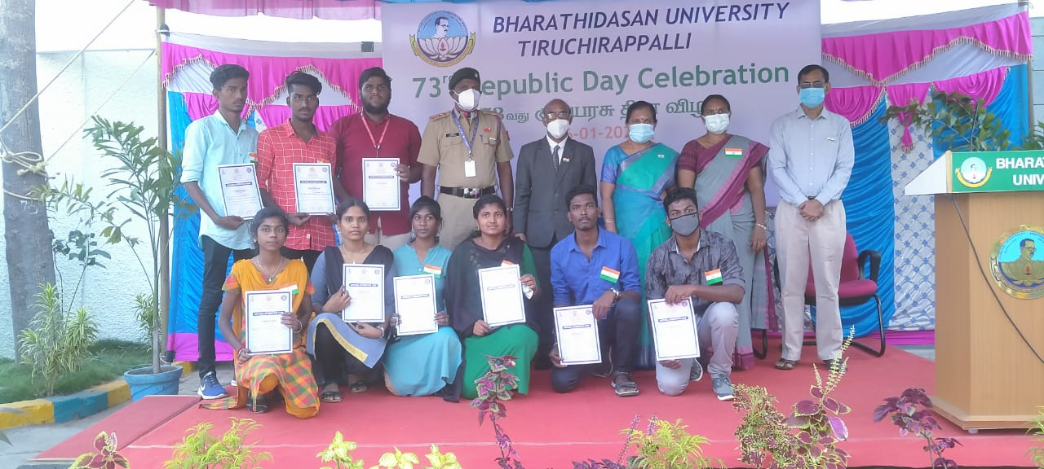

CHILD LABOURS DAY PLAEDGE
On the date of 9th February 2022 Held at Jamal Mohamed College. The pledge was taken for abolishing slaves in factories. On behalf Jamal Mohamed College NSS, Our College Principal, Secretary Correspondent, vice principal, Part – V Co- Ordinator, HOD’s, Staff Members were participated with our NSS Volunteers. The Pledge in front of MBA Block College Campus. Our volunteers were participated in great Manner.
No. of NSS Volunteers Participated: 07 Date: 09.02.2022
No. of NSS Programme officers participated: 05

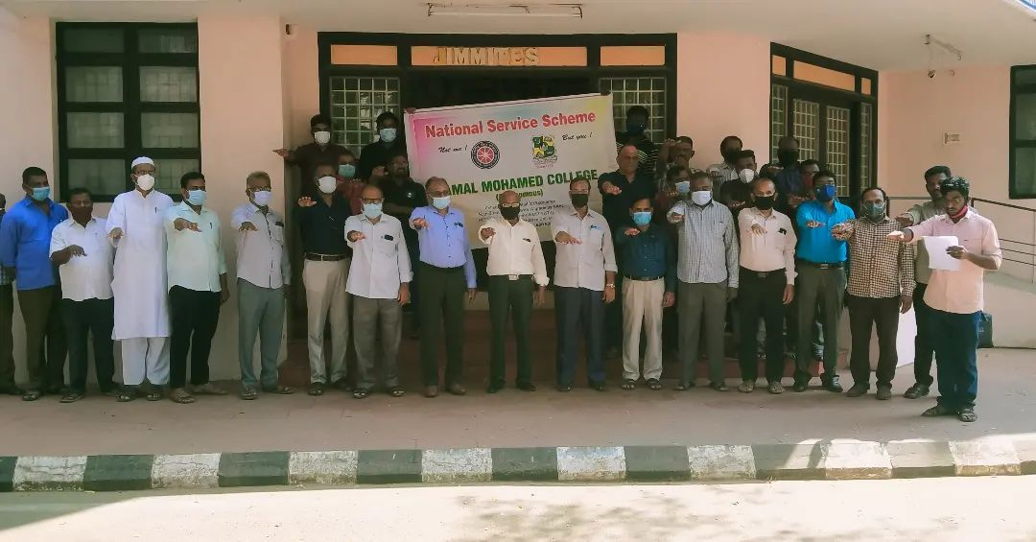

PULVAMA ATTACK
On the date of 14th February 2022 was conducted online mode held at Jamal Mohamed College. The Programme is for 40 CRPF solders those who died on the bomb blast, It also called Black Day. Our NSS volunteers were Memorial tribute for those solders. Our NSS Programme Officers Instructed the NSS Volunteers to make a Memorial tribute video with Good Manner.
No. Of NSS Volunteers Participated: 05 Date: 11. 03.2022 No. Of NSS Programme officers participated: 01

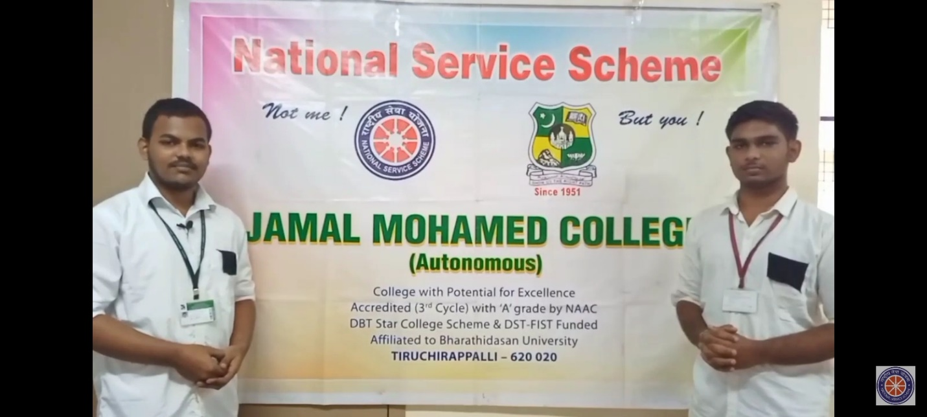

SCIENCE EXHIBITION AT BHARATHIDASAN UNIVERSITY

On The Date of 28th February 2022 Science exhibition was conducted at Bharathidasan University. NSS Co-ordinator of Bharathidasan University
Dr. A. LAKSHMI PRABHA was co-ordinate the programme and Vice- Chancellor of Bharathidasan University Dr. M. SELVAM was felicitate the programme. Our NSS Programme officer instructed our NSS Volunteers to direct the students to visit the exhibition and our NSS Volunteers were done their duty in good manner

No. of NSS Volunteers of Participated: 50 Date: 28.02.2022
No. of NSS Programme officers participated: 01
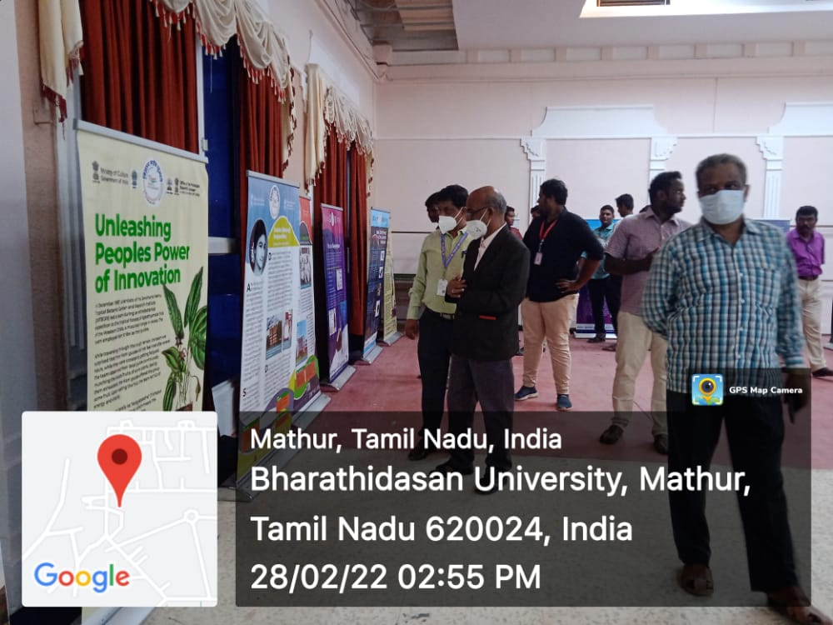

Convocation Day (Men) Aided
On the date of 5th March 2022 Convocation day was held at Jamal Mohamed College. Honble. Minster of Tamil Nadu Ex Minister Mr. was felicitating the programme. Graduates of our College were received their degrees from the Honble. Minister. Our programme officer instructed our NSS Volunteers to organize the programme and direct the visitors to the respective places. Our NSS Volunteers were done their duty in good manner.
No. of. NSS Volunteers Participated: 60 Date: 05.03.2022
No. of. NSS Programmme officers: 05

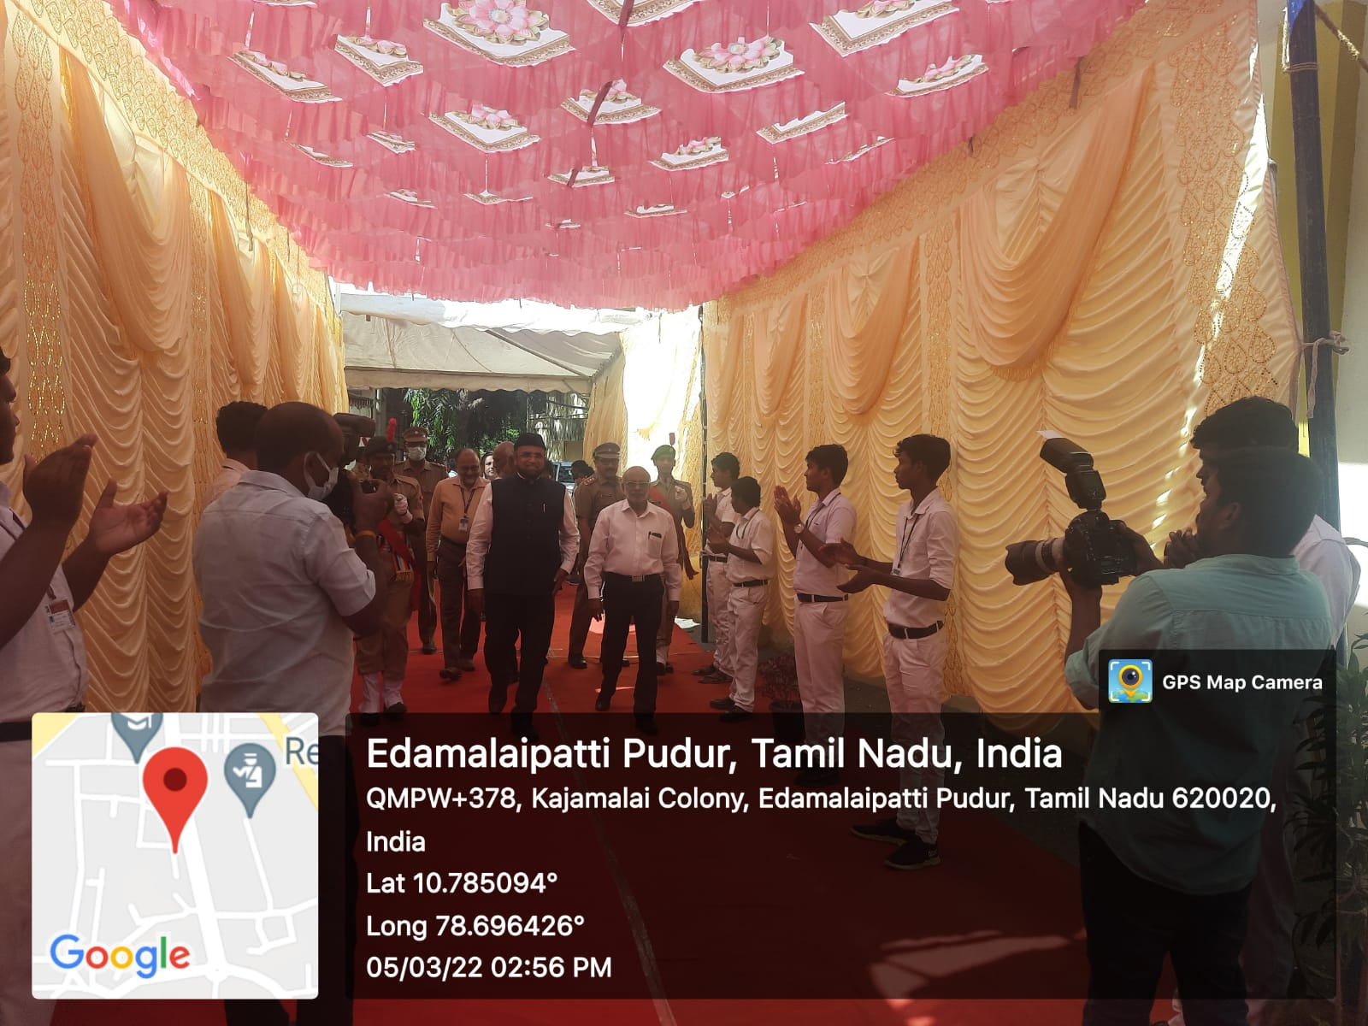

CONVOCATION DAY (WOMEN)

On the date of6th March 2022 Convocation Day (Women) was held at Jamal Mohamed College. Honble Vice Chancellor of Bharathidasan University
Dr.M. Selvam were felicitate the programme. Graduates of our College were received their degrees from the Honble. Minister. Our programme officer instructed our NSS Volunteers to organize the programme and direct the visitors to the respective places. Our NSS Volunteers were done their duty in good manner.

No. of NSS Volunteers of Participated:20 Date:06.03.2022
No. of NSS Programme Officers Participated:05

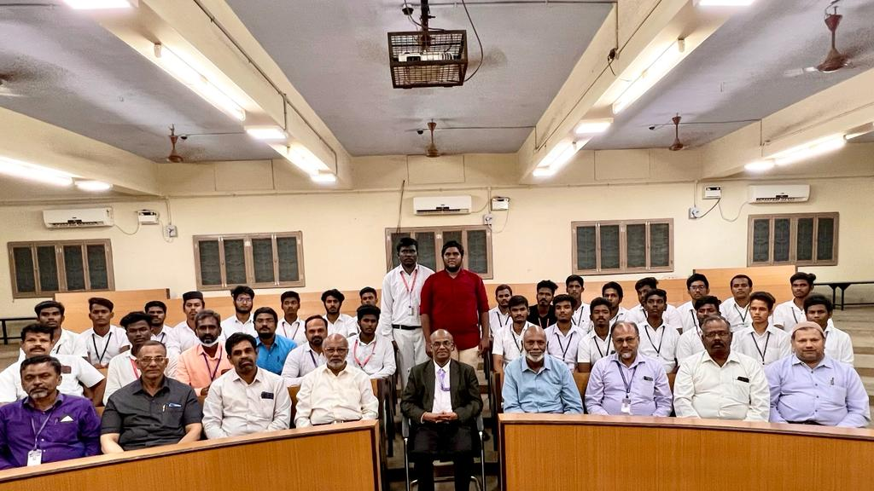

CONVOCATION DAY-MEN SF

On the date of 7th March 2022 Convocation day was held at Jamal Mohamed College. Honble. Minster of Tamil Nadu Mr.S.Selvaraju was felicitating the programme. Graduates of our College were received their degrees from the Honble. Minister. Our programme officer instructed our NSS Volunteers to organize the programme and direct the visitors to the respective places. Our NSS Volunteers were done their duty in good manner

No. of NSS Volunteers of Participated: 60 Date: 07.03.2022
No. of NSS Programme officers participated: 05

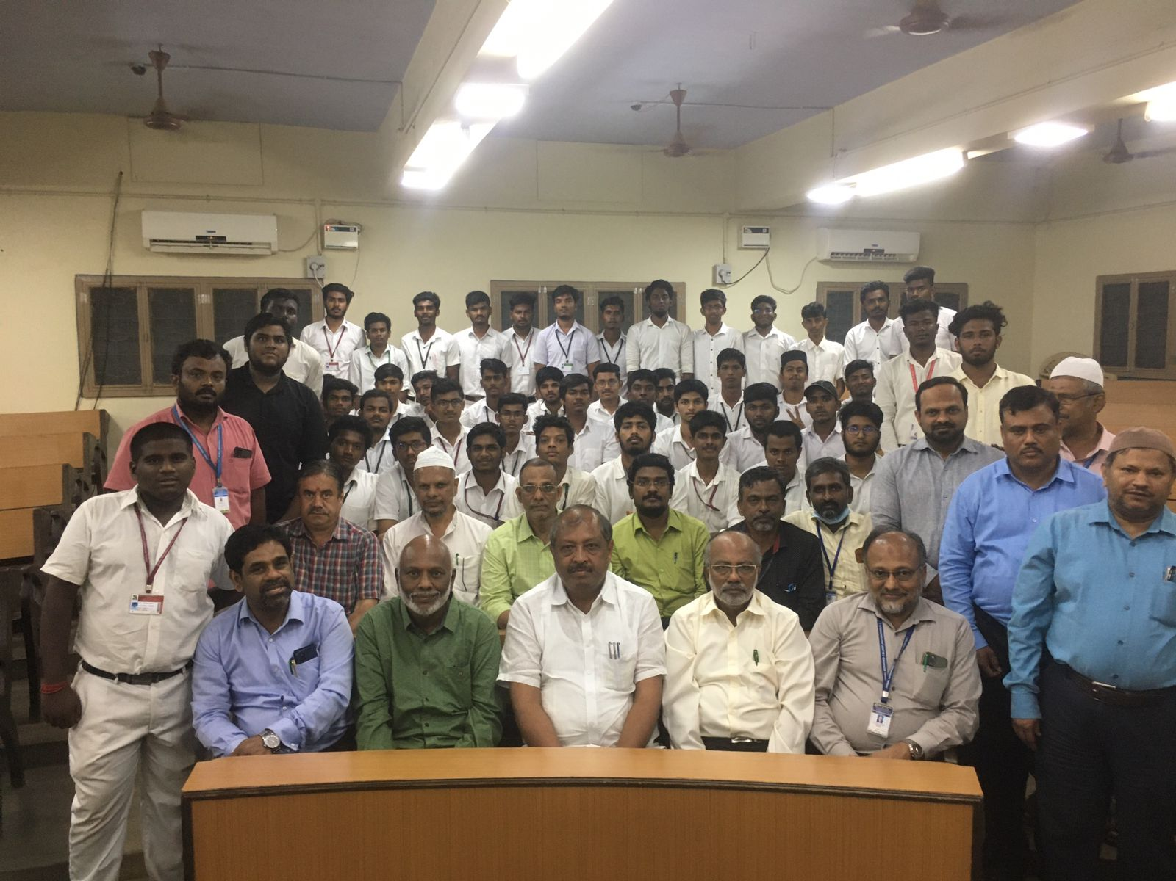

TAMIL DEPARTMENT ARCHAEOLOGICAL

On the date of 11th march 2022 Dept. of Tamil organised a programme for various freedom fighters and their lifestyle. The programme was conducted by Tamil Nadu Archaeology department. Our NSS Programme officer instructed our NSS Volunteers to organize the programme and serve to the dignitaries. Our NSS Volunteers has participated with full involvement and done their duties with good manner.
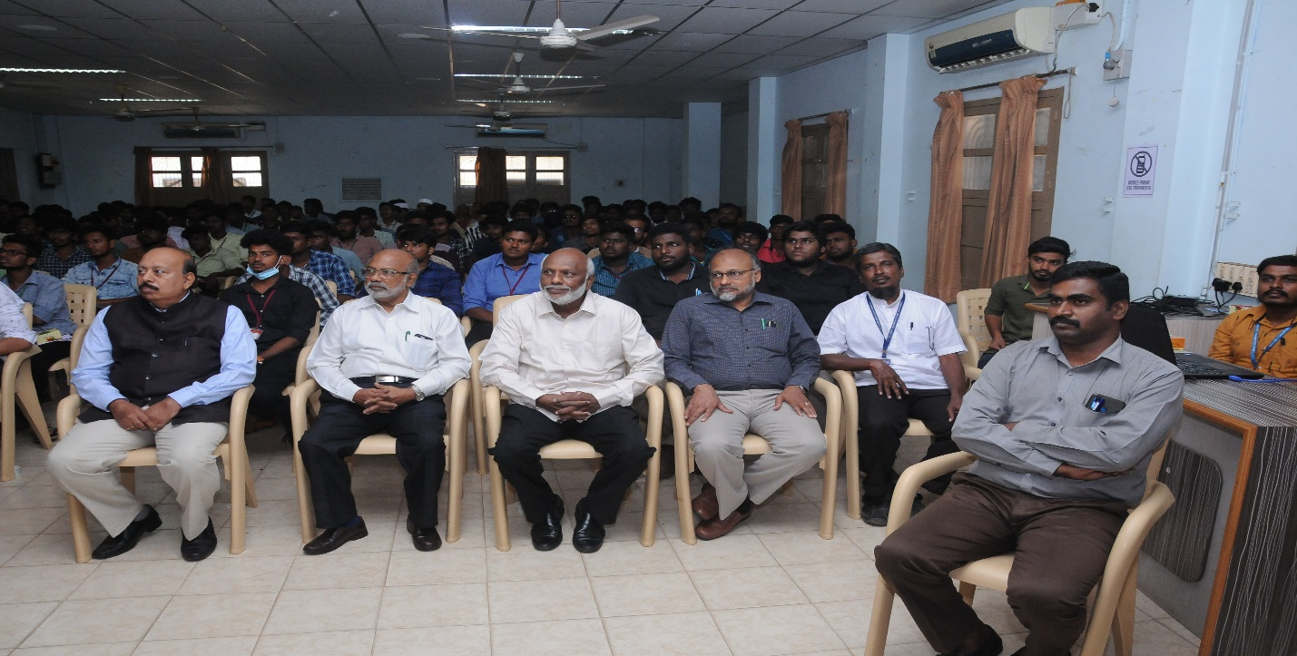
No. Of NSS Volunteers Participated: 10 Date: 11. 03.2022 No. Of NSS Programme officer participated: 01
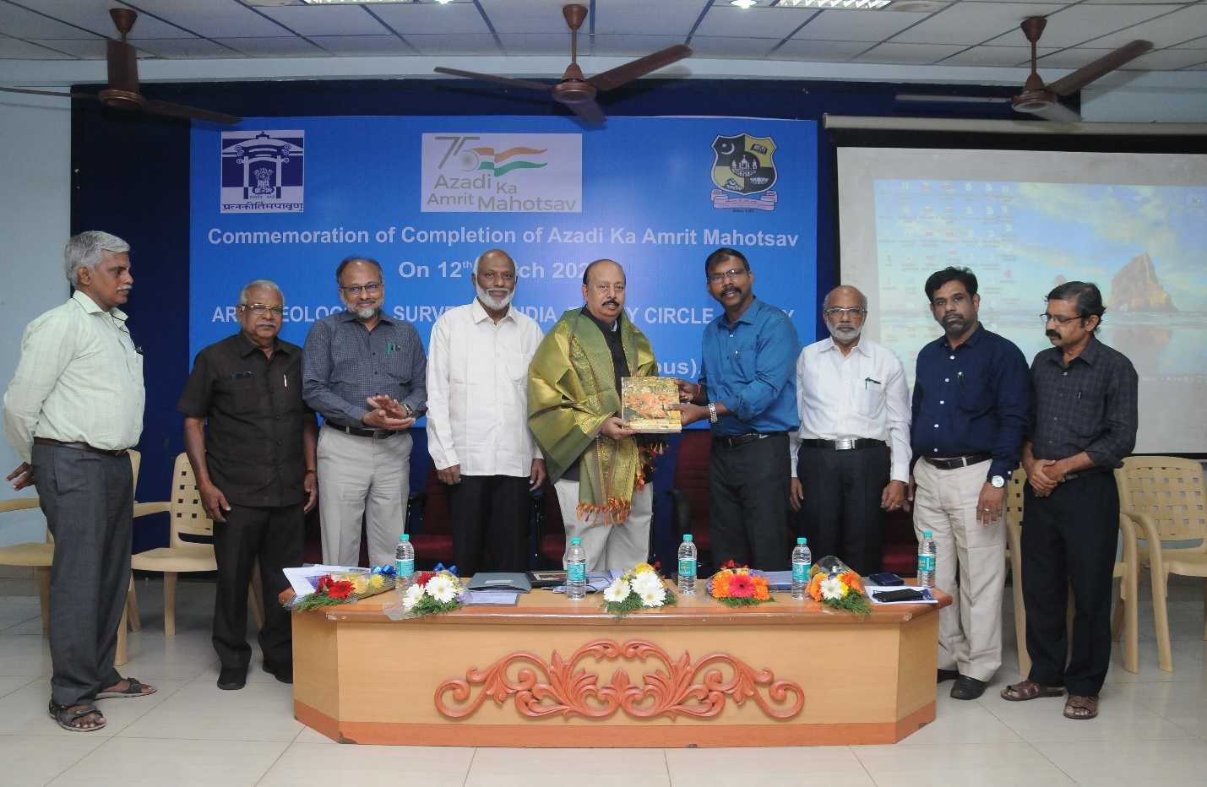
PARADE TRAINING FOR COLLEGE SPORTS MEET – 2022
On the date 11th March to 24th March 2022 Parade training was conducted for NSS Volunteers. Our NSS Programme Officers Instructed our NSS Volunteers make use of this parade training and Our NSS participated with full involvement and they attend without any absence.
No. of NSS Volunteers Participated: 80 Date: 11.12.2021
No. of NSS Programme officers participated: 05 to
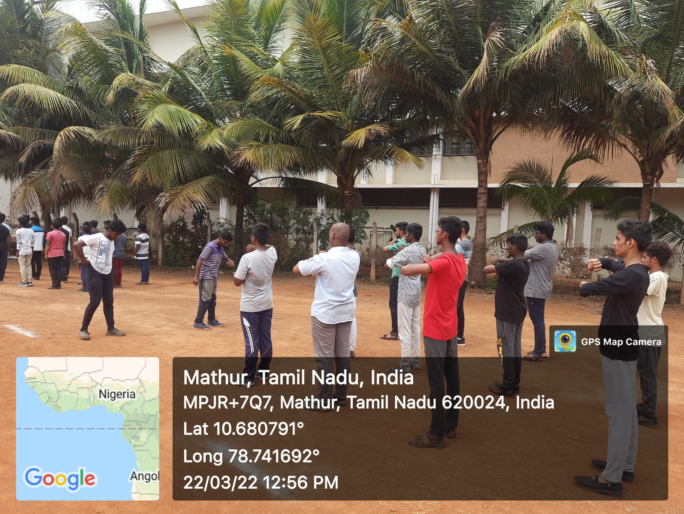
24.03.2022

NSS ORIENTATION PROGRAMME AT BHARATHIDASAN UNIVERSITY
On the date of 16th March 2022, one day orientation on life skills & ending child marriage were conducted at Bharathidasan University. Our College Principal instructed our NSS Programme officers and NSS Volunteers to participate in event and organised the event. Our college NSS volunteers done the duty in great manner.
Number of NSS Volunteers Participated: 05 DATE: 16.03.2022 Number of NSS Programme Officers Participated: 01
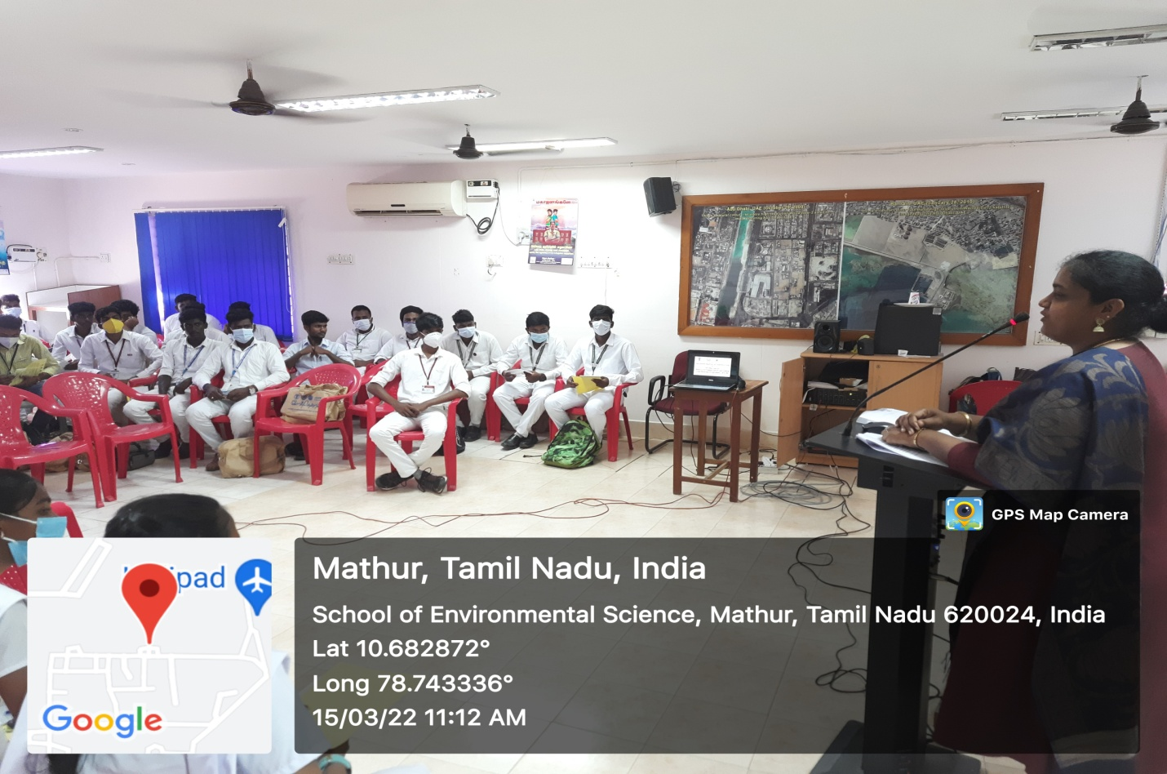

PLACEMENT CELL INTERVIEW PROGRAMME

On the date of 16th march of 2022 campus interview was conducted by placement cell of Jamal Mohamed College. Our NSS Programme officer instructed our NSS volunteers to organize the programme and help the candidates of interview. Our NSS Volunteers were worked with full involvement and our NSS volunteers done their duty in great manner.
No. of NSS Volunteers Participated: 10 Date: 16.03.2022
No. of NSS Programme officers participated: 01

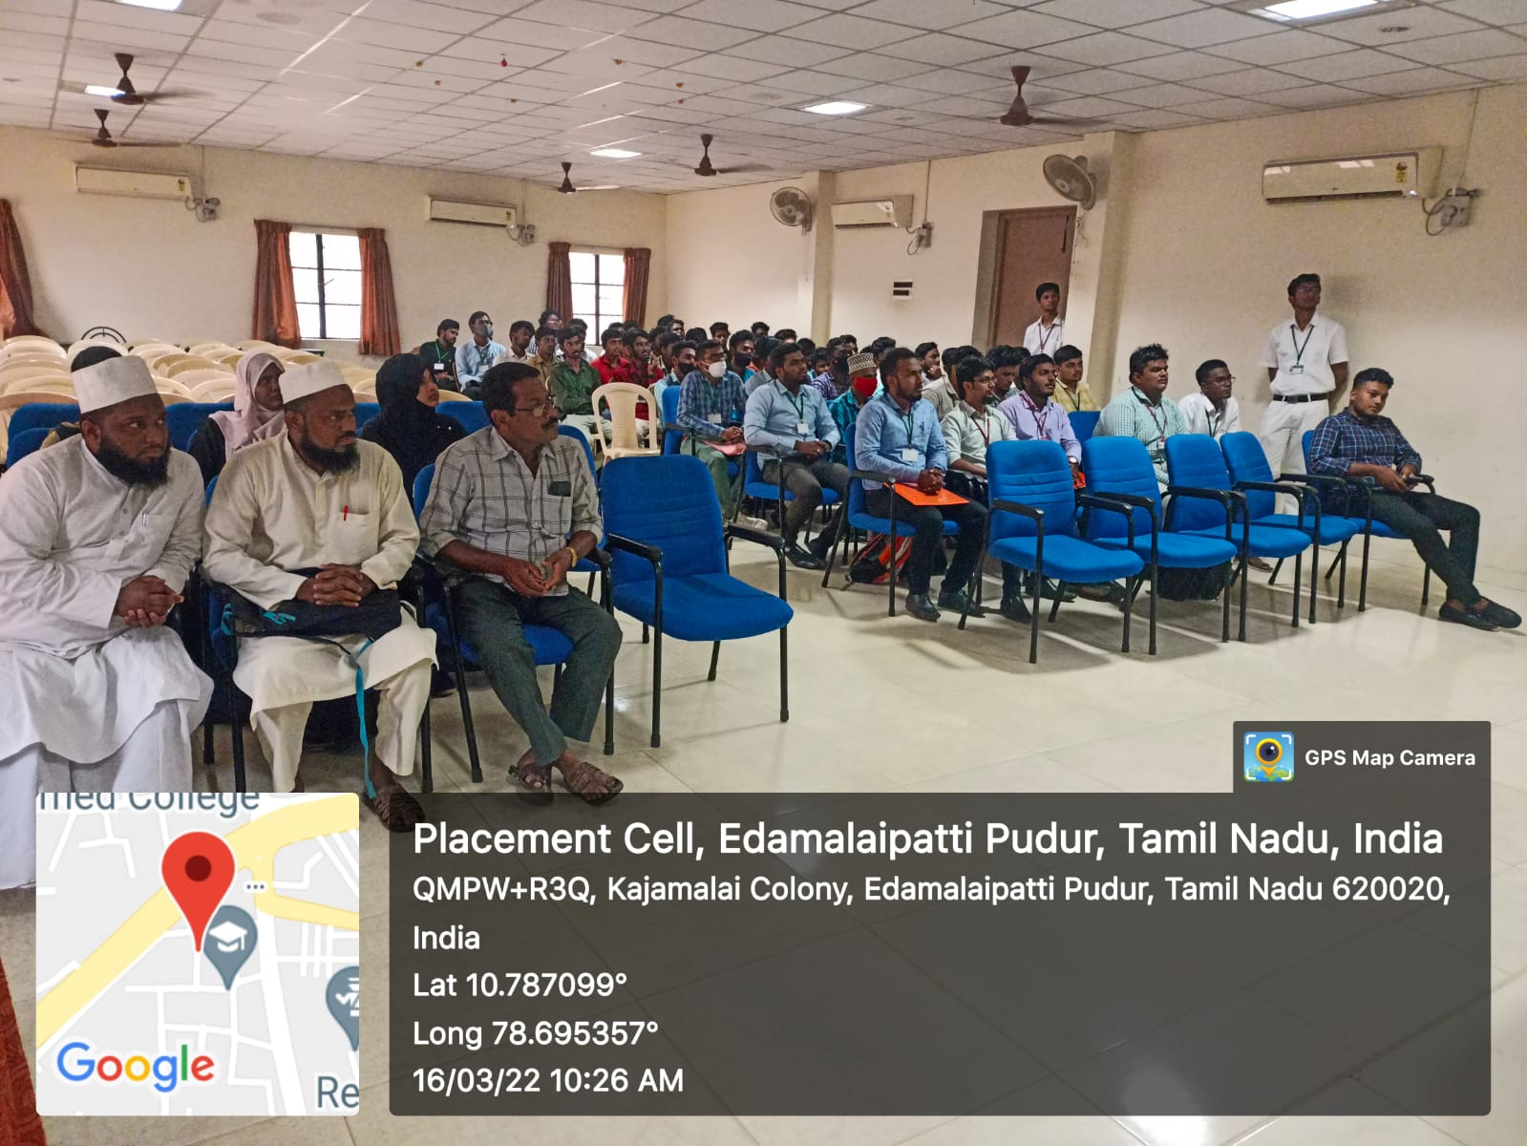

PLACEMENT CELL INTERVIEW PROGRAMME

On the date of 17thmarch of 2022 campus interview was conducted by placement cell of Jamal Mohamed College. Our NSS Programme officer instructed our NSS volunteers to organize the programme and help the candidates of interview. Our NSS Volunteers were worked with full involvement and our NSS volunteers done their duty in great manner.

No. of NSS Volunteers Participated: 12 Date:17.03.2022
No. of NSS Programme officers participated: 01

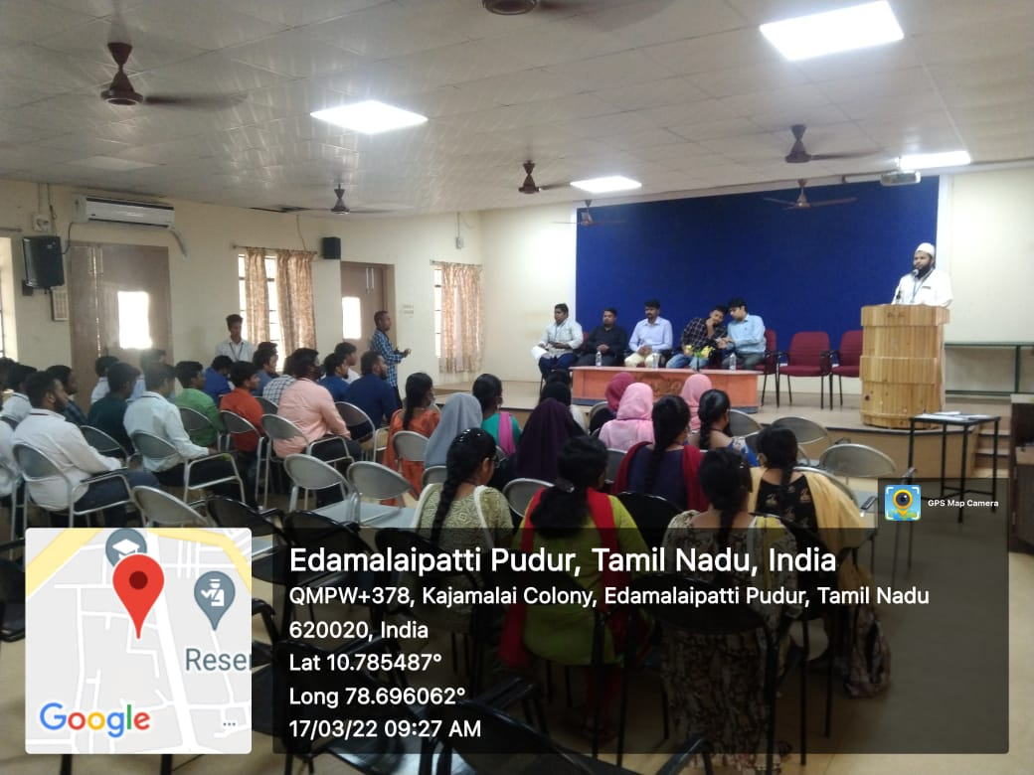

RRC PROGRAMME OFFICER MEETING
On the date of 17th march of 2022, RRC programme officers meet was held at Bharathidasan University. Our NSS Programme officer instructed our NSS volunteers to attend the programme. Honorable vice Chancellor of Bharathidasan University Dr. M. SELVAM was felicitating the programme and CO-Ordinator of NSS & RRC Dr. LAKSHMI PRABHA were presiding the programme. Our NSS Volunteers were participated in the programme with full involvement. And they have done their duty in good manner.

Number of NSS Volunteers Participated: 12 DATE: 17.03.2022 Number of Programme Officers participated: 01
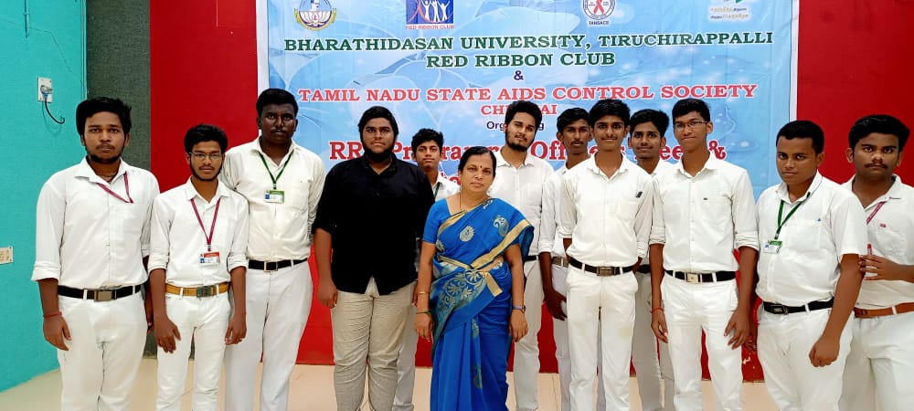

PADIPOM PAGIRVOM TAMIL DEPARTMENT PROGRAMME

On The Date of 18th March 2022 Department of Tamil has organized padipom pagirvom programme at Syed Hussainudeen hall our College. Our college Secretary and correspondent and our college principal has felicitate the programme and chief guest from Madras University has participated and addressed to the gatherings. Our NSS Programme officer instructed our NSS Volunteers to organize the programme and serve to the dignitaries. Our NSS Volunteers has done their duty in god manner

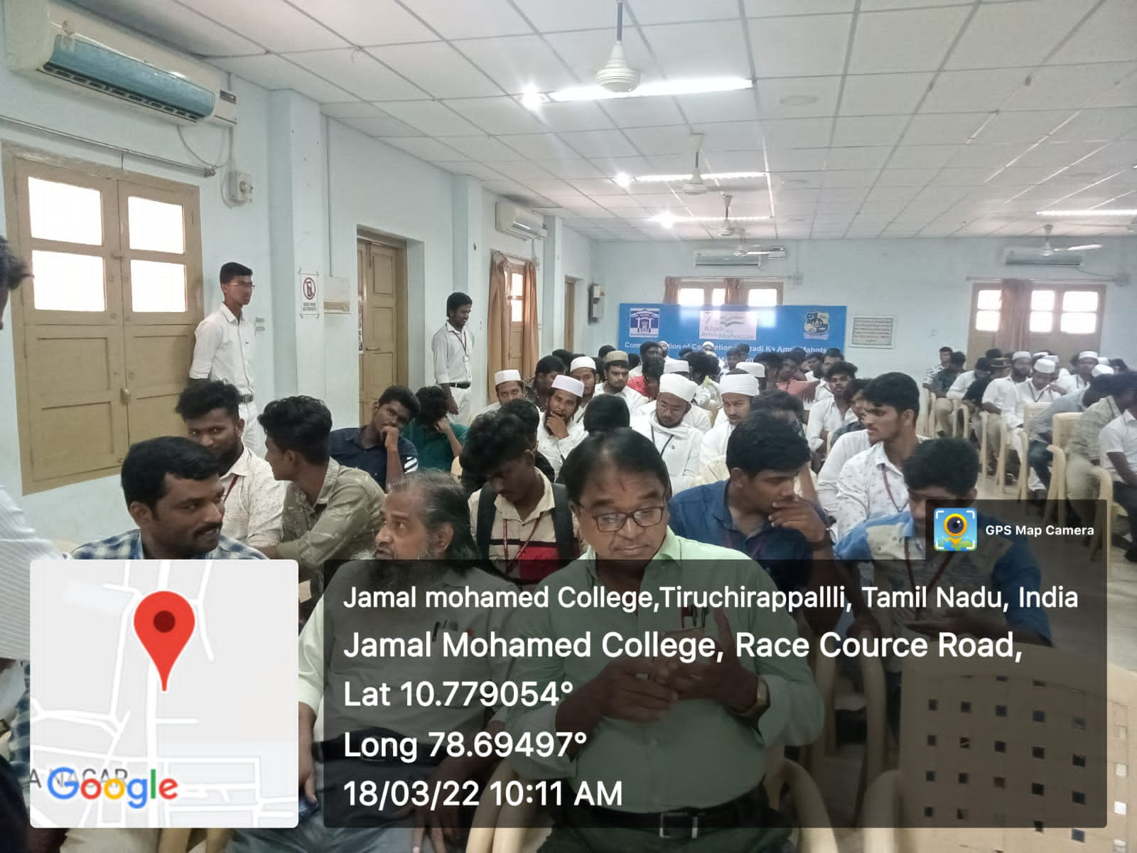
Date: 18.03.2022
No. of NSS Volunteers Participated: 08
No. of NSS Programme officers participated: 01

PLACEMENT CELL INTERVIEW PROGRAMME

On the date of 22th march of 2022 campus interview was conducted by placement cell of Jamal Mohamed College. Our NSS Programme officer instructed our NSS volunteers to organize the programme and help the candidates of interview. Our NSS Volunteers were worked with full involvement and our NSS volunteers done their duty in great manner.

No. of NSS Volunteers Participated: 05 Date: 22.03.2021
No. of NSS Programme officers participated: 01

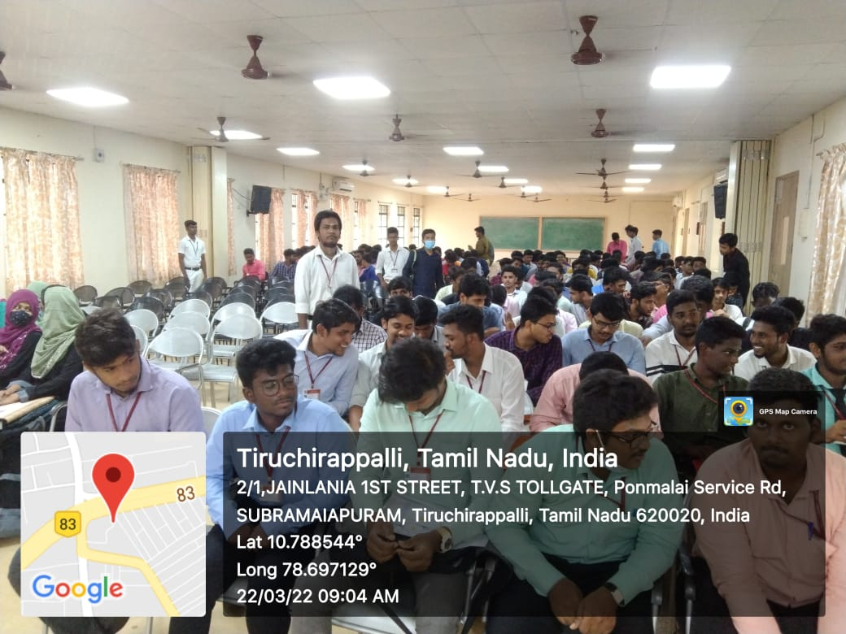

MARTYR’S DAY
On the date of 23rd march 2022 Martyr’s Day Pledge was taken at Jamal Mohamed College. Our NSS Volunteers were Participated in the programme our NSS Programme Officers were addressed few words about the pledge. Our Volunteers were taken pledge with Full involvement.
No. of NSS Volunteers Participated: 55 Date: 23.03.2021
No. of NSS Programme officers participated: 05

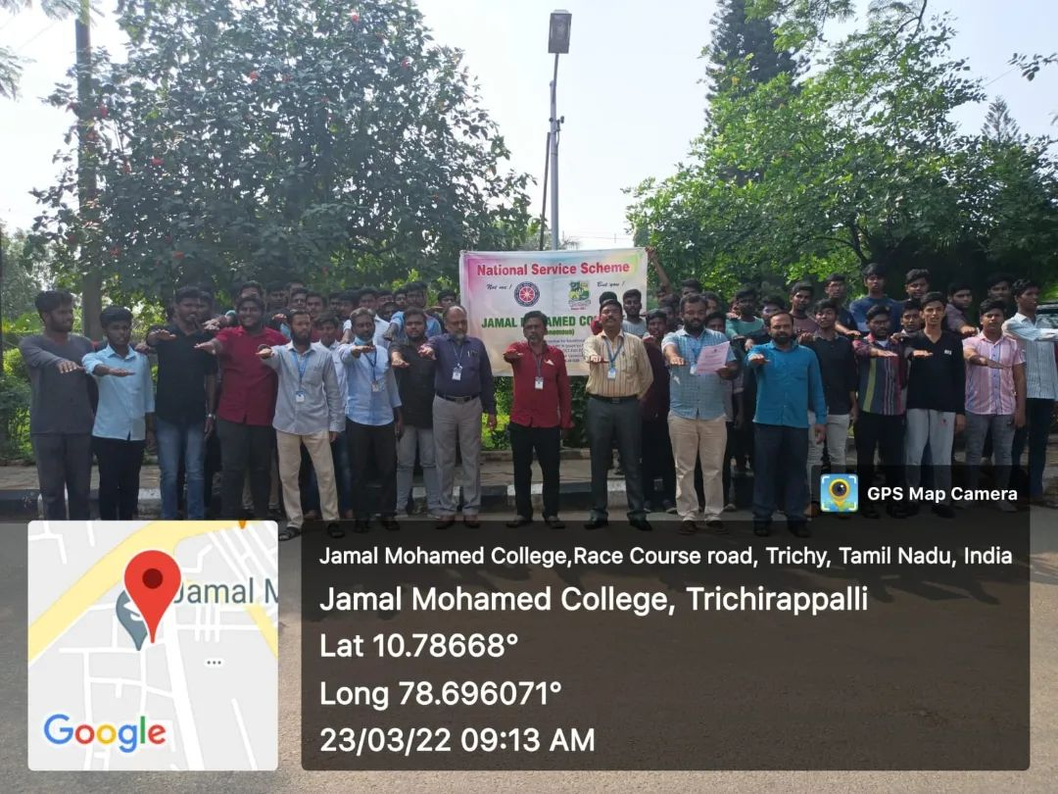

TB RALLY
On the date of 24.03.2022 TB Rally was Conducted Wesley School in which our NSS Volunteers Were Participated. The Chief Guest of this Programme is District Collector S. Sivarasu Flagged off the TB Rally. Our NSS Programme Officer instructed our NSS Volunteers about the programme and our volunteers Participated in Good Manner.

No. of NSS Volunteers Participated: 10 Date: 24.03.2022
No. of NSS Programme Officer: 01

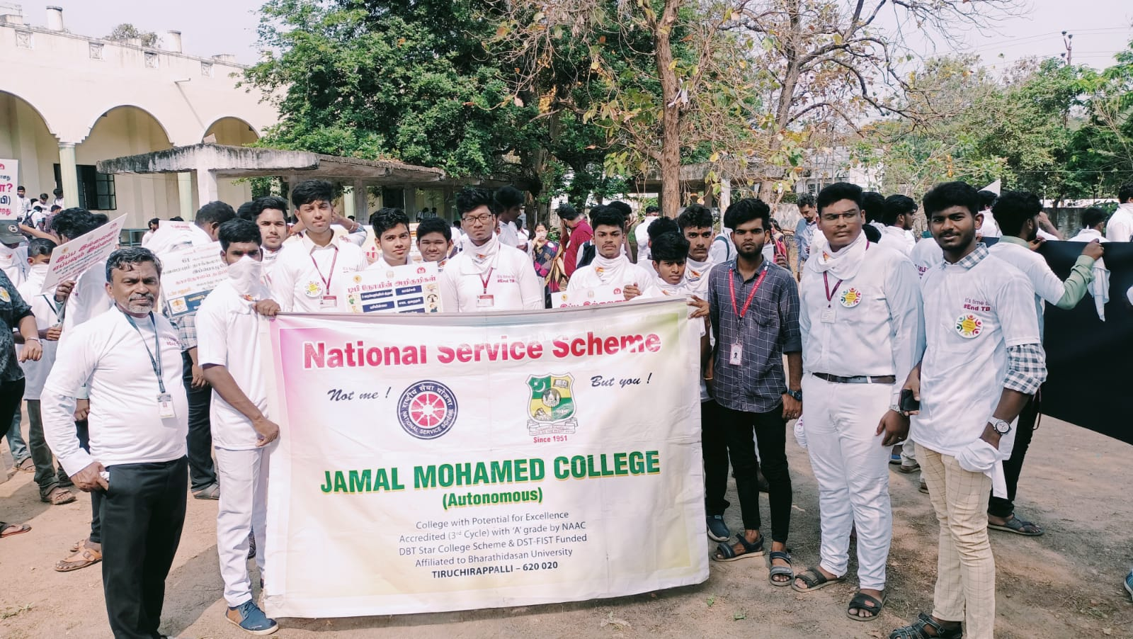

BIKE RALLY ROAD SAFETY AWARENESS

On the date of 25th March 2022 Bike Rally was conducted by NSS Cell of Jamal Mohamed College. Our NSS Volunteers were participated in the rally our NSS Programme officer instructed our NSS Volunteers to attend the Programme with perfect safety measures like wearing helmet. Our NSS Volunteers were participated in the programme with their two wheelers and made the programme a grand success

Date: 25.03.2022
No. of NSS Volunteers of Participated: 30
No. of NSS Programme officers participated: 03

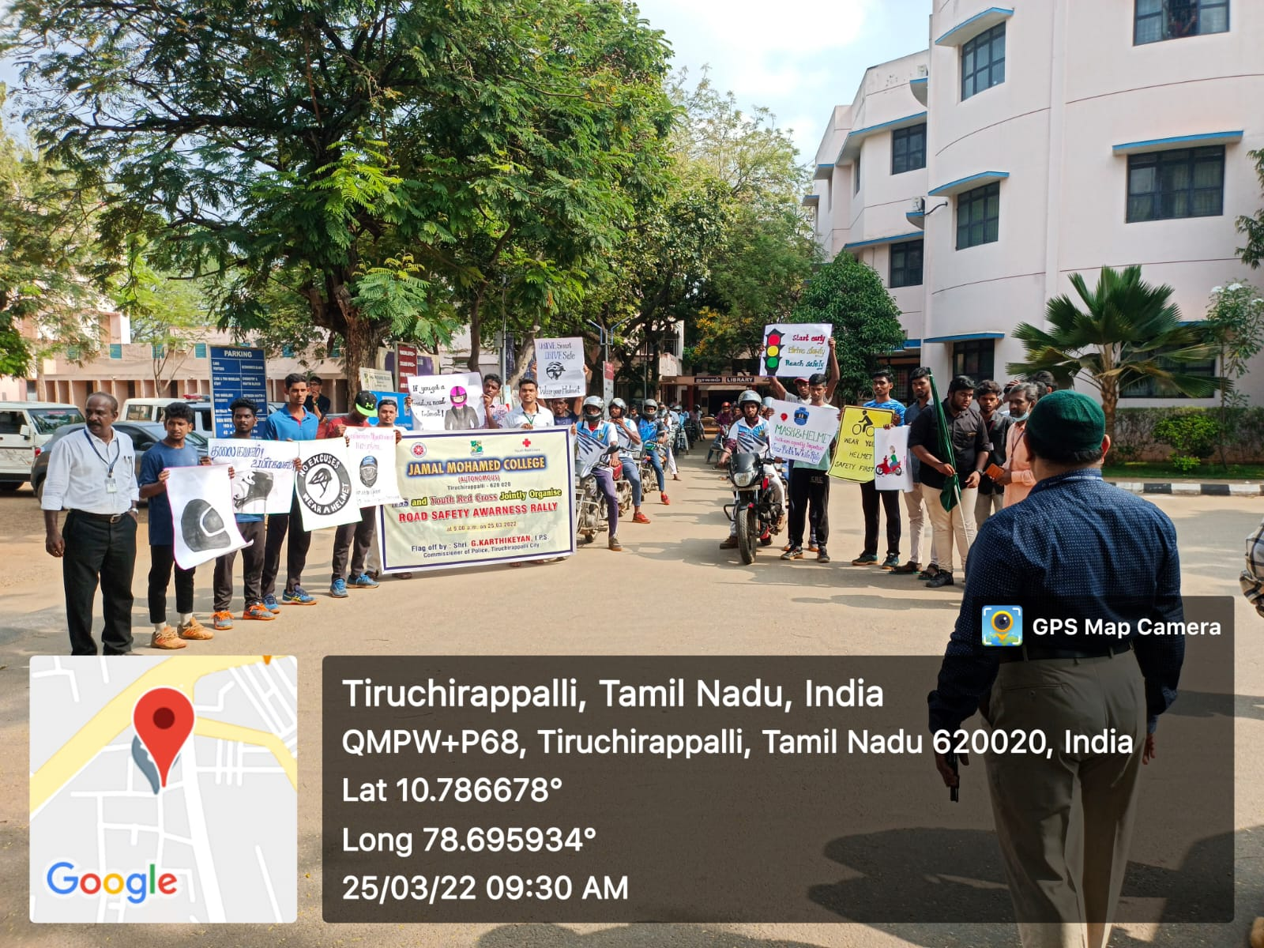

72nd ANNUAL SPROTS MEET
On the date of 25th March 2022 72ndAnnual Sports Meet was conducted Jamal Mohamed College. The Trichy city commissioner of police shri. G. Karthikeyan Addressed the Sports Meet. Our College NSS Volunteers Participated Sports Day march Past with Two Contingent &Organized the Event. The NSS Programme Officers Instructed to the NSS Volunteers organized the Event with Good Manner.
No. of. Volunteers Participated: 80 Date: 05.03.2022
No. of. Programme officers: 05

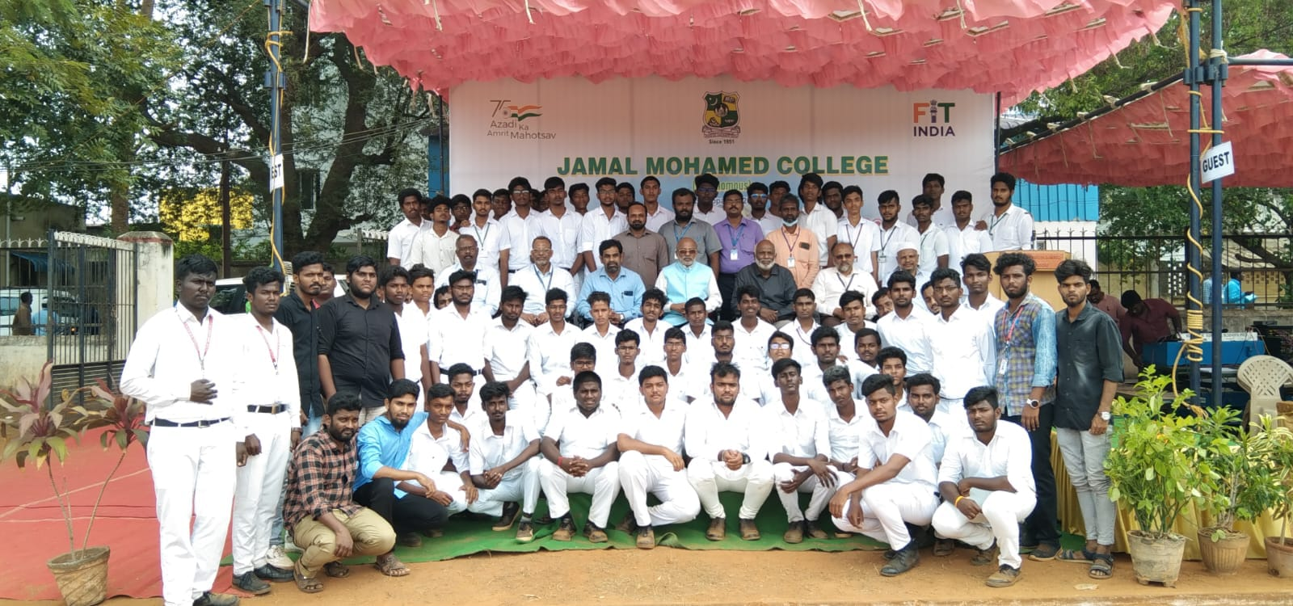

FIT INDIA AWARENESS PROGRAM – 2022
On the date of 25.03.2022 The Fit India Awareness Programme was conducted by NSS Cell of Bharathidasan University. The Program was organized by NSS Unit of Jamal Mohamed College and Successfully Completed the program and Good Manner.
No. of. NSS Volunteers Participated: 04 Date: 25.03.2022
No. of. NSS Programme officers: 01

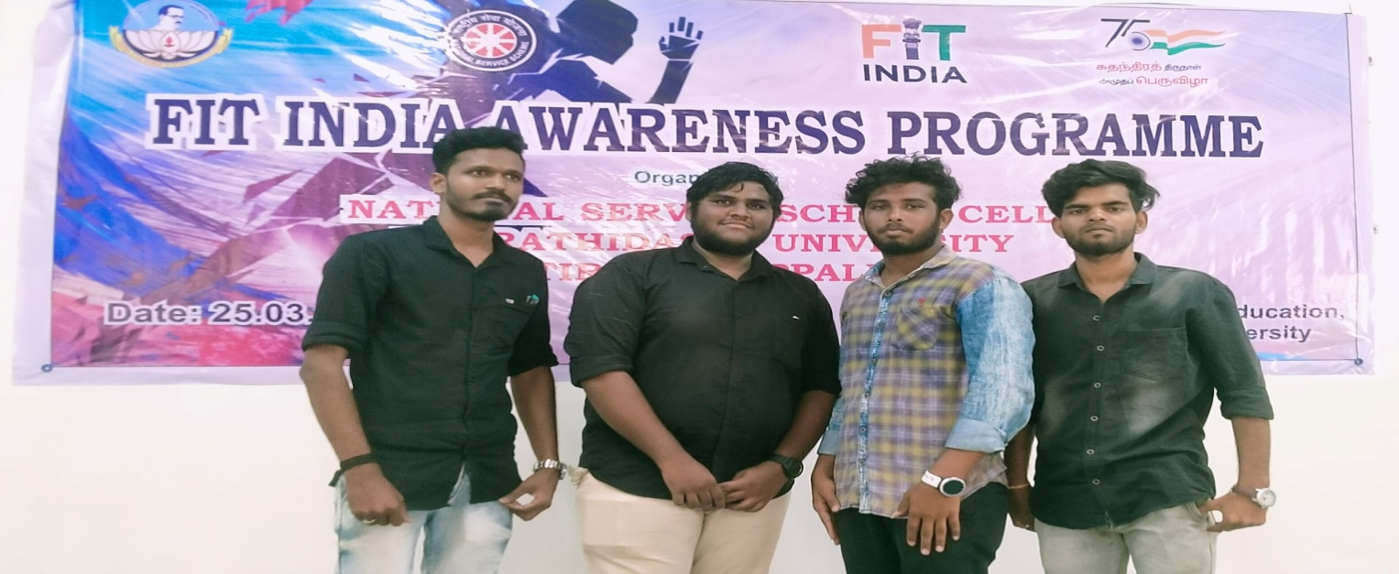

TAMIL DEPARTMENT PANNATTU AAYVARNGAM

On The Date of 26th March 2022 Department of Tamil has organized pannul aayvarangam programme at Syed Hussainudeen hall in our College. Our college Secretary and correspondent and our college principal has felicitate the programme. Nearly 40 professors have addressed the speech about M.R.M. ABDUL RAHMAN and they shared about some books. Our NSS Programme officer instructed our NSS Volunteers to serve the dignitaries and organize the programme. Our NSS Volunteers has done their duty in good manner.
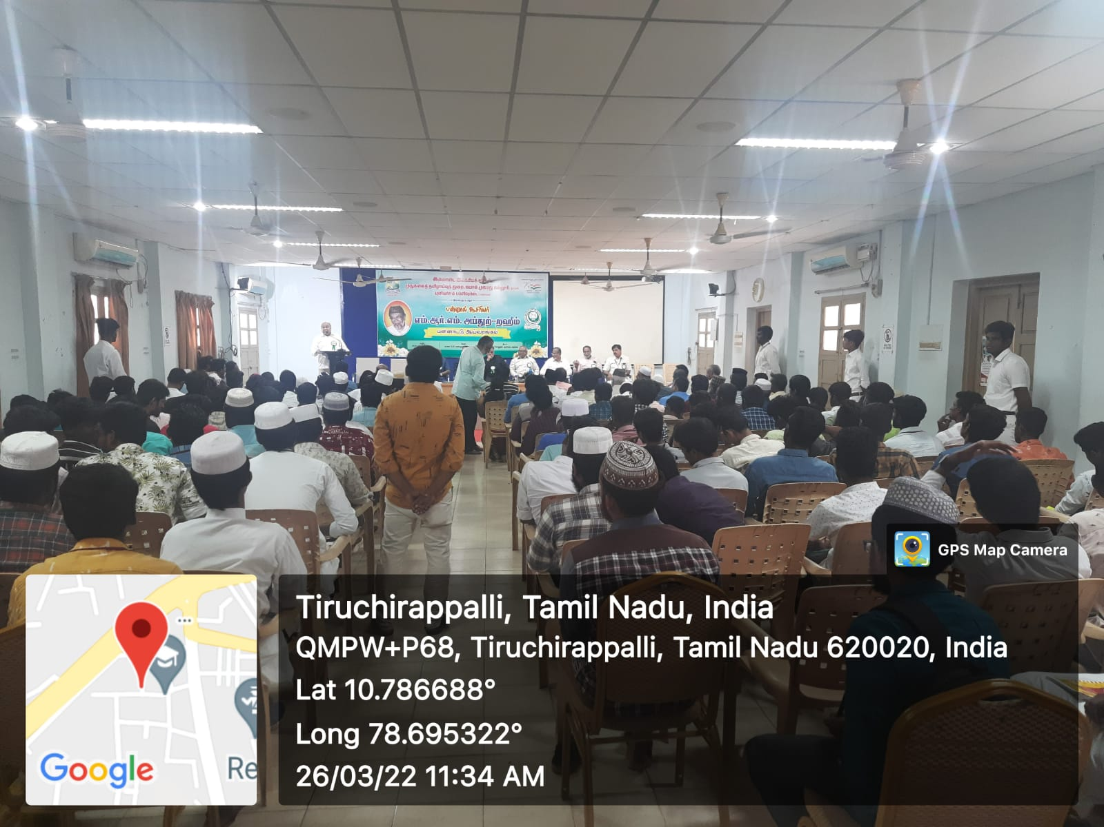

No. of NSS Volunteers of Participated: 07 Date: 26.03.2022
No. of NSS Programme Officer: 01

MEGA JOB FAIR
On The Date of 27th March 2022 Mega Job Fair Held at Jamal Mohamed College. The Principal of Jamal Mohamed College Addressed the programme. The Bharathidasan University Placement Cell Conducted the Mega Job Fair. The Placement Cell of Jamal Mohamed College and Our NSS Volunteers Organized the Programme. Our NSS Programme Officers Instructed to the NSS Volunteers and successfully complete the Mega Job Fair with Good Manner.
No. of NSS Volunteers Participated: 45 Date: 27.03.2022
No. of NSS Programme officers participated: 02

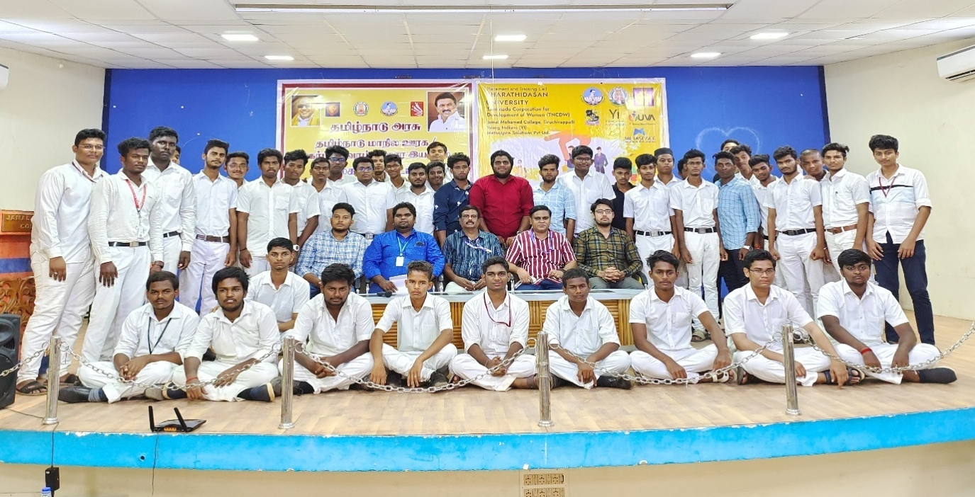

FOOD DONATION
On the date of 27th March 2022 Food Donation Programme was organized by Jamal Mohamed College NSS to TEN Needy People. Our College NSS Programmme Officers instructed to the NSS Volunteers gave the food parcel to the Needy people in good manner.

No. of NSS Volunteers Participated: 10 Date: 27.03.2022
No. of NSS Programme Officers: 01

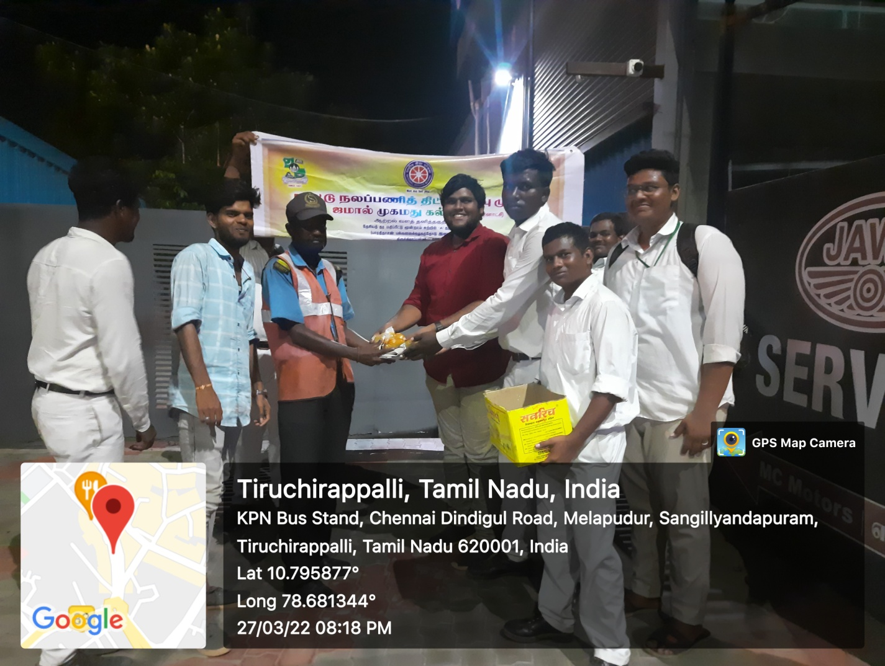

PLACEMENT CELL INTERVIEW PROGRAMME

On the date of 28th march of 2022 campus interview was conducted by placement cell of Jamal Mohamed College. Our NSS Programme officer instructed our NSS volunteers to organize the programme and help the candidates of interview. Our NSS Volunteers were worked with full involvement and our NSS volunteers done their duty in great manner.

No. of NSS Volunteers Participated: 06 Date: 28.03.2022
No. of NSS Programme officers participated: 01

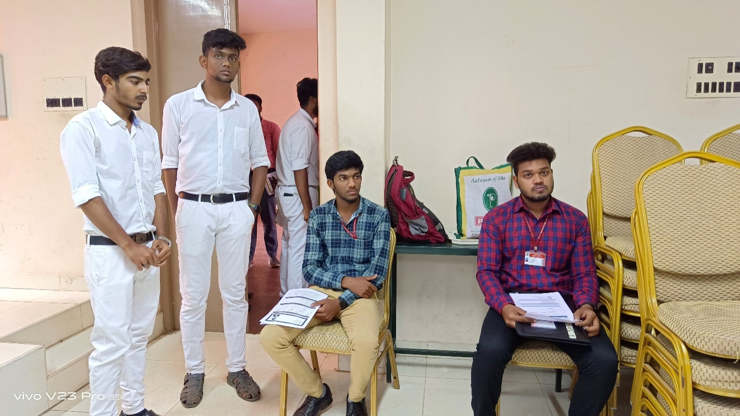

WOMEN’S EMPOWERMENT & PERSONALITY DEVOLOPMENT AT BDU
On the Date of 29th March 2022 women’s Empowerment Held at Bharathidasan University. The Registrar of Bharathidasan University Dr.L.Ganesan Felicitated the Programme and the vice Chancellor of Bharathidasan University Dr.M.SELVAM addressed the gathering. Our College NSS Volunteers organised the Programme in good manner.
No. of NSS Volunteers of Participated: 15 Date: 28.10.2021
No. of NSS Programme officers participated: 01

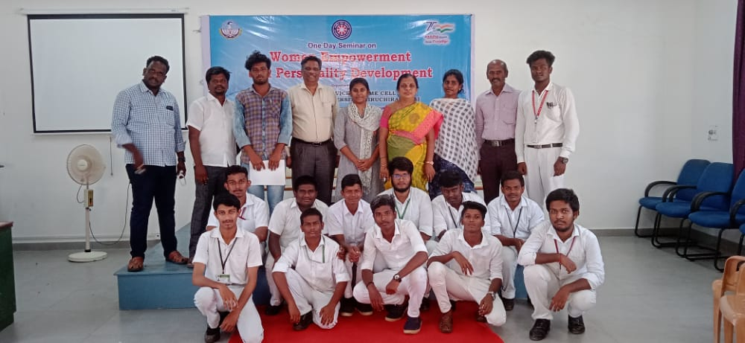

PLACEMENT CELL INTERVIEW PROGRAMME

On the date of 30th march of 2022 campus interview was conducted by placement cell of Jamal Mohamed College. Our NSS Programme officer instructed our NSS volunteers to organize the programme and help the candidates of interview. Our NSS Volunteers were worked with full involvement and our NSS volunteers done their duty in great manner.

No. of NSS Volunteers Participated: 05 Date: 30.03.2022
No. of NSS Programme officers participated: 01

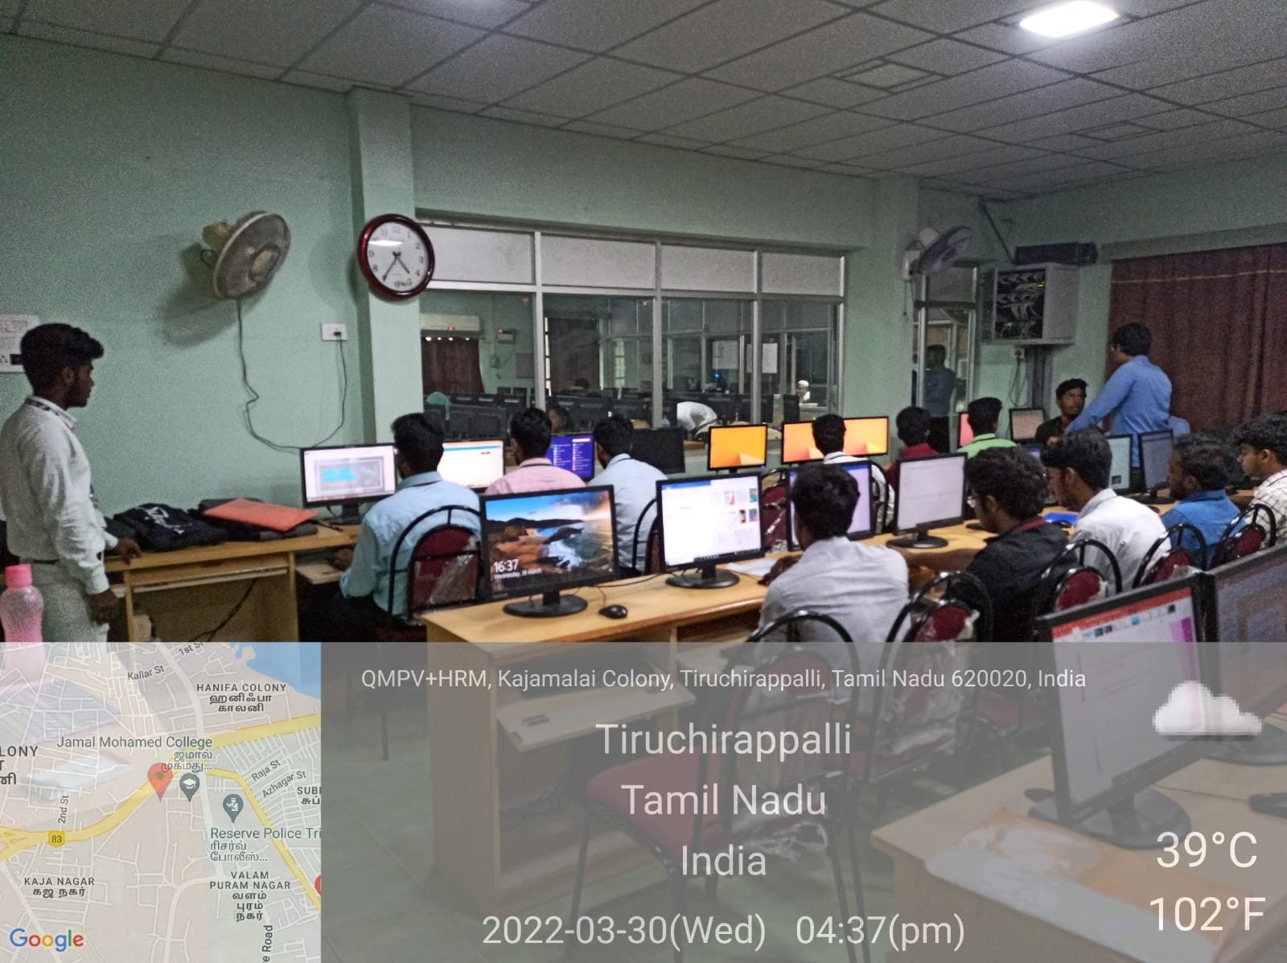

MASJIDH CLEANING AT COLLEGE CAMPUS

On the date of 30th march 2022 Masjid cleaning held at Jamal Mohamed College Campus. Our college NSS Programme officers has instructed our NSS Volunteer to Clean the Places of around the Masjid at Jamal Mohamed College campus and our volunteers has clean the place With team work. All the volunteers has Participated in the programme with full involvement and our NSS Volunteers has do their duties in good manner.

No. of NSS Volunteers of Participated: 35 Date: 30.03.2022
No. of NSS Programme officers participated: 03

